September Newsletter

Greetings from the Lake and River Parish.

Can you believe summer is almost over? Our children have returned to school. Please let us keep our teachers and children in our prayers. This is a whole new thing with this virus. Please pray for their safety.

Our summer folks will be leaving soon we pray for their safe travels. They will be so missed. They are such a big part of our church and our community.

Exciting things are happening in our churches. Pastor Christiane has brought her vibrant spirit into our church and we are visiting more. We will be starting new things like a bereavement group, a prayer group. We welcome new families who move to the area. There be will new Sunday School classes and we will endeavor to be more active in our community.

One of the things we are doing is celebrating everyone one in the village’s birthdays. Once a month we will celebrate the birthdays at the church with cupcakes and fellowship. September's celebration will be September 12th at United church of Cape Vincent at 2PM to 4PM.

We are also looking for volunteers to host October's Birthday celebrations.

September Birthdays so far:
Robin Booth, Bob Doud, Jeannie Ebert, Gavin Gippe, Tom Gault, Rob Hoehn, Mike Hasner, Rosalyn Moll, Linda Rowe, Julie Worden, Linda Schmitt, Dennis Pearson, Sarah Lockwood, Rick Martin, Jana Powell, Roland Sherman, Pastor Christiane Depestre, Margo Falknham, Beth White, Kevin Kieff, Bob Crane, Mary Titus, Sheila White, Gary Lockwood, Richard Edsall, Perry Golden, Karen Stumpf, Shelia Lawrence, Terry Snyder, Sam Delong Jaylyn Ward, Karen Trask Debbie White. Jackie Shaw. If there are any other birthdays that we missed please let us know.

Patti Esford has made a lovely basket for a new family who attends our church. We want to welcome new people into our community and into our church. I know there are lots of houses that have sold so we want to get out there and meet these new folks in our community. We would like to get some volunteers who may be interested in making baskets to welcome people into the community. Patti made such a wonderful basket and it is such a sweet thing to do.

The outreach committee is becoming more active in this
endeavor. The church has a new Facebook Page called the Lake and River. And the church Website is LakeandRiverParish.Org. Conference Website is UNYUMC.ORG

We are also looking to have more volunteers to join the Outreach Committee. Extra hands are welcome. Please contact Lee Page Email: bearwatchpa@gmail.com. Lee Page Outreach Committee

Also, PPRC is taking a survey. We would love for you to take and send to Linda. “ What is the 3 most important things you think a pastor should do. Please email to Trowe7@twcny.rr.com

We are hoping to have a music jam session with our youth. This is just a thought for now.

Hope everyone is well as they read this newsletter.
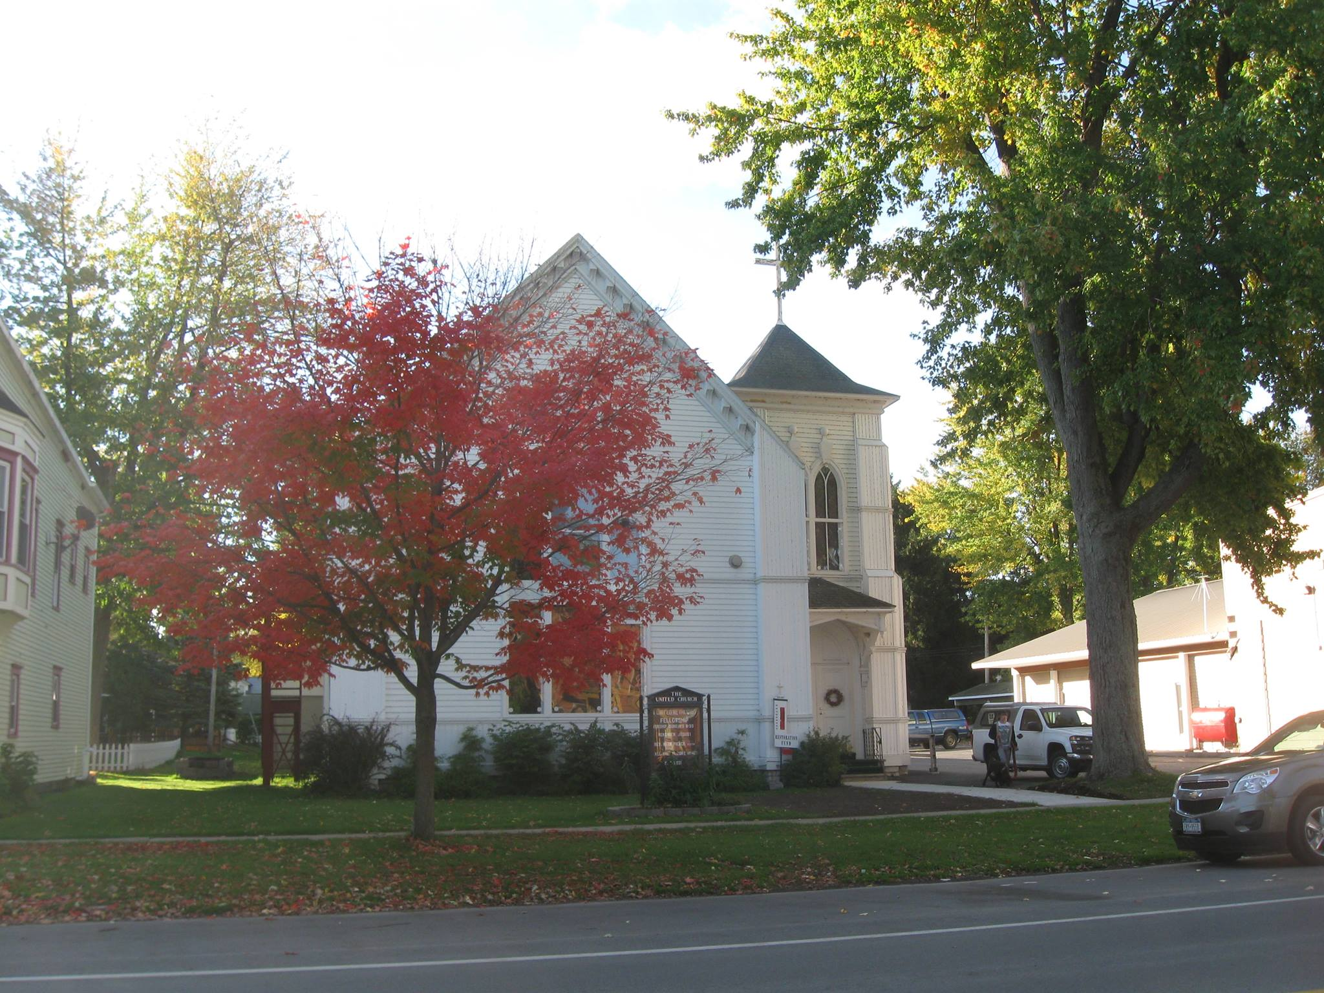

Dear friends,

I greet you warmly in the Name of Jesus! Time is going rapidly, and it is already two months since I have joined you in the Lake and River Parish. I thank God for the time of adjustment and discernment. We will continue to build our relationships, getting to know each better and better, reaching out to the members of our communities.

The major part of 2020 has brought with it many challenges. These, we have met in our Churches, Communities, Nation, and the World. Through all the changing scenes of life, we know one thing for sure: “We’ve come this far by faith, leaning on the Lord”.

God who has brought us this far, will not now leave us alone. God has planted me in this Parish to be on this segment of the journey with you. In so doing, we need each other’s love, prayers, a sincere desire to do the will of God (not our will), work together so everyone may be a vital part of a loving Church Family and Community.

I challenge us to intentionally begin/continue to pray for our Churches and their Communities. Sometime in October, a grief and loss group will start meeting, as well as a prayer group. These may be both in person and via a conference telephone call. Our desired destination is ONE LOVE! With God’s help, we will get there!

I will continue to uphold children, parents, mentors, bus drivers, teachers, administrators, and all who work in our schools, ask God's blessings on them as they begin the new school year. Let us be loving and caring toward them.

We thank God for all that has passed and trust God for all that is to come. May the days, months and years ahead be of spiritual growth and maturity through our spiritual disciplines, fellowship, and service. All to the glory of God!

Your pastor,
Chris

The United Church of Cape Vincent will have worship followed by a Congregational Meeting on September 20 at 9:30 during the Morning Worship time.
The Three Mile Bay United Church will have a devotional exercise followed by a Congregational Meeting on September 20 at 11:00 during the Morning Worship time.

