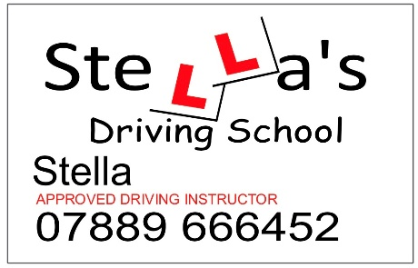

Terms and Conditions of Stella’s Driving School:
I am legally qualified to provide driving tuition in the UK; to provide lessons of a high standard I will always conduct myself ethically and professionally. My expectation is that my students will act the same (including listening to instruction, concentrating fully, being punctual and not be hindered by intoxication of either drink or drugs). I will ensure my training vehicle is well maintained and expect my students to treat it the same. Smoking/ vaping/ eating/ drinking is not permitted in the vehicle and lesson time will not be paused to allow for such activities including carrying out personal or professional errands. Any offences committed whilst using my vehicle or during a lesson will result in you, as the driver, not me, receiving the fine/points/conviction.

To be confirmed as a student of mine you will need to provide proof of your entitlement to drive (i.e. be a full or provisional licence holder) by providing a licence check code prior to the first lesson being undertaken. I reserve the right to cancel any such lesson or lessons should I not be provided with this information or find that it has been provided falsely. Any monies paid in advance for such lessons may not be returned. You must also confirm that you can read a clean number plate from a distance of 20.5meters. If this is not possible, I will not allow the lesson(s) to go ahead, and any monies paid in advance for such lessons may not be returned/ I may still charge upfront for duration of the intended lesson.

You must also notify me of any matter that affects your ability or entitlement to have driving tuition. This includes but is not limited to taking medication that may affect the ability to drive safely, any medical condition that may affect ability to drive, any lack or loss, of a valid provisional driving licence, any revocation of driving entitlement.

Lesson fees are required at least 48 hours prior to lessons being undertaken, any cancellations by yourself after this may result in me retaining the payment.

All matters relating to the timing, location and duration of individual lessons shall be subject to agreement between you and me.

In the event of mechanical breakdown or other cause, I reserve the right to rearrange the lesson to a time convenient to both parties.

On the rare occasion weather may affect the time, safety or quality of the lesson I reserve the right to rearrange or cancel the lesson entirely.

You are responsible for booking your driving test however you must ensure that both my vehicle and I are available for the chosen date and time and notify me of this as soon as possible. I will always prioritise a driving test over an arranged lesson therefore may postpone or rearrange other lessons to accommodate this. However, it will be up to my professional judgement to determine whether I support you at a particular time for a driving test and may withhold the use of my vehicle for a test you wish to undertake without such support.

Formal complaints about my conduct can be made using the following link https://www.gov.uk/complain-about-a-driving-instructor ; however I do ask that any issue is raised with me initially to provide me the opportunity to resolve it.

