Effie Procopiou Rice
Divine Influence LLC.
24 Clover Street, Meriden, CT 06450
203-213-2993
“Be the Love you Wish to See in the World”

May 2025

In 2025 – Our Work Together Is

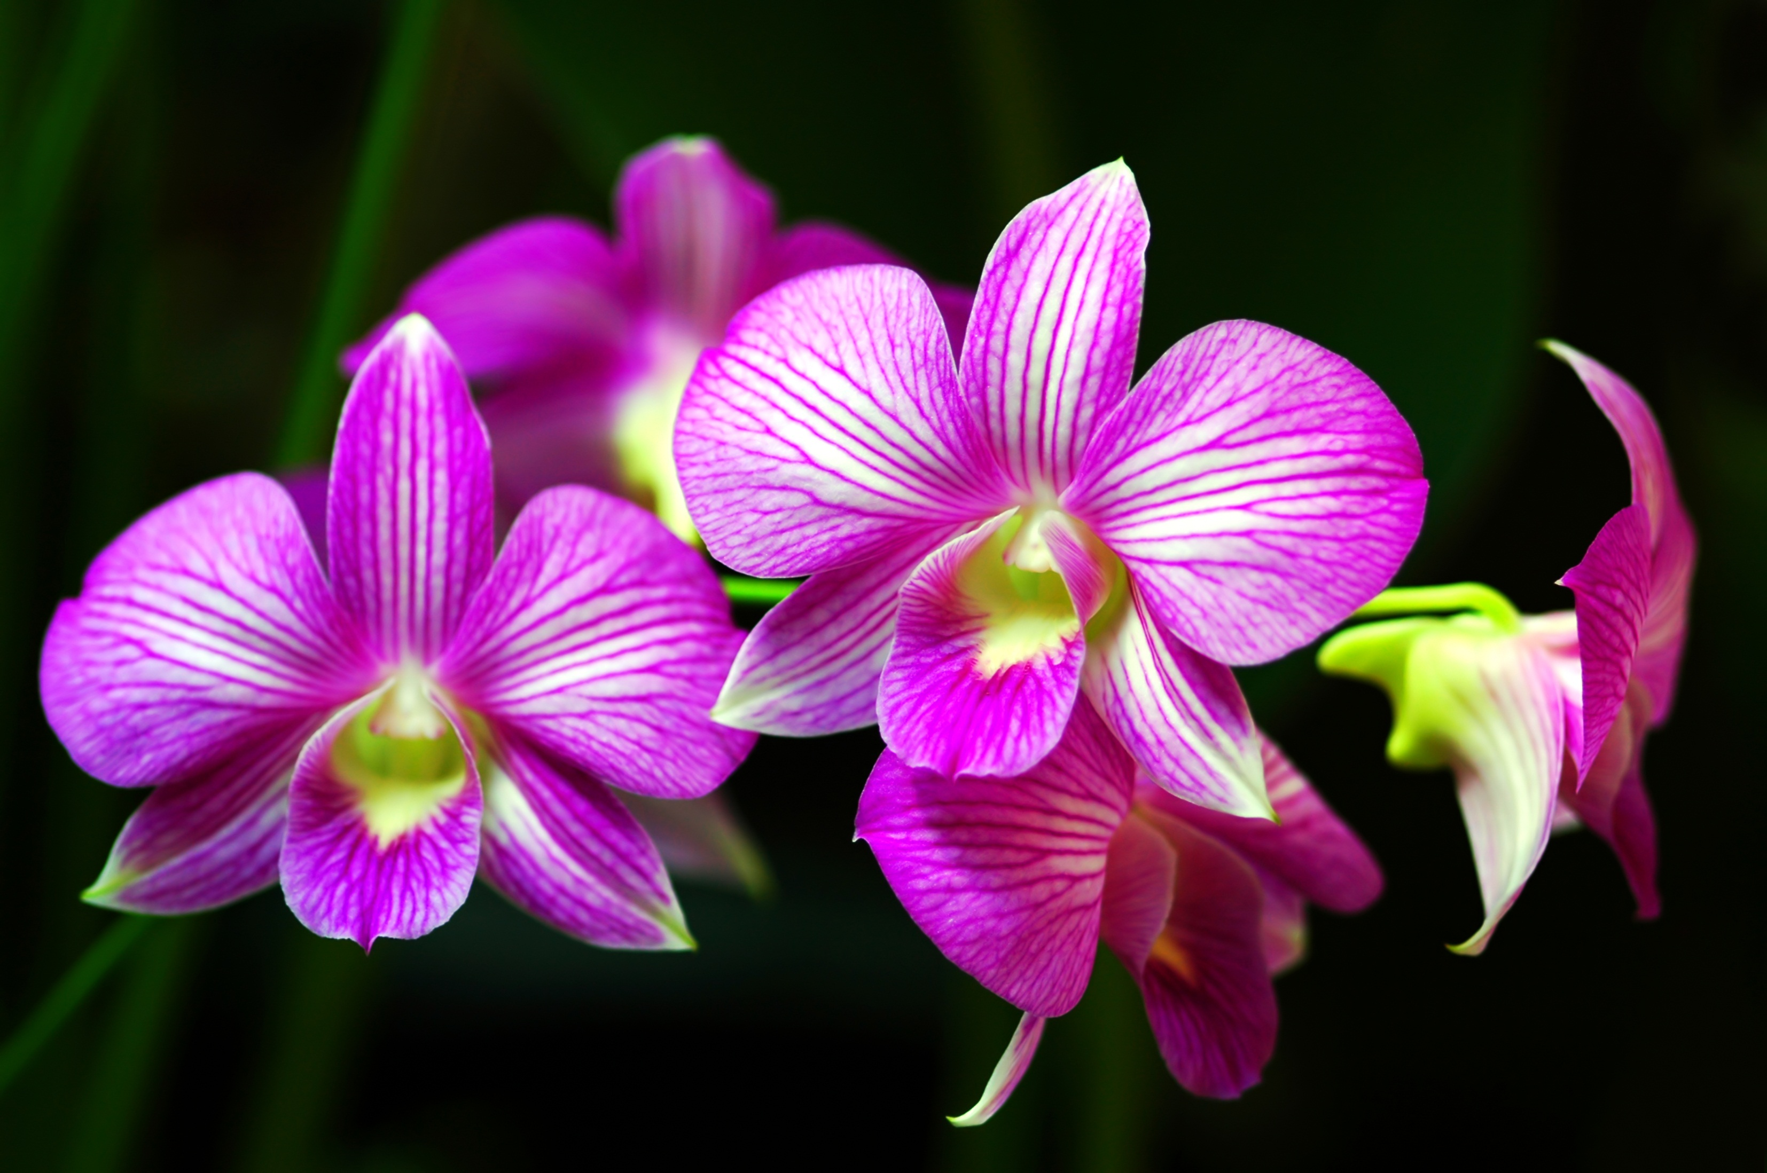

Designed To Support Growth And Transformation
A Year to Expand into Mastery !

Please note: RSVP a "MUST" for ALL classes!

Teacher’s Boot Camp
Saturday, May 3, 2025
8:30am - 11:30am

Monday Boot Camp
Monday, May 5, 2025
5:00pm - 7:00pm

Men’s Boot Camp
Tuesday, May 6, 2025
Learn to balance the masculine & feminine
& change your life and your relationships
5:00pm - 7:00pm

Boot Camp for Beginners
Wednesday, May 7, 2025
5:00pm – 7:00pm

The Seven Steps to Ascension
Book III
Advanced Level and Completion
Thursday, May 8, 2025
10:00 am – 3:00 pm
Includes Lunch, Workbook, Attunement, Crystal and Certificate
By connecting with Divine Light you will learn to enter the Seventh Dimension to realize the Ascension plan. You will learn how to activate all Chakra fields, and to raise them from the 3rd and 4th level to the 5th level, allowing an energetic balancing shift into the Seventh Dimension
Level I and II Certification Required.
Sign up and Deposit required.

Friday, May 9, 2025
STARGATE Meditation - 6:00pm – 7:00pm
ONGOING SERIES – Opening Up to the Stargate’s Advanced Meditation – Open the mind that unlocks the cosmic memory. RSVP PLEASE!

The Seven Steps to Ascension
Book II
Wednesday, May 14, 2025
10:00 am – 3:00 pm
Includes Lunch, Workbook, Attunement, Crystal and Certificate
By connecting with Divine Light you will learn to enter the Seventh Dimension
to realize the Ascension plan. You will learn how to activate all Chakra fields,
and to raise them from the 3rd and 4th level to the 5th level,
allowing an energetic balancing shift into the Seventh Dimension
Level I Certification Required.
Sign up and Deposit Required

Thursday, May 15, 2025
Capstone Meditation – 6pm – 7pm RSVP PLEASE!

Friday, May 16, 2025
Magnified Healing - 11:00 am – 3:00 pm
Magnified Healing is a fifth dimensional frequency vibration; its focus is on the heart. Magnified healing helps to build one's light body for ascension. It brings forth the energies from the Light Source, and the Three-Fold Flame. IT HEALS KARMA and awakens the wisdom of the soul, to bring inner peace. This is the highest attunement to the God Most High of the Universe, and utilizes channeled energies from Lady Kwan Yin and Lord Sananda.
Sign up and deposit required.
Fee includes CD, Teacher's manual, Essence, Certificate, and Chart Picture of Higher Self.

Boot Camp for Beginners
Saturday, May 17, 2025
8:30am - 10:30am

Advanced Boot Camp Classes
Monday, May 19, 2025
4:30pm - 6:30pm

The Seven Steps to Ascension
Book 1
Tuesday, May 20, 2025
10:00 am – 3:00 pm
Includes Lunch, Workbook, Attunement, Crystal and Certificate
By connecting with Divine Light you will learn to enter the Seventh Dimension to realize the Ascension plan. You will learn how to activate all Chakra fields, and to raise them from the 3rd and 4th level to the 5th level, allowing an energetic balancing shift into the Seventh Dimension.
Sign up and Deposit required.

Thursday, May 22, 2025
Children Spriritual Development Class
Ages 4 – 12 ½ years old
6:00pm – 7:00pm

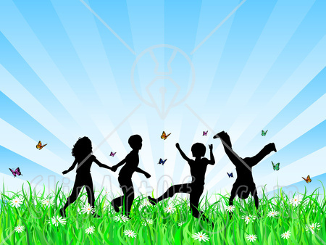
RSVP ASAP Please!

############################################
Remember, 2025 is the Chance to Be Free !
###################################
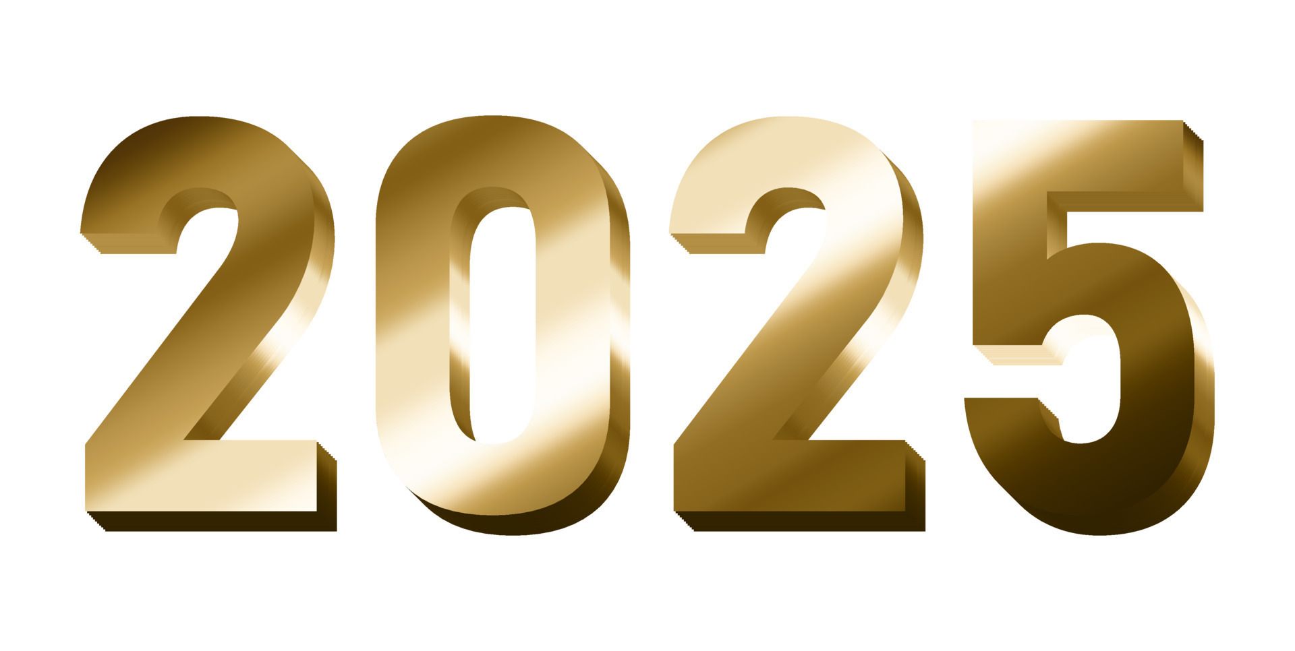
Love one Another
Walk Your Talk !
LOVE Heals
HUMAN DESIGN

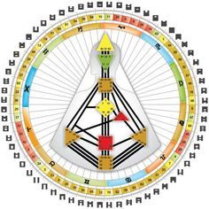

Learn Who You Are and Who You Are Not
Learn about your inner self and how to guide you true life direction.
To Sign Up See Effie
Your Chart and 1 hour analysis with Ron
$60.00

In addition to the above classes, I am also available for private body Energy Healings, Reiki, Holographic Sound Healing, Serenity Vibrational Healing ®, and Sound Meditation.
30 Minute SESSIONS - Cost $60

Sound and Light Therapy Chair
Basic sounds from a drum, deep tones of our Vibrational Chair, and the toning of Crystal Bowls activate and regulate all energetic and physical fields throughout your body.
By Appointment Only, following a healing session.
Healing $60 + Chair $20 = $80.00
I offer all levels of Reiki, up to Master and Karuna. I also teach Sound Healing, Magnified – Holographic Sound Healing, Serenity Vibrational Healing ®, and Sound Meditations.
I teach Ascension workshops and classes on the study of “ A Course In Miracles ”.
Private Spiritual Counseling is also available, by appointment only – Changing Times in a changing world! Spiritual Counseling brings loving support and insightful assistance from the Angelic Realm.
Sending you Rainbows of “MY LOVE!”
Let us be about our Father’s business,
and allow our Father in 2022 to guide us in ALL things in this new year!
Blessings to all!
I WISH YOU ALL PEACE BEYOND ALL UNDERSTANDING!
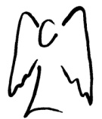
SENDING YOU HEARTFELT RAINBOW LIGHT AND BUTTERFLY KISSES.
SEALED WITH GRATITUDE

Truth is safe, and ONLY LOVE IS SURE!
Let’s Be Abundant with God’s Love!!!
ADONAI my beloved sisters and brothers! Effie

