Effie Procopiou Rice
Divine Influence LLC.
24 Clover Street, Meriden, CT 06450
203-213-2993
“Be the Love you Wish to See in the World”

August 2022



In 2022 - Walk In Gratitude
A Year to Expand into Mastery!

Please note: RSVP a "MUST" for ALL classes!

Men’s Boot Camp
Tuesday, August 2, 2022
Learn to balance the masculine & feminine
& change your life and your relationships
5:00-7:00pm

Boot Camp for Beginners
Wednesday, August 3, 2022
5pm - 7pm

Thursday Evening - Weekly Qi Kung Classes - 6pm – 7pm RSVP PLEASE!

Friday, August 5, 2022
STARGATE Meditation - 6pm – 7pm
ONGOING SERIES – Opening Up to the Stargate’s Advanced Meditation – Open the mind that unlocks the cosmic memory. RSVP PLEASE!

Teacher’s Boot Camp
Saturday, August 6, 2022
5:00 - 7:00pm

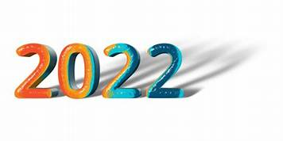
We Must Be The Change We Wish To See In This World.
Walk Your Talk!

Monday Boot Camp
and
Lion’s Gate Portal
Monday, August 8, 2022
8:30am - 11:30am

The Seven Steps to Ascension
Book III
Advanced Level and Completion
Tuesday, August 9, 2022
10am – 3 pm
Includes Lunch, Workbook, Attunement, Crystal and Certificate
By connecting with Divine Light you will learn to enter the Seventh Dimension to realize the Ascension plan. You will learn how to activate all Chakra fields, and to raise them from the 3rd and 4th level to the 5th level, allowing an energetic balancing shift into the Seventh Dimension
Level I and II Certification Required.
Sign up and Deposit required.

Wednesday Boot Camp for Beginners
Wednesday, August 10, 2022
5:00pm - 7:00pm

Thursday, August 11, 2022
Children Spriritual Development Class
Ages 4 – 12 ½ years old
6:00pm – 7:00pm
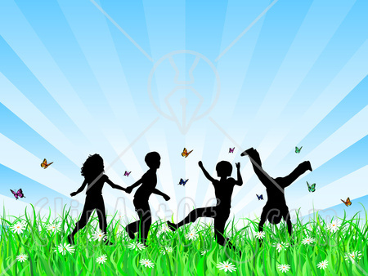
RSVP ASAP Please!

The Seven Steps to Ascension
Book 1
Friday, August 12, 2022
10am – 3pm
Includes Lunch, Workbook, Attunement, Crystal and Certificate
By connecting with Divine Light you will learn to enter the Seventh Dimension to realize the Ascension plan. You will learn how to activate all Chakra fields, and to raise them from the 3rd and 4th level to the 5th level, allowing an energetic balancing shift into the Seventh Dimension.
Sign up and Deposit required.

Saturday Boot Camp
Saturday, August 13, 2022
8:30am - 11:30am

Advanced Boot Camp Classes
Monday, August 15, 2022
4:30pm - 6:30pm

The Seven Steps to Ascension
Book II
Tuesday, August 16, 2022
10am – 3pm
Includes Lunch, Workbook, Attunement, Crystal and Certificate
By connecting with Divine Light you will learn to enter the Seventh Dimension
to realize the Ascension plan. You will learn how to activate all Chakra fields,
and to raise them from the 3rd and 4th level to the 5th level,
allowing an energetic balancing shift into the Seventh Dimension
Level I Certification Required.
Sign up and Deposit Required

########################
Life’s a Joy
Then you Ascend !
###################

Thursday, August 18, 2022
Capstone Meditation – 6pm – 7pm, RSVP PLEASE!

Friday, August 19, 2022
Magnified Healing - 11am-3pm,
Magnified Healing is a fifth dimensional frequency vibration; its focus is on the heart. Magnified healing helps to build one's light body for ascension. It brings forth the energies from the Light Source, and the Three-Fold Flame. IT HEALS KARMA and awakens the wisdom of the soul, to bring inner peace. This is the highest attunement to the God Most High of the Universe, and utilizes channeled energies from Lady Kwan Yin and Lord Sananda.
Sign up and deposit required.
Fee includes CD, Teacher's manual, Essence, Certificate, and Chart Picture of Higher Self.

Boot Camp for Beginners
Saturday, August 20, 2022
8:30am - 10:30am

In addition to the above classes, I am also available for private body Energy Healings, Reiki, Holographic Sound Healing, Serenity Vibrational Healing ®, and Sound Meditation.
45 Minute SESSIONS - Cost $60

Sound and Light Therapy Chair
Basic sounds from a drum, deep tones of our Vibrational Chair, and the toning of Crystal Bowls activate and regulate all energetic and physical fields throughout your body.
By Appointment Only, following a healing session.
Healing $60 + Chair $20 = $80.00
I offer all levels of Reiki, up to Master and Karuna. I also teach Sound Healing, Magnified – Holographic Sound Healing, Serenity Vibrational Healing ®, and Sound Meditations.
I teach Ascension workshops and classes on the study of “ A Course In Miracles ”.
Private Spiritual Counseling is also available, by appointment only – Changing Times in a changing world! Spiritual Counseling brings loving support and insightful assistance from the Angelic Realm.
Sending you Rainbows of “MY LOVE!”
Let us be about our Father’s business,
and allow our Father in 2022 to guide us in ALL things in this new year!
Blessings to all!
I WISH YOU ALL PEACE BEYOND ALL UNDERSTANDING!
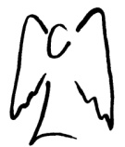
SENDING YOU HEARTFELT RAINBOW LIGHT AND BUTTERFLY KISSES.
SEALED WITH GRATITUDE

Truth is safe, and ONLY LOVE IS SURE!
Let’s Be Abundant with God’s Love!!!
ADONAI my beloved sisters and brothers! Effie

