***Effie Procopiou Rice  
Divine Influence  
E&R Halo Productions and Healing Center LLC  
24 Clover Street, Meriden, CT 06450  
203-213-2993***

**“***Be the Love you Wish to See in the World***”**



I Choose Freedom and I Soar!

***Happy 2021!  
A year to reach your highest excitement  
and raise your vibrations!***

**Please note: RSVP a "MUST" for ALL classes!**

**Monday Boot Camp**July 5, 2021  
5-7pm

**Men’s BootCamp  
Tuesday, July 6, 2021**Learn to balance the masculine & feminine   
& change your life and your relationships  
5:00-7:00pm

**New Boot Camp for Beginners  
Wednesday, July 7, 2021  
5pm to 7pm**

**BE FREE!**

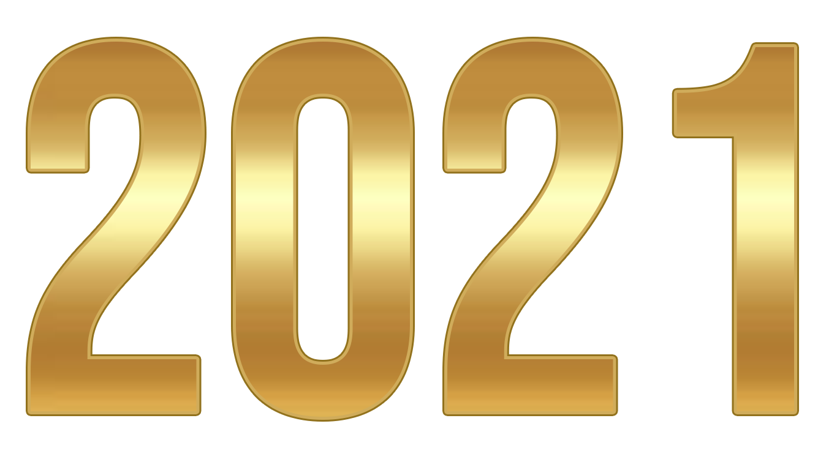

[This Photo](https://sxoleioportarias.blogspot.com/p/blog-page_31.html) by Unknown Author is licensed under [CC BY-SA](https://creativecommons.org/licenses/by-sa/3.0/)

**Thursday July 8, 2021  
Children’s Spiritual Development Class** – Ages 4 to 12. 5-6pm.

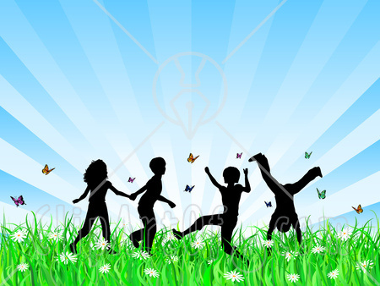

**RSVP ASAP Please!**

**2021 Mt Shasta Retreat Members**

**Meeting for Travelers**

Trip Information and Q and A  
Saturday, July 9, 2021  
6:00 pm

**2020 Teachers Advanced Bootcamp**  
Saturday, July 10, 2021  
8:30am-12pm

**Monday  
Advanced Boot Camp Classes  
July 12, 2021  
4:30-6:30pm**

**Tuesday, July 13, 2021**

**Magnified Healing** - Magnified Healing is a fifth dimensional frequency vibration; its focus is on the heart. Magnified healing helps to build one's light body for ascension.  It brings forth the energies from the Light Source, the Three-Fold Flame.  IT HEALS KARMA and awakens the wisdom of the soul, to bring inner peace.  This is the highest attunement to the God Most High of the Universe, and utilizes channeled energies from Lady Kwan Yin and Lord Sananda. 11am-3pm. Fee includes CD, Teacher's manual, Essence, Certificate, and framed Chart picture of Higher Self

**New Wednesday Bootcamp for Beginners  
July 14, 2021**  
5 to 7pm

**Tuesday, July 15, 2021  
ONGOING SERIES** - Opening Up to the Stargates Advanced Meditation- Opening the mind that unlocks the cosmic memory. 6pm-7pm.

**The Seven Steps to Ascension**  
**Book 1  
Friday, July 16, 2021, 10am-3pm Cost $200  
Includes Lunch, Workbook, Attunement, Crystal and Certificate**  
By connecting with Divine Light you will learn to enter the Seventh Dimension to realize the Ascension plan. You will learn how to activate all Chakra fields, and to raise them from the 3rd and 4th level to the 5th level, allowing an energetic balancing shift into the Seventh Dimension.  
**Sign up and Deposit required.**

**New Beginners**

**2021 Atlantean Series**

**NEW Saturday Boot Camp  
Saturday, July 17, 2021  
8:30am- 12pm**   **A Year to FORGIVE & BE FREE**

A spiritual retreat bootcamp with like-minded souls.   
Learn to activate self-love, self-worth, self-compassion.  
Learn to activate abilities within your DNA, depending on your perception of what is possible.   
You have these abilities encoded within each of your human blueprint.

**“Love is the only Power there is”­­­­­­­­­­­­­­­**

**The Seven Steps to Ascension  
Book II  
Tuesday, July 27, 2021  
10am-3pm  
Includes Lunch, Workbook, Attunement, Crystal and Certificate**   
By connecting with Divine Light you will learn to enter the Seventh Dimension   
to realize the Ascension plan. You will learn how to activate all Chakra fields,   
and to raise them from the 3rd and 4th level to the 5th level,   
allowing an energetic balancing shift into the Seventh Dimension.  
**Level I Certification Required-----Sign Up and Deposit**

**New Boot Camp (Beginners)**

July 28, 2021  
4:30-6:30pm

########################

***Think Good Thoughts!***####################

**Thursday, July 29, 2021   
Capstone Meditation –** 6pm-7pm. **RSVP PLEASE!**

**The Seven Steps to Ascension  
Book III  
Advanced Level and Completion  
Friday, July 30, 2021**

**10am-3pm**

**Includes Lunch, Workbook, Attunement, Crystal and Certificate   
By connecting with Divine Light you will learn to enter the Seventh Dimension to realize the Ascension plan. You will learn how to activate all Chakra fields, and to raise them from the 3rd and 4th level to the 5th level, allowing an energetic balancing shift into the Seventh Dimension**

**Level I and II Certification Required.**

*** **NOW TAKING DEPOSITS** ***

***2022 Sedona Trip  
A Magical Journey into the Unknown!***

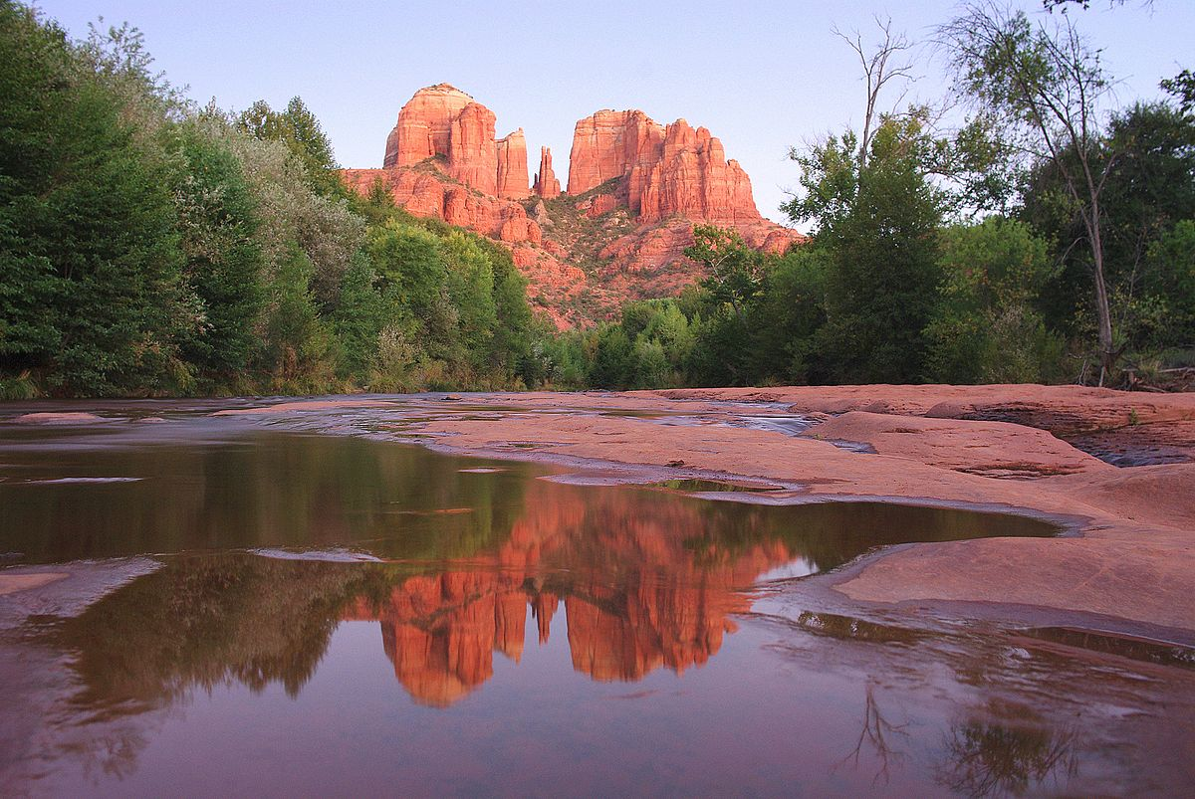

**Sign up NOW for April, 2022 Sedona Journey!**--- Only taking 10 people! ---

**Sound and Light Therapy Chair**Basic sounds from a drum, deep tones of the vibrational chair, and ringing of crystal bowls activate and regulate all energetic and physical fields throughout your body.   
By Appointment Only, following a healing session.

**In addition to the above classes, I am also available for private body ENERGY and HEALING SESSIONS – Holographic Sound Healing, Serenity Vibrational Healing ®, and E&R Halo Productions Sound Meditations.**

**I teach all levels of Reiki, up to Master and Karuna. I also teach sound healing, magnified healing, and Ascension workshops.**   
**Private Spiritual Counseling is also available, by appointment only** – **Changing Times in a changing world! Spiritual Counseling brings loving support and insightful assistance from the Angelic Realm.**  *Sending you Rainbows of “MY LOVE!”  
Let us be about our Father’s business,   
and allow our Father in 2021 to guide us in ALL things in this new year!  
Blessings to all!   
  
I WISH YOU ALL PEACE BEYOND ALL UNDERSTANDING!*

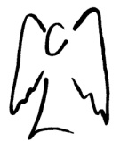

SENDING YOU HEARTFELT RAINBOW LIGHT AND BUTTERFLY KISSES.   
SEALED WITH GRATITUDE



**Truth is safe, and ONLY LOVE IS SURE!***Let’s Be Abundant with God’s Love!!!  
ADONAI my beloved sisters and brothers!*

*Effie*