Effie Procopiou Rice
Divine Influence
E&R Halo Productions and Healing Center LLC
24 Clover Street, Meriden, CT 06450
203-213-2993
“Be the Love you Wish to See in the World”



Happy Summer Solstice

Happy 2021!
A year to reach your highest excitement
and raise your vibrations!

Please note: RSVP a "MUST" for ALL classes!
Monday Boot Camp
June 7, 2021
5-7pm

Men’s BootCamp
Tuesday, June 8, 2021
Learn to balance the masculine & feminine
& change your life and your relationships
5:00-7:00pm
New Boot Camp for Beginners
Wednesday, June 2, 2021
5pm to 7pm

2020 Teachers Advanced Bootcamp
Saturday, June 5, 2021
8:30am-12pm

Friday , June 4, 2021
Magnified Healing - Magnified Healing is a fifth dimensional frequency vibration; its focus is on the heart. Magnified healing helps to build one's light body for ascension. It brings forth the energies from the Light Source, the Three-Fold Flame. IT HEALS KARMA and awakens the wisdom of the soul, to bring inner peace. This is the highest attunement to the God Most High of the Universe, and utilizes channeled energies from Lady Kwan Yin and Lord Sananda. 11am-3pm. fee includes CD, Teacher's manual, Essence, Certificate, and framed Chart picture of Higher Self

Monday
Advanced Boot Camp Classes
June 14, 2021
4:30-6:30pm

Thursday, June 24, 2021
ONGOING SERIES - Opening Up to the Stargates Advanced Meditation- Opening the mind that unlocks the cosmic memory. 6pm-7pm

New Wednesday Bootcamp for Beginners
June 9, 2021
5 to 7pm

Thursday June 10, 2021
Children’s Spiritual Development Class – Ages 4 to 12. 5-6pm
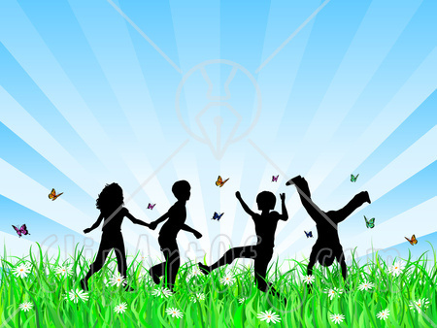
RSVP ASAP Please!

BE FREE!
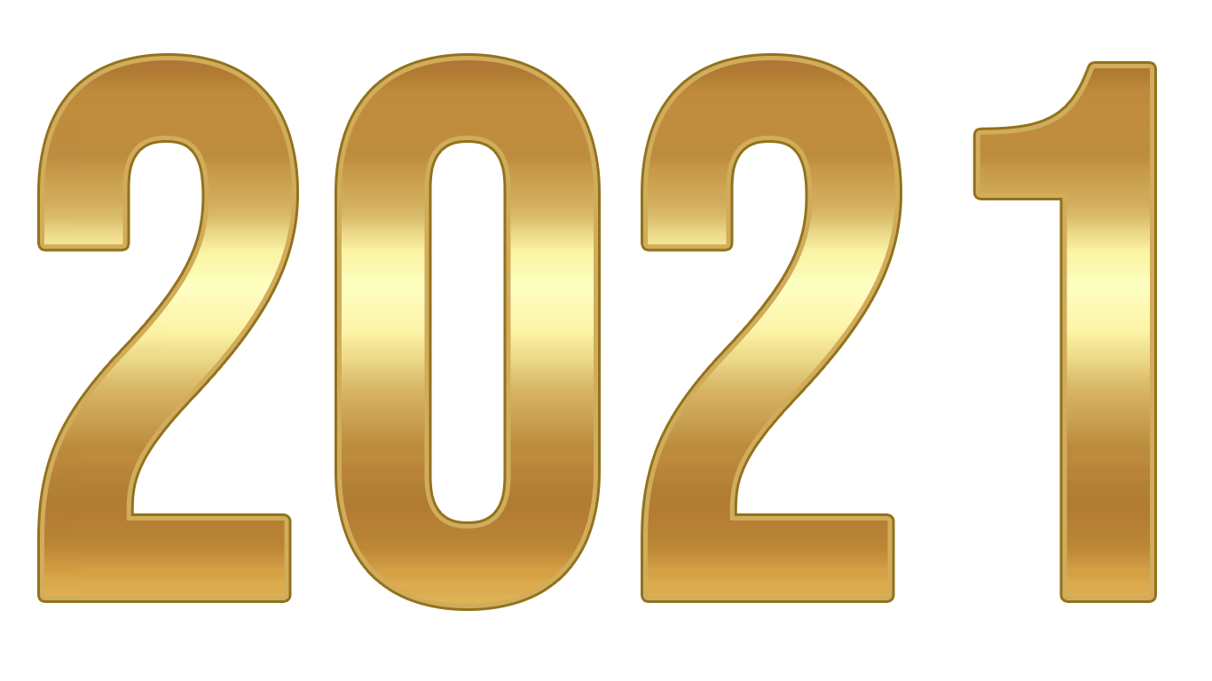
The Seven Steps to Ascension
Book 1
Friday, June 11, 2021, 10am-3pm
Includes Lunch, Workbook, Attunement, Crystal and Certificate
By connecting with Divine Light you will learn to enter the Seventh Dimension to realize the Ascension plan. You will learn how to activate all Chakra fields, and to raise them from the 3rd and 4th level to the 5th level, allowing an energetic balancing shift into the Seventh Dimension.
Sign up and Deposit required.

New Beginners
2021 Atlantean Series
NEW Saturday Boot Camp
Saturday, June 12, 2021
8:30am- 12pm
A Year to FORGIVE & BE FREE
A spiritual retreat bootcamp with like-minded souls.
Learn to activate self-love, self-worth, self-compassion.
Learn to activate abilities within your DNA, depending on your perception of what is possible.
You have these abilities encoded within each of your human blueprint.
“Love is the only Power there is”

The Seven Steps to Ascension
Book II
Sunday, June 13, 2021
10am-3pm
Includes Lunch, Workbook, Attunement, Crystal and Certificate
By connecting with Divine Light you will learn to enter the Seventh Dimension
to realize the Ascension plan. You will learn how to activate all Chakra fields,
and to raise them from the 3rd and 4th level to the 5th level,
allowing an energetic balancing shift into the Seventh Dimension.
Level I Certification Required

New Boot Camp (Beginners)
June 21, 2021
4:30-6:30pm

Thursday, June 17, 2021
Capstone Meditation – 6pm-7pm RSVP PLEASE!

########################
Think Good Thoughts!
####################

The Seven Steps to Ascension
Book III
Advanced Level and Completion
Friday, June 18, 2021
10am-3pm
Includes Lunch, Workbook, Attunement, Crystal and Certificate
By connecting with Divine Light you will learn to enter the Seventh Dimension to realize the Ascension plan. You will learn how to activate all Chakra fields, and to raise them from the 3rd and 4th level to the 5th level, allowing an energetic balancing shift into the Seventh Dimension
Level I and II Certification Required.

*** NOW TAKING DEPOSITS FOR BOTH RETREATS ***

SPIRITUAL RETREAT at MOUNT SHASTA

Sign up ASAP! --- Only taking 20 people for 2021 --- Deposit Required
This Photo by Unknown Author is licensed under CC BY-NC-ND

UPDATE ON SHASTA!
Due to the pandemic, our facilitator needs to change dates, tentatively into August. Ron and I will be going in July to plan your trip with facilitators at this time. Dates to be announced in BootCamps!

2021 Sedona Trip
A Magical Journey into the Unknown!

***Sign up NOW for April Sedona Journey!
April 5 to April 11, 2021 --- Only taking 10 people! --- Deposit Required

Sound and Light Therapy Chair
Basic sounds from a drum, deep tones of the vibrational chair, and ringing of crystal bowls activate and regulate all energetic and physical fields throughout your body.
By Appointment Only, following a healing session.
In addition to the above classes, I am also available for private body ENERGY and HEALING SESSIONS – Holographic Sound Healing, Serenity Vibrational Healing ®, and E&R Halo Productions Sound Meditations.
I teach all levels of Reiki, up to Master and Karuna. I also teach sound healing, magnified healing, and Ascension workshops.
Private Spiritual Counseling is also available, by appointment only – Changing Times in a changing world! Spiritual Counseling brings loving support and insightful assistance from the Angelic Realm.
Sending you Rainbows of “MY LOVE!”
Let us be about our Father’s business,
and allow our Father in 2021 to guide us in ALL things in this new year!
Blessings to all!
I WISH YOU ALL PEACE BEYOND ALL UNDERSTANDING!
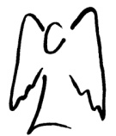
SENDING YOU HEARTFELT RAINBOW LIGHT AND BUTTERFLY KISSES.
SEALED WITH GRATITUDE

Truth is safe, and ONLY LOVE IS SURE!
Let’s Be Abundant with God’s Love!!!
ADONAI my beloved sisters and brothers!
Effie

