Effie Procopiou Rice
Divine Influence
E&R Halo Productions and Healing Center LLC
24 Clover Street, Meriden, CT 06450
203-213-2993
Please note: RSVP a "MUST" for ALL classes!
“Be the Love you Wish to See in the World”


2020 - A year to reach your highest excitement!
So BUCKLE UP!!!
This Photo by Unknown Author is licensed under CC BY-NC

The Seven Steps to Ascension
Book I
Sunday, March 1, 2020, 10am-3pm
Includes Lunch, Workbook, Attunement, Crystal and Certificate
By connecting with Divine Light you will learn to enter the Seventh Dimension to realize the Ascension plan.
You will learn how to activate all Chakra fields, and to raise them from the 3rd and 4th level
to the 5th level, allowing an energetic balancing shift into the Seventh Dimension.
Sign Up and Deposit required.

Monday Boot Camp
March 2, 2020
5-7pm

Men’s BootCamp
Tuesday, March 3, 2020
Learn to balance the masculine & feminine
& change your life and your relationships
5:00-7:00pm

New Boot Camp for Beginners
Wednesday, March 4, 2020
5pm to 7pm

Thursday, March 5, 2020
ONGOING SERIES - Opening Up to the Stargates Advanced Meditation- Opening the mind that unlocks the cosmic memory. 6:30-8pm.

2020 Teachers Advanced Bootcamp
Saturday, March 7, 2020
8:30am-12pm

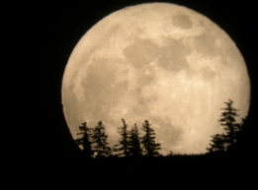 Day Before - Full Moon Meditation
Sunday, March 8, 2020. 6-7pm. 6-7pm

Monday
Advanced Boot Camp Classes
March 9, 2020
4:30-6:30pm

Wednesday, March 11, 2020
ONGOING SERIES – Activation of the Capstone with Sound and Thought to harmonize within you. The capstone is the crowning glory that takes us beyond, into a higher realm. VERY INTENSE
MEDITATION. 6:30-8pm.

Thursday, March 12, 2020
Children’s Spiritual Development Class – Ages 4 to 12. 5-6pm.
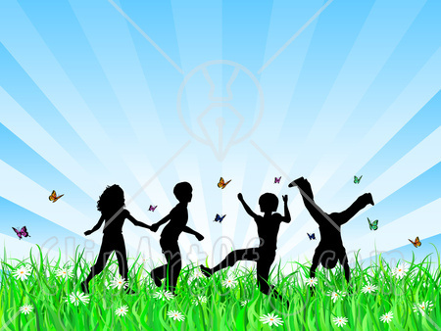
RSVP ASAP Please!

New Beginners
2020 Atlantean Series
NEW Saturday Boot Camp
Saturday, March 14, 2020
8:30am- 12pm
A Year to FORGIVE & BE FREE
A spiritual retreat boot camp with like-minded souls.
Learn to activate self-love, self-worth, self-compassion.
Learn to activate abilities within your DNA, depending on your perception of what is possible. You have these abilities encoded within each of your human blueprint.
“Love is the only Power there is”

Sunday, March 15, 2020 – PLEASE RSVP for CONCERT ASAP!
Sound Healing Concert with Effie and Ron. RSVP A MUST – Seating Limited. Vibrational medicine used to unblock channels on some levels to help you move forward. 6pm-7pm.

Saturday, March 21, 2020
Magnified Healing - Magnified Healing is a fifth dimensional frequency vibration; its focus is on the heart. Magnified healing helps to build one's light body for ascension. It brings forth the energies from the Light Source, the Three-Fold Flame. IT HEALS KARMA and awakens the wisdom of the soul, to bring inner peace. This is the highest attunement to the God Most High of the Universe, and utilizes channeled energies from Lady Kwan Yin and Lord Sananda. 11am-3pm. Fee includes CD, Teacher's manual, Essence, Certificate, and framed Chart picture of Higher Self

The Seven Steps to Ascension
Book II
Sunday, March 22, 2020
10am-3pm
Includes Lunch, Workbook, Attunement, Crystal and Certificate
By connecting with Divine Light you will learn to enter the Seventh Dimension to realize the Ascension plan. You will learn how to activate all Chakra fields, and to raise them from the 3rd and 4th level to the 5th level, allowing an energetic balancing shift into the Seventh Dimension.
Level I Certification Required-----Sign Up and Deposit

LOVE
HEALS

The Seven Steps to Ascension
Book III
Advanced Level and Completion
Sunday, March 29, 2020
10am-3pm
Includes Lunch, Workbook, Attunement, Crystal and Certificate
By connecting with Divine Light you will learn to enter the Seventh Dimension to realize the Ascension plan. You will learn how to activate all Chakra fields, and to raise them from the 3rd and 4th level to the 5th level, allowing an energetic balancing shift into the Seventh Dimension
Level I and II Certification Required.

Sedona
A Magical Journey into the Unknown!

***Sign up NOW for a Sedona Journey!***
Date to Be Determined

Sunday, June 7, 2020
2nd Annual Spiritual Boot Camp Special Event!
10am-3pm
Lunch Included!
Payment upon Registration
RSVP a MUST!
Hilton Garden Inn
Route 68, Wallingford CT


This Photo by Unknown Author is licensed under CC BY-NC-ND

SPIRITUAL RETREAT
at
MOUNT SHASTA
July 23-28th, 2020
Filled & Closed!

Sound and Light Therapy Chair
Basic sounds from a drum, deep tones of the vibrational chair, and ringing of crystal bowls activate and regulate all energetic and physical fields throughout your body.
By Appointment Only, following a healing session.
In addition to the above classes, I am also available for private body ENERGY and HEALING SESSIONS – Holographic Sound Healing, Serenity Vibrational Healing ®, and E&R Halo Productions Sound Meditations.
I teach all levels of Reiki, up to Master and Karuna. I also teach sound healing, magnified healing, and Ascension workshops.
Private Spiritual Counseling is also available, by appointment only – Changing Times in a changing world! Spiritual Counseling brings loving support and insightful assistance from the Angelic Realm.
Sending you Rainbows of “MY LOVE!”
Let us be about our Father’s business,
and allow our Father in 2019 to guide us in ALL things in this new year!
Adonai Blessings to all! ---- Effie
I WISH YOU ALL PEACE BEYOND ALL UNDERSTANDING!
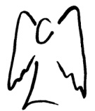
SENDING YOU HEARTFELT RAINBOW LIGHT AND BUTTERFLY KISSES.
SEALED WITH GRATITUDE

Truth is safe, and ONLY LOVE IS SURE!
Let’s Be Abundant with God’s Love!!!
ADONAI my beloved sisters and brothers!
and a Blessed Happy Holiday Season!
Effie

