Abstract Title (Georgia in Bold 14 Pts Font, Centered)
FirstName Surname^{1*}, FirstName Surname², and FirstName Surname³
ª Affiliation 1
^{b} Affiliation 2
^{c} Affiliation 3
*Corresponding Author’s Email:
Keywords: 3–5 relevant terms that define the work
Text
Abstract should be prepared using this template. It should outline the aim, scope, and main conclusions of the work. The sections can be Introduction, Methodology, Results, and Summary. Total length should be close to but not exceed two pages, including figures, tables, equations, and references. The abstract should be saved as a PDF file before uploading it to Microsoft CMT.
Guidelines
The abstract should be prepared on A4-size (210 x 297 mm) sheets. Each side should have a 25 mm margin. Text should be in Georgia, 12 points, fully justified, and spaced single lines apart. Explain the main methods, models, or procedures used in your research. Provide the necessary details, such as material systems, simulations, or experimental setups, concisely and clearly. Avoid excessive detail that belongs in a full paper.
An abstract may include figures, tables, and equations. They should be included in the text, centered, and numbered sequentially as illustrated below. For citing figures, use Fig. 1, similarly, Table 1, and Eq. (1).
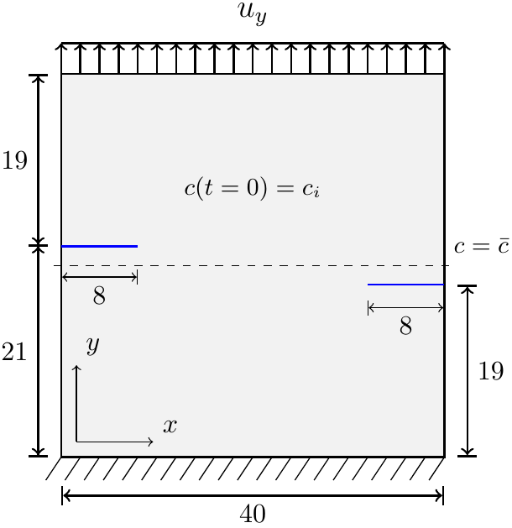
Figure 1: Figures should be centered and followed by a numbered caption.
The following is an example of the equations.
$F=\int_{V}{\left(f\left(c\right)+\frac{β}{2}{\left(∇c\right)}^{2}+\frac{1}{2}σϵ^{el}\right)}dV$ (1)
Table 1: Tables should be centered and preceded by a numbered caption
 | P-1 | P-2 | P-3 | P-4 | P-5
D_{o Flank-Flank} | 2.384 | 2.393 | 2.408 | 2.424 | 2.378
t - Flank | 0.196 | 0.223 | 0.224 | 0.224 | 0.207
t– Flank | 0.241 | 0.228 | 0.226 | 0.225 | 0.233
D_{o Intra-Extra} | 2.358 | 2.270 | 2.274 | 2.303 | 2.379
t - Intrados | 0.243 | 0.281 | 0.293 | 0.282 | 0.200
t - Extrados | 0.204 | 0.199 | 0.202 | 0.205 | 0.217

Conclusions
An abstract may include references. In-text references should consist of the last names of authors and the year, for example, in Cook et al. [1]. Entries in the “References” section should be single-spaced. Each entry should consist of the following (adapted as necessary): names of authors (last name first), year, paper or publication title, journal or book title, publisher, journal volume and number, page numbers’ range.
References
[1] Cook, R. D., Malkus, D. S., Plesha, M. E. and Witt, R. J. (2002). Concepts and Applications of Finite Element Analysis, 4th ed., John Wiley & Sons.
[2] Frater, G. S. and Packer, J. A. (1992). “Weldment design for RHS truss connections. II: Experimentation,” J. Structural Engineering, ASCE, 118(10), 2804-2820.
[3] Hughes, T. J. R. and Allik, H. (1969). “Finite Elements for Compressible and Incompressible Continua,” Proc., Symposium on Application of Finite Element Methods in Civil Engineering, ASCE, Nashville, TN, 27-62.
[4] Cahn, J.W. and Hilliard, J.E. (1958) “Free Energy of a Nonuniform System. I. Interfacial Free Energy”, The Journal of Chemical Physics, 28(2):258-267

