
Attendance and Engagement Policy

Authorised:THU
Date:28/07/26
Renewal:28/07/26

Safe, Connected, Ready to Learn

Vision
Every interaction is an intervention: safe relationships create successful learners.

Ethos

"Do all the good you can, by all the means you can, in all the ways you can, in all the places you can, at all the times you can, to all the people you can, as long as ever you can."
– John Wesley

At Mount School, we believe that positive relationships, high expectations and therapeutic support create the conditions for successful learning. Through a trauma-informed and restorative approach, we support pupils to become safe, connected and ready to learn, preparing them for successful futures and positive participation in their communities.

Contents
- Policy Statement
- Aims
- Attendance, Engagement and Safeguarding
- Attendance, Engagement and Wellbeing
- Roles and Responsibilities
- Recording Attendance
- Reporting Absence
- Authorised and Unauthorised Absence
- Punctuality
- Attendance Monitoring and Early Intervention
- Persistent Absence
- Emotionally Based School Avoidance
- Children Missing Education
- Medical Appointments and Illness
- Leave of Absence During Term Time
- Supporting Re-Engagement Following Absence
- Use of LearnTrek
- Links with S.C.O.R.E.
- Working with Parents, Carers and External Agencies
- Monitoring and Review

Appendix 1-Concern flowchart
Appendix 2 – Attendance Support Plan
Appendix 3 – Parent/Carer Absence Reporting Expectations
Appendix 4 – Linked Policies
Appendix 5 – Updated Attendance Codes

- Policy Statement

Mount School is committed to promoting positive attendance, punctuality, engagement and participation in learning for all pupils.
We recognise that regular attendance is important for educational achievement, emotional wellbeing, personal development and successful outcomes in adulthood. We also recognise that many pupils may experience barriers to attendance due to social, emotional, mental health, medical, family or other individual circumstances.
As a specialist provision, Mount School adopts a trauma-informed, restorative and relational approach to attendance. We seek to understand and address the underlying factors affecting attendance and engagement, working collaboratively with pupils, families, local authorities and external agencies to remove barriers and promote success.
Attendance is everyone's responsibility. Through positive relationships, high expectations and therapeutic support, we aim to create a school environment where pupils feel safe, connected and ready to learn.
Mount School uses LearnTrek as its primary system for recording attendance, punctuality, lesson attendance, engagement, attendance interventions and attendance-related concerns.

- Aims

This policy aims to:
- Promote positive attendance, punctuality and engagement in learning.
- Ensure all pupils have access to education appropriate to their individual needs.
- Foster a culture where attendance is valued and supported.
- Identify attendance concerns at the earliest opportunity.
- Work collaboratively with pupils, parents/carers and external professionals to address barriers to attendance.
- Support pupils experiencing attendance difficulties through a graduated and individualised approach.
- Promote emotional wellbeing and school connectedness.
- Recognise the relationship between attendance, safeguarding and pupil welfare.
- Ensure attendance is monitored accurately and consistently through LearnTrek.
- Fulfil statutory responsibilities relating to attendance recording, monitoring and reporting.

3. Attendance, Engagement and Safeguarding
Mount School recognises that attendance is a key safeguarding responsibility.
Poor attendance, persistent absence or significant changes in attendance patterns may indicate that a pupil is experiencing difficulties which require additional support or intervention.
Attendance concerns may be linked to:
- Mental health difficulties.
- Emotional wellbeing concerns.
- Bullying or peer relationship difficulties.
- Family circumstances.
- Medical needs.
- Social care involvement.
- Child protection concerns.
- Emotionally Based School Avoidance.
- Exploitation or other safeguarding risks.
All attendance concerns will be considered within the wider context of pupil wellbeing and safeguarding.
Where attendance concerns raise safeguarding concerns, staff will follow the Safeguarding and Child Protection Policy and record concerns appropriately on LearnTrek.
The school will work proactively with families, placing authorities and external agencies where attendance concerns indicate a potential safeguarding risk.

- Attendance, Engagement and Wellbeing

At Mount School, we understand that attendance and emotional wellbeing are closely linked.
Many pupils may have experienced previous difficulties with education, disrupted educational experiences, adverse childhood experiences, trauma, anxiety or other factors which impact their ability to attend and engage consistently.
The school adopts a supportive and relational approach to attendance, recognising that improving attendance often requires understanding and addressing the underlying causes of absence.
Staff will seek to:
- Build positive relationships with pupils and families.
- Identify barriers to attendance at an early stage.
- Promote a sense of belonging and connection within the school community.
- Support emotional regulation and wellbeing.
- Work collaboratively with external agencies where appropriate.
- Develop individualised strategies to support attendance and engagement.
The school recognises that attendance improvement is often a gradual process. Progress will be recognised through relational support, individual targets and the wider S.C.O.R.E. framework rather than through a separate attendance reward system.

- Roles and Responsibilities

Principal
The Principal has overall responsibility for:
- Promoting a culture of positive attendance and engagement.
- Ensuring statutory attendance requirements are met.
- Monitoring attendance trends and patterns.
- Ensuring appropriate interventions are implemented where concerns arise.
- Working with external agencies, placing authorities and local authorities where required.
- Ensuring attendance arrangements are regularly reviewed and evaluated.
Head of Provision
The Head of Provision is responsible for:
- Overseeing the implementation of this policy.
- Monitoring attendance and engagement data.
- Supporting attendance interventions and plans.
- Liaising with families and external professionals.
- Ensuring attendance concerns are appropriately recorded and addressed.
- Ensuring attendance concerns are considered alongside safeguarding, wellbeing and behaviour information.
Staff
All staff are responsible for:
- Promoting positive attendance and engagement.
- Building supportive relationships with pupils.
- Recording attendance accurately.
- Monitoring pupil engagement and wellbeing.
- Identifying and reporting attendance concerns.
- Recording attendance-related concerns and interventions on LearnTrek.
- Working collaboratively with families and professionals to support attendance.
Parents and Carers
Parents and carers are expected to:
- Ensure their child attends school regularly and punctually.
- Notify the school of absence as soon as possible.
- Provide reasons for absence.
- Work in partnership with the school to address attendance concerns.
- Engage with attendance support plans and meetings where required.
- Inform the school of any issues which may affect attendance or punctuality.
Pupils
Pupils are expected to:
- Attend school regularly.
- Arrive on time and ready to learn.
- Engage positively in learning opportunities.
- Seek support from trusted adults when experiencing difficulties.
- Work collaboratively with staff to overcome barriers to attendance and engagement.

6. Recording Attendance
Mount School will maintain accurate attendance records in line with statutory requirements.
Registers will be completed for morning and afternoon sessions. Where appropriate, individual lesson attendance and engagement will also be recorded through LearnTrek.
Attendance records will show whether a pupil is:
- Present.
- Absent.
- Late.
- Attending an approved educational activity.
- Absent for an authorised reason.
- Absent for an unauthorised reason.
Staff responsible for completing registers must ensure that records are accurate, timely and completed in accordance with school procedures.
Where attendance information is unclear, staff will seek clarification as soon as possible.

7. Reporting Absence
Parents/carers are expected to contact the school as soon as possible on the first day of absence.
Parents/carers should provide:
- The pupil's name.
- The reason for absence.
- The expected length of absence, where known.
- Any relevant medical or wellbeing information.
- Any support the pupil or family may require.
If no reason for absence is received, the school will make reasonable attempts to contact parents/carers to confirm the pupil's whereabouts and welfare.
Where contact cannot be made, or where there are concerns about a pupil's safety or wellbeing, this may be treated as a safeguarding concern.
All absence information and follow-up actions will be recorded on LearnTrek.

8. Authorised and Unauthorised Absence
Mount School will determine whether absence is authorised or unauthorised in line with relevant legislation, guidance and the individual circumstances of the pupil.
Authorised absence may include:
- Genuine illness.
- Medical or dental appointments that cannot reasonably be arranged outside school hours.
- Exceptional family circumstances.
- Religious observance.
- Approved educational activity.
- Other circumstances authorised by the Principal or Head of Provision.
Unauthorised absence may include:
- Absence without explanation.
- Absence where the reason provided is not accepted by the school.
- Holidays taken during term time without approval.
- Persistent lateness after registers have closed.
- Avoidable absence without agreed support or authorisation.
The school will consider each case individually and will work with families to understand the reasons for absence.

9. Punctuality
Punctuality is important because it helps pupils to feel settled, prepared and ready to learn.
Arriving late can:
- Increase anxiety.
- Disrupt routines.
- Impact learning.
- Affect relationships with peers and staff.
- Make it harder for pupils to regulate and engage.
Mount School recognises that lateness may be linked to wider needs or barriers. Where punctuality becomes a concern, staff will work with the pupil and family to understand the reasons and agree appropriate support.
Punctuality and readiness for learning are reflected within the S.C.O.R.E. framework, particularly through “On Time and Ready”.
Persistent lateness will be monitored through LearnTrek and may lead to further support, meetings or intervention.

10. Attendance Monitoring and Early Intervention
Attendance will be monitored regularly by the Head of Provision and other appropriate staff.
Monitoring will include:
- Morning and afternoon attendance.
- Lesson attendance where appropriate.
- Patterns of absence.
- Repeated lateness.
- Changes in engagement.
- Links between attendance, wellbeing and behaviour.
- Concerns raised by staff, parents/carers or external agencies.
Where concerns are identified, the school will use a graduated approach. This may include:
- Informal conversations with the pupil.
- Contact with parents/carers.
- Review of LearnTrek records.
- Identification of barriers to attendance.
- Attendance support meetings.
- Individual attendance support plans.
- Multi-agency discussion.
- Referral to external agencies where appropriate.
The focus will be on early support, understanding barriers and promoting successful engagement with education.

11. Persistent Absence
Mount School recognises that persistent absence can have a significant impact on learning, wellbeing, relationships and future outcomes.
Persistent absence will be monitored carefully. Where a pupil's attendance falls below expected levels, the school will consider:
- The pupil's individual needs.
- Previous educational experiences.
- Medical or mental health factors.
- Family circumstances.
- Safeguarding concerns.
- Barriers to engagement.
- Any known emotionally based school avoidance.
The school will work with pupils, families and professionals to develop appropriate support.
This may include:
- Attendance support plans.
- Increased home-school communication.
- Pastoral support.
- Adjustments to routines or transitions.
- Reintegration planning.
- Therapeutic support.
- Multi-agency meetings.
- Local authority involvement where appropriate.
Persistent absence will always be considered in the context of safeguarding and pupil wellbeing.

12. Emotionally Based School Avoidance
Mount School recognises that some pupils may experience Emotionally Based School Avoidance.
Emotionally Based School Avoidance may occur when a pupil experiences significant emotional distress linked to attending school. This may be connected to anxiety, trauma, unmet needs, previous educational experiences, peer relationships, family circumstances or other factors.
Mount School will respond to Emotionally Based School Avoidance through a supportive and individualised approach.
This may include:
- Building trusted relationships.
- Listening to pupil voice.
- Identifying triggers and barriers.
- Working closely with parents/carers.
- Developing gradual reintegration plans.
- Considering adjustments to routines or timetables.
- Supporting emotional regulation.
- Involving external professionals where appropriate.
- Reviewing progress regularly.
The aim is to support pupils to feel safe, connected and able to re-engage with education.
The school will avoid approaches that shame, blame or punish pupils for anxiety-related attendance difficulties.

13. Children Missing Education
Mount School recognises that children missing education may be at increased risk of harm, exploitation, neglect or poor outcomes.
Where a pupil is absent and the school is unable to establish their whereabouts or confirm their welfare, the school will follow safeguarding procedures.
This may include:
- Repeated attempts to contact parents/carers.
- Contact with emergency contacts.
- Liaison with placing authorities or local authorities.
- Contact with social care where appropriate.
- Recording actions and concerns on LearnTrek.
- Following local children missing education procedures where required.
Staff must act promptly where absence raises concern for a pupil's safety or welfare.

14. Medical Appointments and Illness
Mount School understands that some pupils may have medical needs or appointments which affect attendance.
Parents/carers should inform the school of medical appointments in advance wherever possible.
Where possible, appointments should be arranged outside school hours. However, the school recognises that this is not always possible.
Where medical needs have a significant impact on attendance, the school will work with parents/carers and relevant professionals to consider appropriate support.
This may include:
- Individual healthcare planning.
- Adjustments to routines.
- Reintegration following illness.
- Liaison with medical professionals.
- Consideration of emotional wellbeing needs.

15. Leave of Absence During Term Time
Parents/carers should not normally take pupils out of school during term time.
Requests for leave of absence during term time must be made in advance and will be considered by the Principal.
Leave of absence will only be authorised in exceptional circumstances.
When considering requests, the school may take account of:
- The reason for the request.
- The pupil's attendance record.
- The pupil's individual circumstances.
- The timing and length of the requested absence.
- The impact on learning and wellbeing.
- Any safeguarding considerations.
Unauthorised leave during term time will be recorded as unauthorised absence.

16. Supporting Re-Engagement Following Absence
Mount School recognises that returning to school after absence can be difficult for some pupils.
Staff will support re-engagement by:
- Welcoming pupils back positively.
- Avoiding shame or blame.
- Checking in with the pupil.
- Supporting emotional regulation.
- Helping the pupil reconnect with trusted adults.
- Identifying any missed learning or support needs.
- Considering adjustments where needed.
- Communicating with parents/carers where appropriate.
Where absence has been prolonged or linked to anxiety, trauma or emotional distress, a planned reintegration approach may be used.

17. Use of LearnTrek
LearnTrek is Mount School's primary system for recording and monitoring attendance, punctuality, engagement and attendance-related concerns.
LearnTrek may be used to record:
- Morning and afternoon attendance.
- Lesson attendance.
- Punctuality.
- Engagement in learning.
- Reasons for absence.
- Parent/carer contact.
- Attendance concerns.
- Safeguarding concerns linked to attendance.
- Attendance interventions.
- Support plans and reviews.
Staff are expected to ensure that LearnTrek records are accurate, timely and professional.
Information recorded on LearnTrek may be used to identify patterns, inform interventions, support safeguarding decisions and evidence the school's response to attendance concerns.

18. Links with S.C.O.R.E.
Mount School's S.C.O.R.E. framework supports pupils to develop the behaviours, attitudes and relationships needed for successful engagement in school.
S.C.O.R.E. stands for:
- Safe Choices
- Connection and Respect
- On Time and Ready
- Resilience and Effort
- Engagement in Learning
Attendance is not rewarded through a separate attendance reward system.
Instead, punctuality, readiness, resilience and engagement are recognised through the wider S.C.O.R.E. framework.
This ensures that recognition is fair, individualised and focused on meaningful progress, particularly for pupils who may experience barriers to attendance due to SEMH needs, medical needs, anxiety or other circumstances.

19. Working with Parents, Carers and External Agencies
Mount School values partnership working with parents, carers, placing authorities, local authorities and external professionals.
Where attendance concerns arise, the school will seek to work collaboratively to understand and address barriers.
This may include working with:
- Parents and carers.
- Social workers.
- Education welfare services.
- Health professionals.
- CAMHS or mental health services.
- Local authority officers.
- Transport providers.
- Other relevant professionals.
The school will communicate clearly and sensitively with families and will seek to ensure that support is coordinated and purposeful.

20. Monitoring and Review
Attendance and engagement will be monitored regularly by school leaders.
Attendance data will be reviewed to:
- Identify individual concerns.
- Identify patterns and trends.
- Inform support and intervention.
- Consider safeguarding implications.
- Evaluate the effectiveness of attendance support.
- Inform wider school improvement.
This policy will be reviewed annually or sooner if required due to changes in legislation, guidance or school practice.

Appendix 1 – Attendance Concern Flowchart
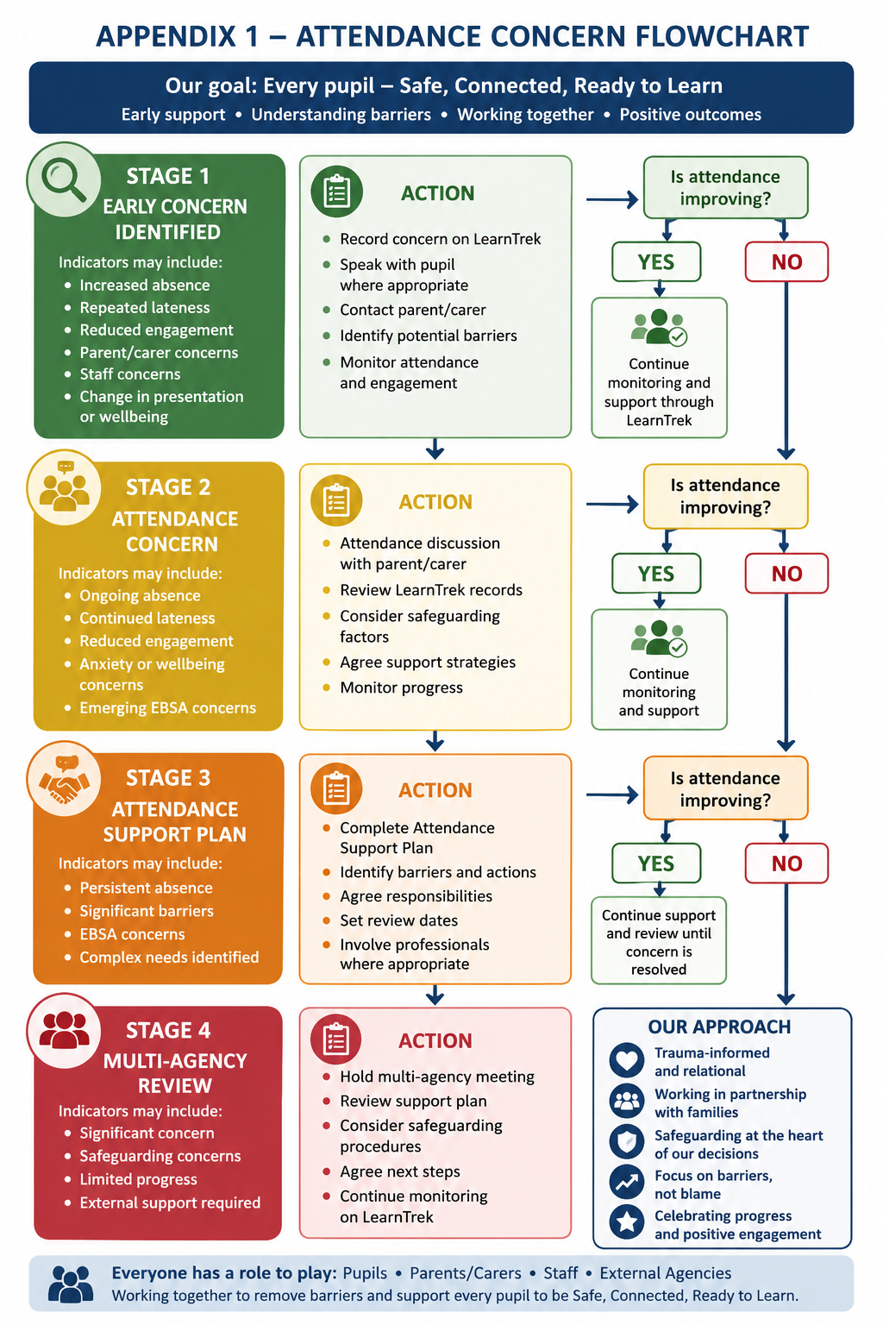
Appendix 2 – Attendance Support Plan
Pupil Details
Pupil name:
Year group:
Date of plan:
Staff member completing plan:
Review date:

Current Attendance Concern
Summary of concern:
Current attendance pattern:
Punctuality concerns:
Lesson attendance concerns:
Engagement concerns:

Pupil Voice
What is going well?
What feels difficult?
What helps you come into school?
Who do you feel safe speaking to?
What support would help?

Parent/Carer Voice
Parent/carer views:
Identified barriers:
Support requested:

Identified Barriers
Tick all that apply:
- Anxiety.
- Low mood.
- Medical needs.
- Sleep difficulties.
- Transport difficulties.
- Family circumstances.
- Peer relationships.
- Bullying concerns.
- Previous educational experiences.
- Transition difficulties.
- Sensory needs.
- Curriculum concerns.
- Other.
Details:

Support Actions
Action:
Person responsible:
Timescale:
Review date:

External Agencies Involved
Agency/professional:
Role:
Contact details:
Actions agreed:

Review
Date reviewed:
Progress made:
Further concerns:
Next steps:
Plan closed or continued:

Appendix 3 – Parent/Carer Absence Reporting Expectations
Parents/carers should contact Mount School as soon as possible on the first day of absence.
When reporting absence, please provide:
- Your child's name.
- The reason for absence.
- How long you expect your child to be absent.
- Any medical or wellbeing information the school should know.
- Whether any support is needed.
If school does not receive a reason for absence, staff will contact parents/carers to confirm the pupil's whereabouts and welfare.
If staff are unable to make contact, or if there are concerns about a pupil's safety, the absence may be treated as a safeguarding concern.
Parents/carers are expected to work in partnership with Mount School to support regular attendance, punctuality and engagement.

Appendix 4 – Linked Policies
This policy should be read alongside:
- Safeguarding and Child Protection Policy.
- Positive Behaviour, Relationships and Regulation Policy.
- Anti-Bullying Policy.
- ICT and Online Safety Policy.
- Pupil ICT User Agreement.
- Positive Handling and Restrictive Physical Intervention Policy.
- Equality, Diversity and Inclusion Policy.
- Health and Safety Policy.
- Curriculum Policy.
- Admissions and Transition Policy.
- Pupil Induction Procedure.
- Staff Code of Conduct.
- Complaints Policy.

Appendix 5: Updated Attendance codes 2026

School attendance codes: guidance [HTML] | GOV.WALES

