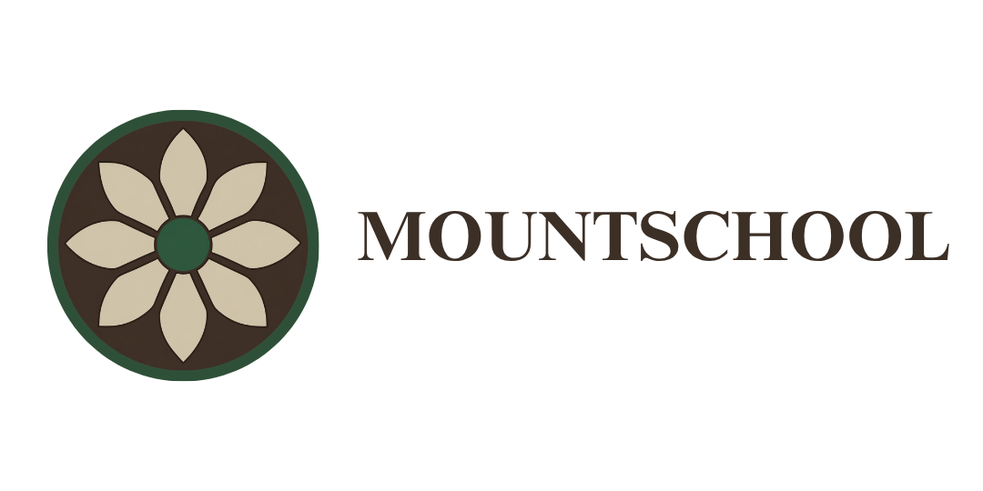

Curriculum Policy

Authorised:THU
Date:28/07/26
Renewal:28/07/27

Safe, Connected, Ready to Learn

Vision

Every interaction is an intervention: safe relationships create successful learners.

Ethos
"Do all the good you can, by all the means you can, in all the ways you can, in all the places you can, at all the times you can, to all the people you can, as long as ever you can." – John Wesley

At Mount School we believe that positive relationships, high expectations and a therapeutic approach create the conditions in which all pupils can succeed.
We are committed to providing a safe, nurturing and inclusive environment where every member of our school community is valued, respected and supported.
Through trauma-informed and restorative practices, we seek to remove barriers to learning and enable pupils to become safe, connected and ready to learn.
Our curriculum is designed to support academic achievement, personal development, emotional wellbeing and successful transitions into adulthood. We recognise that many pupils arrive at Mount School having experienced disrupted education, adverse childhood experiences, trauma and barriers to learning. Through a personalised, ambitious and engaging curriculum, we seek to rebuild confidence, develop resilience and create meaningful opportunities for future success.
The curriculum reflects the Four Purposes of the Curriculum for Wales and supports pupils to become:
- Ambitious, capable learners ready to learn throughout their lives.
- Enterprising, creative contributors ready to play a full part in life and work.
- Ethical, informed citizens of Wales and the world.
- Healthy, confident individuals ready to lead fulfilling lives as valued members of society.

Contents
- Policy Statement
- Curriculum Vision
- Curriculum Aims
- Legal Framework
- Roles and Responsibilities
  - Principal
  - Head of Provision
  - Teaching Staff
  - Pupils
- Curriculum Design Principles
- Curriculum for Wales
- Areas of Learning and Experience (AoLEs)
- Literacy, Numeracy and Digital Competence
- Personalised Learning and Inclusion
- Additional Learning Needs (ALN)
- Relationships and Sexuality Education (RSE)
- Careers and Work-Related Learning
- Personal Development, Wellbeing and Enrichment
- Assessment, Progress and Reporting
- Teaching and Learning
- External Partnerships
- Monitoring and Review
- Associated Documents

1. Policy Statement
Mount School is committed to providing a broad, balanced, relevant and ambitious curriculum that enables all pupils to achieve their potential, regardless of their starting point, background or barriers to learning.
The curriculum is designed to meet the academic, social, emotional and developmental needs of pupils and reflects the school's vision of creating safe, connected and successful learners.
Many pupils arrive at Mount School having experienced disrupted education, trauma, adverse childhood experiences, social, emotional and mental health difficulties and additional learning needs. The curriculum therefore seeks to remove barriers to learning through personalised pathways, therapeutic approaches and high-quality teaching.
The curriculum supports pupils to develop the knowledge, skills, understanding and confidence required to progress successfully into further education, employment, training and adult life.
Mount School is committed to delivering a curriculum that is inclusive, engaging and aspirational and which prepares pupils to become active participants in their communities and wider society.

2. Curriculum Vision
At Mount School, we believe that every child deserves access to a curriculum that enables them to thrive academically, socially, emotionally and personally.
Our curriculum is built upon the principle that every interaction is an intervention and recognises that positive relationships are fundamental to successful learning.
The curriculum has been designed to:
- Re-engage pupils in education.
- Develop confidence, resilience and self-esteem.
- Promote positive wellbeing and emotional regulation.
- Provide meaningful academic challenge.
- Support individual interests, talents and aspirations.
- Prepare pupils for successful transitions into adulthood.
- Enable pupils to become active and responsible members of society.
The curriculum reflects the Four Purposes of the Curriculum for Wales and supports pupils to become:
Ambitious, Capable Learners
Pupils are encouraged to develop curiosity, independence, resilience and a lifelong love of learning.
Enterprising, Creative Contributors
Pupils are supported to develop creativity, innovation, problem-solving skills and confidence in applying their learning in a range of contexts.
Ethical, Informed Citizens
Pupils develop an understanding of their rights, responsibilities and place within local, national and global communities.
Healthy, Confident Individuals
Pupils are supported to develop positive physical, emotional and mental wellbeing and the skills required to lead safe, healthy and fulfilling lives.

3. Curriculum Aims
The Mount School curriculum aims to:
- Provide all pupils with a broad, balanced and relevant education.
- Deliver a curriculum that is personalised and responsive to individual needs.
- Promote high expectations and aspiration for all learners.
- Support academic achievement and personal development.
- Develop literacy, numeracy and digital competence across the curriculum.
- Promote emotional wellbeing and positive mental health.
- Support pupils to understand and manage risk.
- Encourage independence, responsibility and resilience.
- Develop social, communication and relationship skills.
- Promote respect for diversity, equality and inclusion.
- Foster creativity, curiosity and critical thinking.
- Support successful progression into further education, employment or training.
- Develop the knowledge, skills and cultural capital required for life beyond school.
- Promote pupil voice and participation in curriculum development.
- Ensure that learning is engaging, meaningful and relevant.
The curriculum seeks to provide pupils with the skills, experiences and qualifications necessary to achieve positive outcomes and make informed choices about their futures.
- All children with a broad, balanced and relevant education which provides continuity and progression and takes individual differences into account.
- Provide a holistic structure for understanding health and well-being.
- Access to a highly personalised curriculum which takes account the National Areas of Learning as well as being relevant to individual needs.
- Essential skills such as literacy, numeracy and Digital Competence Framework (DCF) and the roles these take in both academic achievement and skills that facilitate social mobility and success in adult life.
- Pupils to access a range of ‘wider skills’ necessary for modern life and work. These include critical thinking and problem solving, planning and organising, creativity and innovation and personal effectiveness.
- Support for pupils’ spiritual, moral, social and cultural development.
- Promotion of a love of learning including reading for pleasure and reading for fluency.
- A focus on the core difficulties that lie at the heart of trauma informed behaviour. We work closely with our clinical team.
- Access to learning for all pupils, with high expectations for every pupil and appropriate levels of challenge and support.
- Subject choices that support pupils’ learning and progression and enable them to work towards achieving their goals.
- Equipping pupils with the knowledge and cultural capital they need to succeed in life.
It is vital that all pupils due to their presenting trauma and vulnerabilities and/or ALN, have a clear and planned transition pathway for when they leave school. Thus, great importance is placed on the curriculum being personalised, progressive and structured so that it allows pupils to achieve and develop a sense of satisfaction that helps build their motivation and confidence. Pupils are given careers advice that supports them to focus on realistic options for further education and future career choices.

Planning and delivery

Mount School will consider the social and emotional needs of each pupil and understand that:
- Pupils learn when best when they feel safe and build relationships with all staff.
- Pupils learn best when offered a range of learning experiences.
- Pupils learn best when a range of appropriate teaching strategies are employed.
- Pupils learn best when they understand the purpose of what they are doing and have ownership of the learning activities and the curriculum as a whole.
- Pupils learn best within a well-planned developmental curriculum which has continuity and progression as its core.
- Pupils learn best when they know that there is a partnership between home and school.
- Pupils learn best when the activity they are undertaking is differentiated, as necessary, to meet their needs.

Pupils learn best when lessons are engaging, enabling, and motivating.
Pupils should:
- Learn to be adaptable, how to deal with and solve problems in different situations, how to work independently and as a team member.
- Begin to acquire a set of moral values such as honesty, sincerity, personal responsibility, on which to base and improve their own behaviour.
- Be expected to behave in an acceptable way and learn to become responsible for their own actions.
- Care for, respect and take pride in their schoolwork, peers and staff.
- Learn to communicate their knowledge, feelings and thoughts in the appropriate way.
- Know how to apply the basic principles of health, hygiene, and safety.
Pupils should be given opportunities to learn the skills and knowledge in the following areas:
- Mathematics and Numeracy - think and solve problems mathematically in a variety of situations. All pupils have two numeracy sessions a week where they develop specific areas according to the pupils’ needs.
- Languages, literacy and communication - read, write, and listen for a variety of purposes. Students have one reading lesson a week and a literacy intervention session a week which focuses on termly literacy targets.
- Science and Technology - develop an enquiring mind using a scientific approach to problem solving and develop and use technological skills.
- Humanities - know about geographical, historical, and social aspects of the local and wider environment and have some knowledge of the beliefs of the major world religions.
- Health and Wellbeing - physical health and development, mental health, and emotional and social well-being.
- Expressive Arts-It allows individuals to explore their lives and identities through creative expression, fostering personal, social and cultural understanding.
How our Curriculum works
- Pupils are placed in appropriate learning groups from KS2-KS4 based on chronological age. This is then differentiated by academic levels and behavioural dynamics, (not by chronological age – stage, not age) and follow a timetable which focuses on academic as well as social and emotional development. Some pupils may be taught on a 1-1 or very small group basis depending on the activity and or pupil/grouping.
- School starts the day with tutor time to get pupils into the correct mind-set for learning and to remove potential barriers to learning. This is followed by 2 45-minute lessons, and either a Literacy or numeracy intervention and then 4 more sessions of 45 minutes with breaks for morning and lunch. The Mount School Curriculum model promotes core subject learning at least 4 times a week, tailored bespoke interventions to support pupils SEMH and ALN needs. In addition a range of other chose subjects and vocational qualifications.
- Traditional subjects taught through the Welsh National Curriculum will be incorporated into schemes of work for their subject/class.
- Schemes of work are planned and developed with regard to requirements of the Curriculum for Wales, whole school focus on literacy, numeracy and DCF and individual pupil needs.
- Staff will have a creative and innovative approach in their development of schemes of work and will aim for pupils to maximise their access to as full a curriculum as possible. Staff meet on a regular basis to review and develop curriculum areas.
- The curriculum includes literacy, numeracy and DCF across all subjects. Teachers are responsible for developing and evaluating the progress in literacy, numeracy and DCF skills of individual pupils. This is included in our marking policy so that where numeracy, literacy and DCF are used, it is marked with specific codes. Staff understand the importance of literacy, numeracy and DCF in relation to raising standards of work in their own subjects – see A3 across the curriculum documents.
- The curriculum includes four essential transferable skill building areas which align with the four purposes for Wales Curriculum.
- Effective differentiation is used with a variety of differing teaching and learning methods and materials used to suit individual needs.
- Entry to all study is based on academic appropriateness, regardless of sex, race, disability, religion, or belief. Relationships and Sex Education is taught within PSHE.
- All pupils have personal targets through an Individual learning plan, informed by the young people.
- SLT monitor all staff planning which ensures pupils will have access to a broad and balanced curriculum and progression through the curriculum is consistent.
- Work scrutiny, learning walks and planning scrutiny will be carried out by SLT on a regular basis to monitor effective teaching and learning and ensure consistency in marking and feedback to pupils.
- SLT will conduct regular reviews of the school curriculum and the effectiveness of its implementation, delivery and impact.
- Human Rights, Fundamental Values and Protected Characteristics, and the UNCRC are embedded throughout the school curriculum and underpin the aims and vision for Mount School.
- Additional experiences and development opportunities: Rights Respecting School, F1 Schools (STEM racing), Eco School, Leadership Roles meaningful to the pupil, EPAS, Forest School and bespoke careers programme.
- Community links are encouraged throughout the year with personal development and enrichment opportunities being tracked accordingly.

Mount School School’s proposed curriculum includes:

The Independent School Standards (Wales) Regulations 2024 | Curriculum and Assessment (Wales) Act 2021 | Accredited qualifications offered.
Expressive Arts | Expressive Arts | The Arts Award Bronze, Silver
Humanities | Humanities | GCSE-History,Religious Studies, Geography  Entry Level - Humanities
Health & Wellbeing | Health & Wellbeing | PE sports Leader Level 1, Level 2  PSHE (BTEC SWEET) Level 1, Level 2  Health and Social Care-Level 1, Level 2  D of E Bronze/Silver/Gold
Science& Technology | Science & Technology | GCSE-Applied Science  Entry Level Science  Entry Level Cooking
Mathematics | Mathematics and Numeracy | GCSE-Maths  Functional Skills level 1 and 2  Entry Level 1-3
Language & communication | Language, Literacy& Communication | GCSE-English  Functional Skills Level 1, Level 2  Entry Level 1-3
 |  | In addition to this Mount School will look to offer additional qualifications working with external providers such as the Skills Suite, health and beauty, Military preparation, animal care. We will also develop links with providers to tailor qualifications to individual needs.

We offer a range of Entry Pathway Qualifications that allow students to choose specific modules they would like to study based on their aspirations and post-16 requirements these include:

Additional English, Creative Media & Performance Arts, Healthy Living & Fitness, Humanities, ICT Users, Independent Living, Mathematics, Personal & Social Development, Personal Progress and Preparing for Work Science Today.

Pupils can arrive at Mount School at any point within the academic year, and placements can vary in terms of length. Our goal is for all pupils to return to mainstream education when they are ready. Due to this, we are committed to finding the right pathway for everyone including qualifications for, and teaching to, our pupils’ needs. These will be established with the input of the pupil and their parents/carers. There will be an individual timetable and programme for each pupil.

Curriculum Pathways / options
Mount School identifies the type of learning needs for specific pupils, for example aiming for entry level, functional skills or GCSE levels. At KS2 learners will focus on the Welsh National Curriculum areas of learning in readiness for formal qualifications at KS3 and KS4.
Careers information at Mount School is given to also shape the pupil’s curriculum pathway. This also helps shape the subjects required, level of intervention and level of social and emotional experiences needed to ensure maximum opportunity has been given. Pupils can progress through the curriculum levels which is reviewed termly to keep aspirations of all pupils high.
Planning in the Curriculum
- Subject Curriculum Policies
- Long term plans
- Medium Term Plans
- Short Term Plans (not compulsory)

The new 6 AoLE’s (Areas of Learning and Experience)
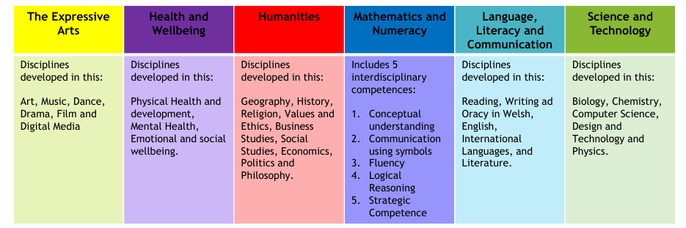
We will plan for the development of the following Cross curricular skills within the AoLE’s using the revised National Framework.
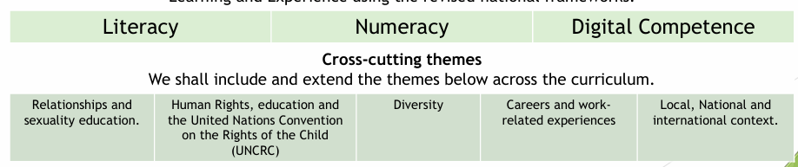
The What Matters Statements for each area will be the basis of our planning for progression depth and breadth of skills and knowledge and for learner progress.
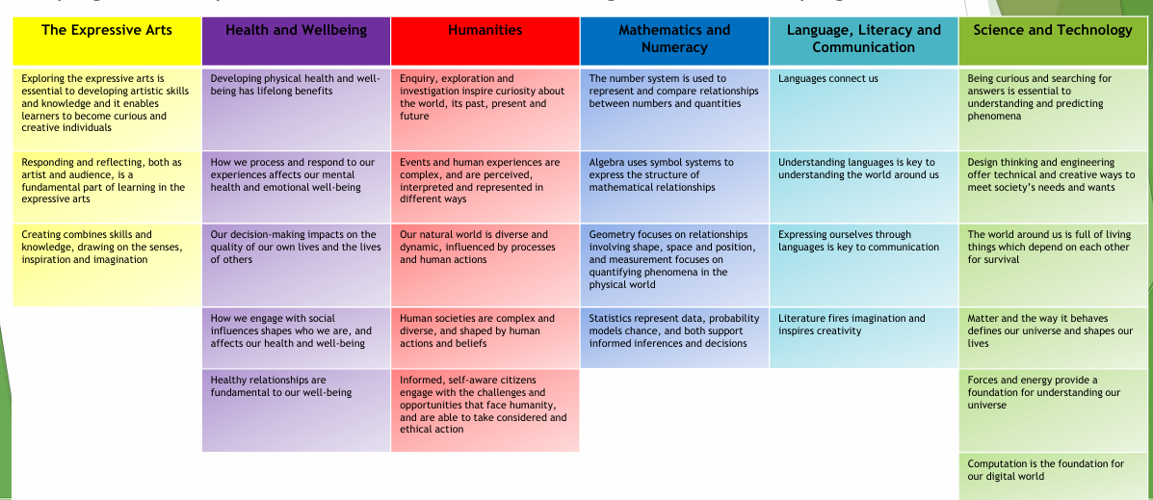
Long term overviews are created by teachers to plan for a broad and balanced curriculum. Learners contribute to mid-term plans by choosing topics of interest to them. These mid-term plans are flexible and are adapted to suit pupils voice throughout the terms. They are then evaluated and progress is assessed. Weekly plans are also created to ensure teaching and learning is adapted to suit all abilities and needs within the classrooms.
Teachers prepare Schemes of Work for each topic and for each subject taught. They include the key learning intentions, activities (where possible), and investigations to be carried out. The teachers (where possible) complete a curriculum route map, which documents the sequence of how pupils develop their skills in individual subjects from the start to the end of their journey with Mount School. This plan also ensures that, where possible, the content of individual subjects' areas is mapped for teachers to deliver topics thematically.
All pupils’ work in each subject is marked according to Mount School marking policy.
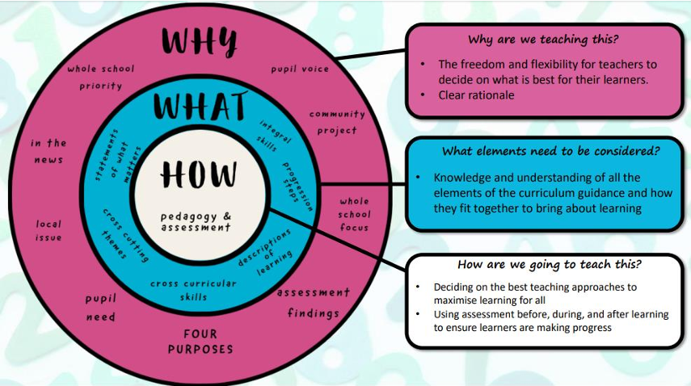

This learning reflects 3 aspects to our curriculum.
Core Experiences- Organised class learning experiences including focused tasks. Teacher planning adapted to reflect pupil voice. Learning experiences mapped across 4 purposes, WMS and progressions steps. (Long and Mid term Plans)
Your Voice- Independent learning opportunities, pupil led with teacher input. Learning experiences planned by pupils and teachers around the main theme. They decide what they would like to learn and when. Learners independently choose how to solve problems and present their work(Weekly )
Themed days/weeks- Responsive and flexible themed weeks and days which are reflective of pupil needs, local community needs and events in wider society . Pupil led with teacher input. Reflective of the four purposes, WMS, SMSC, UNCRC and Fundamental British Values.(As required)

4. Legal Framework
This policy has regard to:
- Curriculum and Assessment (Wales) Act 2021
- Additional Learning Needs and Education Tribunal (Wales) Act 2018
- Equality Act 2010
- United Nations Convention on the Rights of the Child (UNCRC)
- Human Rights Act 1998
- Independent School Standards (Wales) Regulations 2024
- Welsh Government Curriculum for Wales Framework
- Welsh Government Relationships and Sexuality Education (RSE) Code
This policy should be read alongside:
- Behaviour Policy
- Attendance Policy
- Equality, Diversity and Inclusion Policy
- Safeguarding and Child Protection Policy
- Additional Learning Needs (ALN) Policy
- Assessment Policy
- Relationships and Sexuality Education (RSE) Policy
- Careers and Work-Related Learning Procedures
- Educational Visits Procedures
- ICT and Online Safety Policy
Mount School is committed to ensuring that its curriculum remains compliant with current legislation, Welsh Government guidance and the needs of its pupils and wider community.
5. Roles and Responsibilities
Principal
The Principal has overall strategic responsibility for the curriculum and will:
- Ensure that Mount School provides a broad, balanced and ambitious curriculum.
- Monitor the effectiveness of curriculum provision.
- Support the Head of Provision in maintaining high standards of teaching and learning.
- Ensure compliance with relevant legislation and Welsh Government guidance.
- Promote continuous curriculum development and improvement.

Head of Provision
The Head of Provision has day-to-day responsibility for curriculum implementation and quality assurance.
The Head of Provision will:
- Lead the development and implementation of the curriculum.
- Ensure the curriculum meets the needs of all learners.
- Monitor curriculum quality, delivery and impact.
- Ensure compliance with the Curriculum for Wales framework and Independent School Standards (Wales).
- Oversee assessment, progression and reporting arrangements.
- Ensure appropriate interventions and support are available.
- Promote high expectations for all pupils.
- Monitor the effectiveness of teaching and learning.
- Ensure pupil voice informs curriculum development.

Teaching Staff
Teaching staff are responsible for:
- Planning and delivering high-quality learning experiences.
- Adapting learning to meet individual needs.
- Monitoring pupil progress and achievement.
- Promoting literacy, numeracy and digital competence across the curriculum.
- Supporting pupils' social, emotional and personal development.
- Maintaining high expectations for behaviour and learning.
- Contributing to curriculum development and evaluation.
- Ensuring pupil voice is considered within curriculum planning.

Pupils
Pupils are encouraged to:
- Engage positively in learning.
- Attend regularly and punctually.
- Take responsibility for their own learning.
- Contribute their views regarding curriculum experiences.
- Show respect for others and the learning environment.
- Work towards personal, academic and developmental goals.

6. Curriculum Design Principles
The Mount School curriculum has been designed to reflect the needs of pupils with social, emotional and mental health needs, additional learning needs and disrupted educational experiences.
The curriculum is underpinned by the following principles:
Relationships First
Positive relationships are central to successful learning.
Pupils learn best when they:
- Feel safe.
- Feel valued.
- Trust the adults supporting them.
- Experience consistency and predictability.
- Have positive relationships with peers and staff.

Personalised Learning
The curriculum is tailored to meet the needs of individual pupils.
Learning pathways are designed to:
- Reflect individual strengths and interests.
- Address identified barriers to learning.
- Support academic and personal development.
- Promote successful progression.
Where necessary, pupils may access:
- Small group learning.
- One-to-one support.
- Therapeutic interventions.
- Additional literacy and numeracy support.
- Individualised timetables.

High Expectations for All
Mount School maintains high aspirations for every learner.
All pupils are entitled to:
- Access a broad and balanced curriculum.
- Experience appropriate challenge.
- Receive support where required.
- Achieve meaningful qualifications and outcomes.
- Develop confidence and independence.

Inclusion and Equity
The curriculum is inclusive and accessible.
Mount School is committed to ensuring that no pupil is disadvantaged because of:
- Additional learning needs.
- Disability.
- Race or ethnicity.
- Religion or belief.
- Sex.
- Sexual orientation.
- Socio-economic background.
- Care experience.
Appropriate support, adaptations and reasonable adjustments will be implemented where required.

Pupil Voice
Pupils play an active role in shaping their learning experiences.
Opportunities for pupil voice include:
- Student Council participation.
- Individual Learning Plans (ILPs).
- Curriculum discussions.
- Topic selection where appropriate.
- Reviews and target-setting meetings.
The school recognises that involving pupils in decisions about their learning promotes engagement, motivation and achievement.

Preparation for Adulthood
The curriculum prepares pupils for life beyond school.
This includes developing:
- Independence skills.
- Communication skills.
- Employability skills.
- Problem-solving skills.
- Emotional resilience.
- Community participation.
- Financial awareness.
- Career aspirations.
The curriculum is designed to ensure that pupils leave Mount School with the knowledge, skills, experiences and qualifications required for their next stage of education, employment or training.
7. Curriculum for Wales
Mount School's curriculum is aligned with the principles and expectations of the Curriculum for Wales Framework and is designed to support all pupils to progress towards the Four Purposes.
The curriculum promotes progression through meaningful learning experiences that develop knowledge, skills and understanding across a broad range of contexts.
Learning experiences are designed to:
- Build upon prior learning.
- Promote curiosity and engagement.
- Encourage critical thinking and problem solving.
- Develop independence and resilience.
- Support emotional wellbeing and personal growth.
- Enable pupils to apply learning in real-life situations.
The curriculum is flexible and responsive to the needs of individual learners and reflects the school's therapeutic and trauma-informed approach.
Mount School recognises that many pupils arrive with interrupted educational experiences and therefore curriculum planning takes account of starting points, individual needs and long-term aspirations.
Curriculum planning is informed by:
- The Four Purposes.
- The What Matters Statements.
- Progression Principles.
- Cross-curricular responsibilities.
- Individual Learning Plans (ILPs).
- Additional Learning Needs (ALN) provision.
- Pupil voice and aspirations.

8. Areas of Learning and Experience (AoLEs)
The curriculum provides opportunities for pupils to access learning across all six Areas of Learning and Experience (AoLEs).

Expressive Arts
Learners are encouraged to explore creativity, imagination and self-expression through a range of artistic experiences.
This may include:
- Art and Design
- Music
- Drama
- Dance
- Creative Media
Expressive Arts supports emotional expression, confidence, communication and cultural understanding.

Health and Wellbeing
Health and Wellbeing sits at the heart of the Mount School curriculum.
Learning opportunities support pupils to:
- Develop positive mental health.
- Build emotional resilience.
- Understand healthy relationships.
- Develop self-regulation skills.
- Improve physical health and fitness.
- Understand personal safety and wellbeing.
Health and Wellbeing is delivered through both discrete lessons and daily school experiences.

Humanities
Humanities supports pupils to understand:
- History
- Geography
- Religion, Values and Ethics
- Social Studies
- Citizenship
Learning encourages pupils to become informed, ethical and active members of society.

Mathematics and Numeracy
Pupils develop confidence and competence in:
- Number
- Measurement
- Geometry
- Statistics
- Problem Solving
- Financial Awareness
Learning is designed to promote both academic achievement and practical life skills.

Languages, Literacy and Communication
Pupils are supported to develop:
- Reading
- Writing
- Speaking
- Listening
- Oracy
- Communication Skills
The promotion of reading for pleasure and reading fluency forms an important part of the curriculum.
Communication skills are developed across all curriculum areas.

Science and Technology
Pupils are encouraged to explore and understand the world through scientific and technological enquiry.
Learning opportunities may include:
- Biology
- Chemistry
- Physics
- Design Technology
- Engineering
- Computing
- Digital Technologies
Practical learning and problem-solving are key features of this area.

9. Literacy, Numeracy and Digital Competence
Literacy, Numeracy and Digital Competence are embedded across the curriculum and are recognised as essential skills for learning, employment and everyday life.
Mount School is committed to ensuring that all pupils develop competence and confidence in these areas regardless of their starting point.

Literacy
Opportunities to develop literacy skills are incorporated across all curriculum areas.
Pupils are supported to develop:
- Reading fluency.
- Reading comprehension.
- Vocabulary.
- Writing skills.
- Communication skills.
- Oracy and presentation skills.
Targeted literacy interventions may be implemented where additional support is required.

Numeracy
Numeracy skills are developed across all curriculum areas and through targeted interventions where appropriate.
Learning focuses on:
- Mathematical understanding.
- Problem solving.
- Application of mathematics in real-life contexts.
- Financial literacy.
- Functional numeracy skills.
Pupils are encouraged to develop confidence in applying mathematical skills across a range of situations.

Digital Competence
Digital competence is integrated throughout the curriculum and reflects the expectations of the Digital Competence Framework.
Pupils are supported to:
- Use technology safely and responsibly.
- Access digital learning opportunities.
- Develop digital communication skills.
- Create and present digital content.
- Understand online safety and digital citizenship.
- Apply technology to support learning and future employability.
Digital skills are developed progressively throughout a pupil's time at Mount School.

10. Personalised Learning and Inclusion
Mount School recognises that pupils arrive with a wide range of strengths, experiences, interests and needs. Many pupils have experienced disrupted education, trauma, adverse childhood experiences, social, emotional and mental health difficulties or additional learning needs.
The curriculum is therefore designed to be flexible, personalised and responsive.
Individual learning pathways are developed to ensure that pupils are able to:
- Access learning successfully.
- Experience achievement.
- Build confidence and resilience.
- Develop positive attitudes towards learning.
- Progress towards their personal goals and aspirations.
Learning opportunities are adapted to meet individual needs through:
- Differentiated teaching.
- Adaptive teaching approaches.
- Individual Learning Plans (ILPs).
- Therapeutic support.
- Targeted interventions.
- Small group provision.
- One-to-one support where appropriate.
- Personalised timetables where required.
The curriculum aims to remove barriers to learning and promote full participation for all pupils.
Individual Learning Plans (ILPs)
All pupils have an Individual Learning Plan which supports curriculum access and progression.
ILPs may include:
- Academic targets.
- Personal development targets.
- Attendance targets.
- Behavioural targets.
- Literacy and numeracy targets.
- Wellbeing targets.
- Careers and transition goals.
Pupils are actively involved in the development and review of their targets wherever possible.
ILPs are reviewed regularly to ensure they remain relevant and effective.

Therapeutic and Trauma-Informed Practice
The curriculum reflects Mount School's therapeutic and trauma-informed approach.
Learning experiences are designed to:
- Promote emotional regulation.
- Develop resilience.
- Build positive relationships.
- Improve self-awareness.
- Increase engagement with learning.
- Support recovery from disrupted educational experiences.
The school works collaboratively with therapeutic and clinical professionals to ensure that support is embedded within educational provision where appropriate.

Intervention Programmes
Targeted interventions may be used to support pupils in overcoming barriers to learning.
Interventions may include support relating to:
- Literacy.
- Numeracy.
- Speech and language.
- Emotional wellbeing.
- Social skills.
- Behaviour and self-regulation.
- Communication.
- Fine and gross motor skills.
- Transition and reintegration.
The impact of interventions will be monitored and reviewed regularly.

11. Additional Learning Needs (ALN)
Mount School is committed to ensuring that pupils with Additional Learning Needs are able to access a broad, balanced and ambitious curriculum.
The school recognises that pupils may require varying levels of support and will seek to identify and address barriers to learning as early as possible.
Provision will be informed by:
- Individual Learning Plans (ILPs).
- Person-centred planning.
- Professional assessments.
- Multi-agency involvement.
- Pupil voice.
- Parent and carer contributions.
Reasonable adjustments will be implemented where required to ensure equitable access to learning opportunities.

Inclusive Practice
Inclusive practice is embedded throughout the curriculum.
Teaching staff will:
- Adapt learning appropriately.
- Use flexible teaching approaches.
- Provide additional support where required.
- Promote participation and engagement.
- Maintain high expectations for all learners.
All pupils are entitled to experience success and make meaningful progress regardless of their starting point.

Multi-Agency Working
The school will work collaboratively with:
- Parents and carers.
- Social workers.
- Educational psychologists.
- Speech and language therapists.
- Occupational therapists.
- Clinical teams.
- Health professionals.
- Local authorities.
Multi-agency working supports effective curriculum planning and ensures that provision reflects the needs of individual pupils.

12. Relationships and Sexuality Education (RSE)
Relationships and Sexuality Education forms an important part of the Health and Wellbeing Area of Learning and Experience.
RSE is delivered in accordance with:
- Curriculum for Wales Framework.
- Welsh Government RSE Code.
- Equality legislation.
- Safeguarding requirements.
RSE supports pupils to develop:
- Healthy relationships.
- Respect for self and others.
- Understanding of rights and responsibilities.
- Knowledge of personal safety.
- Emotional literacy.
- Awareness of diversity and inclusion.
Learning is delivered in an age-appropriate and developmentally appropriate manner.

Values and Inclusion
Mount School promotes an inclusive approach to RSE which:
- Respects diversity.
- Promotes equality.
- Challenges discrimination.
- Encourages respect for different backgrounds and experiences.
RSE contributes to safeguarding by supporting pupils to recognise healthy and unhealthy relationships and understand how to seek support when required.

Parent and Carer Engagement
The school values positive relationships with parents and carers and will communicate appropriately regarding the content and purpose of RSE provision.
Information about RSE will be made available in accordance with statutory requirements and Welsh Government guidance.
Curriculum Resources and Programmes
Mount School utilises a range of evidence-informed programmes and resources to support the delivery of Health and Wellbeing, Relationships and Sexuality Education (RSE), personal development and emotional wellbeing.
These may include:
- My Happy Mind – supporting emotional wellbeing, resilience, self-awareness and positive mental health.
- My Mind Coach – supporting emotional regulation, wellbeing, self-development and personal growth.
- BTEC SWEET (Skills for Work, Employability and Training) – supporting personal development, employability, life skills, relationships, wellbeing and preparation for adulthood.
- Therapeutic interventions and bespoke resources tailored to individual pupil needs.
- Careers and work-related learning programmes.
- External agency workshops and specialist providers.
The school regularly reviews curriculum resources to ensure they remain age-appropriate, inclusive, evidence-informed and aligned with the Curriculum for Wales and the needs of Mount School pupils.
13. Careers and Work-Related Learning
Mount School is committed to preparing pupils for successful transitions into further education, employment, apprenticeships and adulthood.
Careers education forms an integral part of the curriculum and supports pupils in understanding their strengths, interests, aspirations and future opportunities.
Careers and work-related learning aims to:
- Raise aspirations.
- Develop employability skills.
- Promote independence.
- Increase awareness of career pathways.
- Support informed decision making.
- Prepare pupils for adulthood.

Careers Education
Pupils will have access to a structured programme of careers education appropriate to their age, stage and individual needs.
This may include:
- Careers guidance interviews.
- College and training provider visits.
- Employer encounters.
- External speakers.
- Work-related learning activities.
- Employability workshops.
- CV writing.
- Application writing.
- Mock interviews.
- Transition planning.
Careers education will be personalised to reflect pupils' aspirations and identified pathways.

Qualifications and Progression Pathways
Mount School offers a range of qualification pathways designed to meet the needs and aspirations of individual learners.
Qualifications may include:
- GCSEs.
- Entry Level Qualifications.
- Functional Skills.
- BTEC Qualifications.
- ASDAN Programmes.
- Arts Award Qualifications.
- Vocational Qualifications.
- Duke of Edinburgh Awards.
- Sports Leadership Qualifications.
Additional qualifications and programmes may be offered through external providers where appropriate.
The curriculum is designed to support progression into:
- Mainstream education.
- Further education.
- Apprenticeships.
- Employment.
- Specialist provision.
- Training opportunities.

Preparation for Adulthood
Preparation for adulthood is embedded throughout the curriculum.
Learning opportunities support pupils to develop:
- Independence.
- Communication skills.
- Decision making.
- Problem solving.
- Financial awareness.
- Personal responsibility.
- Community participation.
- Workplace readiness.
Transition planning forms an important part of curriculum delivery and begins as early as appropriate for individual learners.

14. Personal Development, Wellbeing and Enrichment
Personal development and wellbeing are central to the Mount School curriculum.
The school recognises that emotional wellbeing, confidence and resilience are essential foundations for successful learning and positive life outcomes.
The curriculum seeks to support pupils in developing:
- Emotional literacy.
- Self-awareness.
- Self-regulation.
- Resilience.
- Confidence.
- Independence.
- Positive relationships.
- Communication skills.
- Personal responsibility.

Wellbeing Programmes
Mount School utilises a range of evidence-informed programmes and resources to support emotional wellbeing, personal development and positive mental health.
These may include:
- My Happy Mind
- My Mind Coach
- BTEC SWEET (Skills for Work, Employability and Training)
- Therapeutic interventions.
- Personal development programmes.
- Careers education activities.
- Bespoke SEMH interventions.
These programmes support pupils to develop emotional resilience, self-understanding, positive relationships and the skills required for successful adulthood.

Enrichment Opportunities
The curriculum is enhanced through a wide range of enrichment experiences.
Opportunities may include:
- Educational visits.
- Outdoor learning.
- Forest School activities.
- Duke of Edinburgh Award.
- Sports activities.
- Community projects.
- Eco School initiatives.
- EPAS activities.
- F1 in Schools.
- Student Leadership opportunities.
- Rights Respecting Schools activities.
- Cultural experiences.
- Visiting speakers and workshops.
These experiences support pupils in applying learning beyond the classroom and developing wider life skills.

Community Engagement
Mount School encourages pupils to become active members of their local and wider communities.
Opportunities for community engagement may include:
- Volunteering.
- Charity fundraising.
- Community projects.
- Partnership activities.
- Environmental initiatives.
- Work-related learning experiences.
These experiences help pupils develop social responsibility, citizenship and confidence.

15. Assessment, Progress and Reporting
Assessment at Mount School is designed to support learning, identify next steps and celebrate progress.
Assessment arrangements recognise that pupils may arrive with diverse educational experiences and varying starting points.
The school values both academic achievement and personal development when measuring progress.

Assessment Principles
Assessment will:
- Support learning and progression.
- Inform teaching and planning.
- Identify strengths and areas for development.
- Recognise individual achievement.
- Promote pupil engagement and ownership of learning.
Assessment is viewed as an ongoing process rather than a single event.

Formative Assessment
Formative assessment takes place regularly within lessons and learning activities.
Strategies may include:
- Questioning.
- Feedback.
- Observation.
- Discussion.
- Self-assessment.
- Peer assessment.
- Learning conversations.
- Review of work completed.
Formative assessment enables staff to adapt teaching and provide timely support.

Summative Assessment
Summative assessment may include:
- Tests and assessments.
- Qualification outcomes.
- Coursework.
- Projects.
- Presentations.
- Practical assessments.
Summative assessment information supports evaluation of progress and curriculum effectiveness.

Monitoring Progress
Pupil progress is monitored through:
- Individual Learning Plans (ILPs).
- Assessment information.
- Attendance data.
- Behaviour and wellbeing information.
- Intervention outcomes.
- Pupil voice.
- Teacher assessments.
Progress is reviewed regularly and shared with pupils, parents, carers and relevant professionals where appropriate.

Reporting
Mount School will provide information regarding pupil progress through:
- Progress reviews.
- Reports.
- ILP reviews.
- Multi-agency meetings.
- Parent and carer meetings.
- Transition planning meetings.
Reporting arrangements seek to ensure that pupils and families remain fully informed regarding progress, achievements and next steps.
16. Teaching and Learning
Mount School is committed to providing high-quality teaching and learning experiences that engage, challenge and support all pupils.
Teaching and learning approaches reflect the school's therapeutic, trauma-informed and relationship-based ethos and recognise the diverse needs of learners.
Staff understand that pupils learn best when they:
- Feel safe and valued.
- Have positive relationships with adults.
- Experience consistency and structure.
- Understand the purpose of learning.
- Receive appropriate levels of challenge and support.
- Experience success and achievement.
- Are actively involved in their learning.

Teaching Approaches
Teaching approaches at Mount School may include:
- Direct instruction.
- Collaborative learning.
- Practical learning.
- Outdoor learning.
- Project-based learning.
- Independent learning.
- Experiential learning.
- Therapeutic and reflective activities.
- Vocational learning opportunities.
A range of teaching strategies will be used to ensure learning remains accessible, engaging and appropriately differentiated.

Adaptive Teaching
Staff will use adaptive teaching approaches to meet the needs of individual learners.
This may include:
- Differentiated tasks.
- Scaffolded learning.
- Visual supports.
- Additional adult support.
- Alternative methods of recording.
- Personalised learning targets.
- Adjustments to pace and delivery.
Adaptive teaching enables pupils to access learning whilst maintaining high expectations.

Learning Environment
Mount School seeks to create learning environments that are:
- Safe.
- Inclusive.
- Nurturing.
- Respectful.
- Engaging.
- Well organised.
Positive relationships and clear routines support pupils to feel secure and ready to learn.

17. External Partnerships
Mount School recognises the value of working collaboratively with external organisations and agencies to enhance curriculum opportunities and support positive outcomes for pupils.
Partnerships may include:
- Further education providers.
- Training providers.
- Employers.
- Careers services.
- Therapeutic services.
- Community organisations.
- Voluntary sector organisations.
- Sports and outdoor education providers.
- Arts and cultural organisations.

External Learning Opportunities
Where appropriate, pupils may access additional learning opportunities through external providers.
These opportunities may include:
- Vocational qualifications.
- Outdoor education programmes.
- Sports leadership programmes.
- Arts and performance opportunities.
- Work-related learning.
- Volunteering experiences.
- Specialist intervention programmes.
All external provision will be subject to appropriate safeguarding, health and safety and quality assurance arrangements.

Multi-Agency Collaboration
Mount School works collaboratively with a range of professionals to support curriculum access, wellbeing and progression.
This may include:
- Educational Psychologists.
- Social Workers.
- Clinical Teams.
- Speech and Language Therapists.
- Occupational Therapists.
- Careers Advisers.
- Local Authority Officers.
- Health Professionals.
Partnership working supports the development of personalised and effective learning pathways.

18. Monitoring and Review
The Head of Provision is responsible for monitoring the effectiveness, quality and impact of the curriculum.
Monitoring activities may include:
- Learning walks.
- Work scrutiny.
- Planning scrutiny.
- Pupil voice activities.
- Staff feedback.
- Assessment analysis.
- Attendance analysis.
- Behaviour and wellbeing information.
- Qualification outcomes.
- External review and quality assurance processes.

Evaluating Curriculum Impact
The school will regularly evaluate whether the curriculum is successfully:
- Meeting the needs of pupils.
- Supporting progress and achievement.
- Promoting wellbeing.
- Preparing pupils for adulthood.
- Supporting successful transitions.
- Reflecting the Four Purposes of the Curriculum for Wales.
Findings from monitoring activities will inform curriculum development and improvement planning.

Policy Review
This policy will be reviewed annually or sooner where:
- Legislation changes.
- Welsh Government guidance changes.
- Curriculum requirements change.
- School circumstances change.
- Monitoring identifies a need for review.

19. Associated Documents
This policy should be read alongside:
- Behaviour Policy
- Attendance Policy
- Safeguarding and Child Protection Policy
- Equality, Diversity and Inclusion Policy
- Additional Learning Needs (ALN) Policy
- ICT and Online Safety Policy
- Health and Safety Policy
- Educational Visits Procedures
- Assessment Policy
- Relationships and Sexuality Education (RSE) Policy
- Careers and Work-Related Learning Procedures
- Individual Learning Plans (ILPs)

Policy Statement
Mount School is committed to providing a curriculum that is ambitious, inclusive and responsive to the needs of all learners.
Through high-quality teaching, personalised pathways, therapeutic support and meaningful learning experiences, the curriculum seeks to remove barriers to learning and enable pupils to become safe, connected and ready to learn.
By placing relationships, wellbeing and aspiration at the centre of curriculum design, Mount School aims to ensure that every pupil is equipped with the knowledge, skills, qualifications and confidence required to achieve positive outcomes and fulfil their potential.

