
Additional Learning Needs Policy

Authorised.Emma Woodbine
Date:28/07/26

Renewal:28/07/27

Safe, Connected, Ready to Learn

Vision

Every interaction is an intervention: safe relationships create successful learners.

Ethos

"Do all the good you can, by all the means you can, in all the ways you can, in all the places you can, at all the times you can, to all the people you can, as long as ever you can."
– John Wesley

At Mount School, we believe that positive relationships, high expectations and therapeutic support create the conditions for successful learning. Through a trauma-informed and restorative approach, we support pupils to become safe, connected and ready to learn, preparing them for successful futures and positive participation in their communities.

Contents
- Policy Statement
- Aims
- Legislative Framework
- Understanding Additional Learning Needs
- Identification and Assessment
- Graduated Response
- Individual Development Plans (IDPs) and Education, Health and Care Plans (EHCPs)
- Pupil Participation
- Parent and Carer Partnership
- Clinical and Therapeutic Support
- Preparing for Adulthood
- Roles and Responsibilities
- Monitoring and Review
Appendix 1 – Areas of Need
Appendix 2 – Assessment and Intervention Offer
Appendix 3 – Graduated Response Model
Appendix 4 – Linked Policies

1. Policy Statement
Mount School is committed to providing a personalised, inclusive and ambitious education for all learners.
We recognise that every pupil is unique and that some learners require additional support to access education, participate fully in school life and achieve positive outcomes.
As a specialist independent school, we support learners with a wide range of Additional Learning Needs (ALN), Special Educational Needs and Disabilities (SEND), social, emotional and mental health needs, neurodevelopmental differences and attachment or trauma-related needs.
Our approach is centred on understanding each learner as an individual and identifying strengths, interests, aspirations and barriers to learning. Through high-quality teaching, therapeutic support and collaborative working with families and professionals, we aim to remove barriers and enable every learner to thrive.

2. Aims
This policy aims to:
- Promote an inclusive learning environment.
- Identify needs early and accurately.
- Remove barriers to learning.
- Ensure learners receive appropriate support.
- Promote pupil participation and voice.
- Work collaboratively with families and professionals.
- Support positive wellbeing and emotional development.
- Raise aspirations and improve outcomes.
- Prepare learners for adulthood and future success.
- Meet statutory responsibilities relating to ALN and SEND.

3. Legislative Framework
Mount School operates in accordance with:
- Additional Learning Needs and Education Tribunal (Wales) Act 2018
- Additional Learning Needs Code for Wales 2021
- Equality Act 2010
- United Nations Convention on the Rights of the Child (UNCRC)
- Independent School Standards (Wales) Regulations
- Curriculum for Wales Framework
The school recognises both Welsh Individual Development Plans (IDPs) and English Education, Health and Care Plans (EHCPs).
The principles underpinning the ALN system include:
- Person-centred planning.
- Learner participation.
- Early identification of need.
- Collaboration between services.
- High aspirations and improved outcomes.
- A focus on preparation for adulthood.
- Inclusive education.
- Effective transition planning.

4. Understanding Additional Learning Needs
A learner has Additional Learning Needs where they have a learning difficulty or disability which calls for additional learning provision.
Mount School supports learners with a range of needs, including:
- Social, Emotional and Mental Health (SEMH)
- Autism
- ADHD
- Attachment and Trauma Related Needs
- Communication and Interaction Needs
- Cognition and Learning Needs
- Sensory and Physical Needs
- Mild to Moderate Learning Difficulties
Many learners may experience needs across more than one area.
Additional Learning Provision (ALP) refers to educational or training provision that is additional to, or different from, that generally available to learners of the same age.

5. Identification and Assessment
Understanding learner need is a continuous process and begins before admission wherever possible.
Information may be gathered through:
- Previous educational records.
- IDPs and EHCPs.
- Professional reports.
- Parent and carer information.
- Pupil voice.
- Classroom observation.
- Academic assessment.
- Social, emotional and wellbeing assessment.
Mount School uses a range of assessment tools and professional advice to inform planning, intervention and provision.
Assessment information is reviewed regularly to ensure support remains effective, responsive and person-centred.
Assessment tools may include:
- PASS (Pupil Attitudes to Self and School)
- Star Reading
- Star Maths
- Accelerated Reader
- CAT4
- Strengths and Difficulties Questionnaire (SDQ)
- Boxall Profile
- Thrive Assessments
- Educational Psychology Assessments
- Speech and Language Assessments
- Occupational Therapy Assessments
- Clinical Assessments
- Other standardised assessments as appropriate
Assessment tools are reviewed regularly and may change in response to learner needs, emerging evidence and developments within the school.

6. Graduated Response
Mount School adopts a graduated response to supporting learners.
Stage 1 – Quality First Teaching
All learners access high-quality, adaptive teaching within a supportive, nurturing and inclusive environment.
Stage 2 – Targeted Support
Additional interventions, classroom strategies and targeted support are introduced where concerns emerge.
Stage 3 – Specialist Assessment
Specialist advice and assessment may be sought from clinicians and external professionals to gain a deeper understanding of need.
Stage 4 – Individualised Provision
Provision is personalised to meet identified needs and outcomes, drawing on educational, therapeutic and clinical recommendations.
Stage 5 – Review and Adaptation
Support is reviewed regularly and adapted according to progress, outcomes and changing needs.
This graduated response ensures that provision remains responsive, effective and person-centred.

7. Individual Development Plans (IDPs) and Education, Health and Care Plans (EHCPs)
Many learners attending Mount School will have an Individual Development Plan (IDP) or an Education, Health and Care Plan (EHCP).
The school will:
- Contribute to statutory reviews.
- Monitor progress towards agreed outcomes.
- Implement identified provision.
- Work collaboratively with local authorities and professionals.
- Support assessment and planning processes where appropriate.
- Ensure provision is delivered consistently and effectively.
Provision is reviewed regularly to ensure it remains appropriate and responsive to learner needs.
Where learners do not have a statutory plan, school-based assessment and planning processes will be used to identify and meet needs.

8. Pupil Participation
Learners are central to decision making at Mount School.
Pupils are encouraged and supported to:
- Share their views.
- Contribute to target setting.
- Participate in reviews.
- Discuss aspirations and goals.
- Evaluate support provided.
- Contribute to planning for adulthood.
We believe that support should be developed with learners rather than for learners.
The views of pupils are given due consideration in accordance with their age, understanding and individual needs.

9. Parent and Carer Partnership
Mount School values the expertise, knowledge and contribution of parents and carers.
We are committed to:
- Open and honest communication.
- Collaborative planning.
- Regular review meetings.
- Sharing progress and achievements.
- Involving families in decision making.
- Working together to overcome barriers to learning.
Strong partnerships help ensure consistency, stability and positive outcomes for learners.
The school operates an open and supportive approach to communication and seeks to work in partnership with families at all times.

10. Clinical and Therapeutic Support
Mount School adopts an integrated therapeutic approach to supporting learners.
The school works with a range of clinical and therapeutic professionals to support assessment, planning and intervention.
Support may include:
- Educational Psychology
- Occupational Therapy
- Speech and Language Therapy
- Clinical Psychology
- School-Based Counselling
- CBT
- DBT
- EMDR
- Therapy Dog Provision
- Equine Therapy Partnerships
Support may involve:
- Consultation
- Assessment
- Intervention
- Staff guidance
- Integrated planning
- Multi-disciplinary review
Therapeutic and clinical support forms an important part of the school’s holistic approach to meeting additional learning needs.

11. Preparing for Adulthood
Preparation for adulthood is embedded throughout school life and forms an important part of planning for learners with additional learning needs.
Learners are supported to develop:
- Independence
- Communication skills
- Emotional regulation
- Employability skills
- Community participation
- Decision-making skills
- Life skills
- Further education and training pathways
Planning for adulthood is considered throughout a learner’s journey and is reflected within reviews, target setting and transition planning.

12. Roles and Responsibilities
Principal
The Principal has overall responsibility for ensuring effective ALN provision across the school.
Head of Provision / ALNCo
The Head of Provision / ALNCo is responsible for:
- Coordinating ALN provision.
- Monitoring learner progress.
- Supporting staff.
- Liaising with families and professionals.
- Contributing to statutory reviews.
- Promoting inclusive practice across the school.
Staff
All staff are responsible for:
- Identifying potential barriers to learning.
- Implementing agreed strategies and interventions.
- Monitoring progress.
- Promoting inclusion.
- Contributing to review processes.
Pupils
Pupils are encouraged to participate actively in planning and reviewing their support.
Parents and Carers
Parents and carers are encouraged to work collaboratively with the school and contribute to planning and review processes.

13. Monitoring and Review
The effectiveness of ALN provision will be monitored through:
- Learner progress.
- Attendance.
- Engagement.
- Wellbeing.
- Review outcomes.
- Pupil voice.
- Parent feedback.
- Professional advice and recommendations.
The school is committed to continuous improvement and regularly evaluates the impact of provision to ensure positive outcomes for learners.
This policy will be reviewed annually.

Appendix 1 – Areas of Need
The Additional Learning Needs Code for Wales identifies four broad areas of need:
Communication and Interaction
Including speech, language and communication difficulties, autism and social communication needs.
Cognition and Learning
Including learning difficulties, processing difficulties and specific learning needs.
Social, Emotional and Mental Health
Including emotional regulation difficulties, trauma-related needs, attachment needs, anxiety and mental health difficulties.
Sensory and Physical
Including sensory impairments, physical disabilities and medical conditions impacting learning.

Appendix 2 – Assessment and Intervention Offer
Assessment Tools
Assessment tools may include:
- PASS
- Star Reading
- Star Maths
- Accelerated Reader
- CAT4
- SDQ
- Boxall Profile
- Thrive Assessments
- Educational Psychology Assessments
- Speech and Language Assessments
- Occupational Therapy Assessments
- Clinical Assessments
- Other standardised assessments as appropriate
Intervention and Support
Mount School maintains a range of evidence-informed interventions designed to address literacy, numeracy, communication, social, emotional and mental health needs.
Interventions may include:
- Literacy interventions
- Numeracy interventions
- Reading interventions
- Thrive-based approaches
- Emotional literacy interventions
- Social communication interventions
- Sensory regulation support
- Therapeutic interventions
- Individual and group programmes
- Speech and language interventions
- Occupational therapy programmes
The intervention offer is reviewed regularly to ensure it remains responsive to learner needs and reflects current best practice.

Appendix 3 – Graduated Response Model
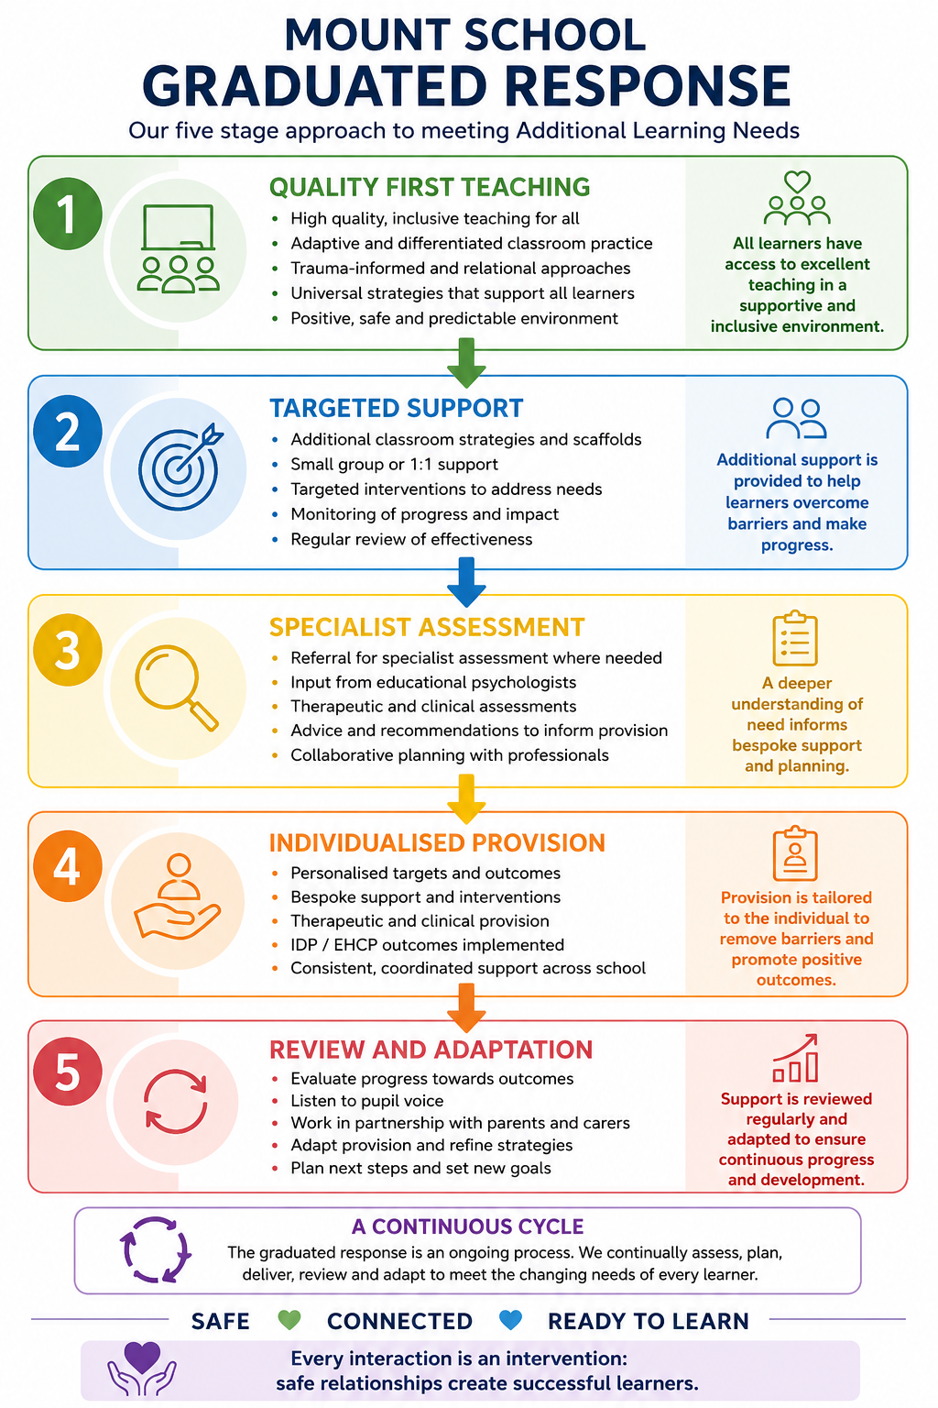

Appendix 4 – Linked Policies
- Positive Behaviour, Relationships and Regulation Policy
- Attendance Policy
- Anti-Bullying Policy
- ICT and Online Safety Policy
- Safeguarding and Child Protection Policy
- Equality, Diversity and Inclusion Policy
- Curriculum Policy
- Complaints Policy

