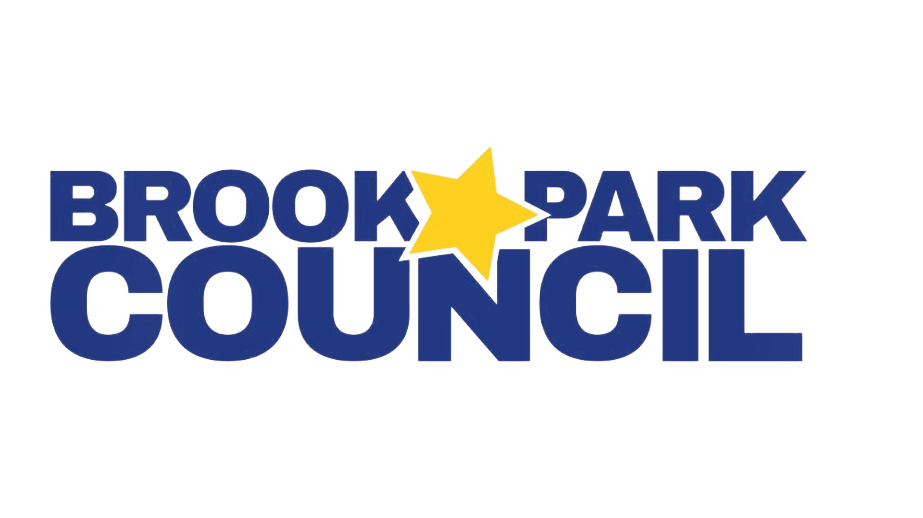
2026-2027 Executive Board
Vice President – Dragana Vidakovic, President@BrookParkCouncil.org
Vice President – Jenn Twardosz, VicePresident@BrookParkCouncil.org
Treasurer – Diane Bortoli, Treasurer@BrookParkCouncil.org
Recording Secretary – Vanessa Ferniza, Recording@BrookParkCouncil.org
Corresponding Secretary –Alexandra Paramo, Corresponding@BrookParkCouncil.org
Volunteer Coordinator – Melissa Herrera, Volunteer@BrookParkCouncil.org
Fundraising Coordinator – Renee Cheema, Fundraising@BrookParkCouncil.org
Board Member at Large –Amanda Meyer, MemberAtLarge@BrookParkCouncil.org

08.17.26 - 7PM - Remote

BPC Meeting Agenda

- Welcome/Call to Order:Dragana Vidakovic , President
  - Pledge of Allegiance
  - Introduction

- Secretary’s Report: Vanessa Ferniza

- Administrative Reports

- Treasurer’s Report: Diane Bortoli
  - Current account balance $31,031.53
  - Quote for 2025-2026 bookkeeping - $150-$200 per month
  - Sales tax exemption certificate status
  - Tax returns update -
    - Federal forms filed through 6/30/2025
    - State tax returns for FY22-25 outstanding

- Board & Committee Chair Reports

- Old Business
- Diane
  - Go Daddy (website platforming) renewed for annual rate on 8/17/2026
  - PTO Today (insurance) - $719 per year
  - Library shelving/invoice
- Vanessa/Diane
  - AI Terms of use document BPC_AI_Terms_of_Use.docx

- New Business
- Diane
  - Should we incorporate in the state of IL
  - Engagement in Board meeting
  - Lessons learned from 2026-2027 Events
- Jenn
  - Backpack drive (at meet the teacher book fair or block party)
  - Wolves game
  - Cubs game
  - Back to school sign
- Melissa
  - BPC Event Chairs Document Update
  - BPC Committee Interest Form
  - Meet the Teacher Bookfair
    - Need: volunteer sign-ups
    - Need: determine what to do with $2,915 scholastic money (expires 8/26/2026)
  - Block Party Update

- Questions or comments

