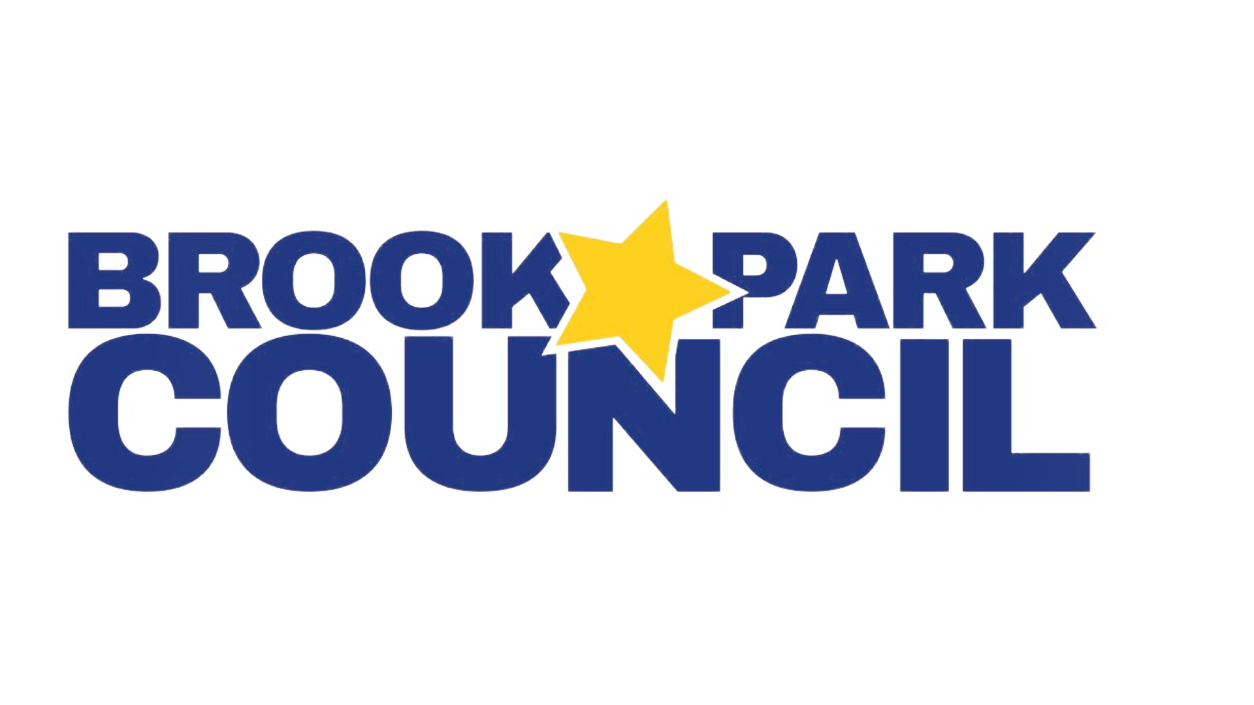
2026-2027 Executive Board
Vice President – Dragana Vidakovic, President@BrookParkCouncil.org
Vice President – Jenn Twardosz, VicePresident@BrookParkCouncil.org
Treasurer – Diane Bortoli, Treasurer@BrookParkCouncil.org
Recording Secretary – Vanessa Ferniza, Recording@BrookParkCouncil.org
Corresponding Secretary – Alexandra Paramo, Corresponding@BrookParkCouncil.org
Volunteer Coordinator – Melissa Herrera, Volunteer@BrookParkCouncil.org
Fundraising Coordinator – Renee Cheema, Fundraising@BrookParkCouncil.org
Board Member at Large –Amanda Meyer, MemberAtLarge@BrookParkCouncil.org

Tuesday, July 28, 2026 - 7:00pm CT - Google Meet

BPC Meeting Agenda

- Welcome/Call to Order: Dragana Vidakovic, President
  - Pledge of Allegiance
  - Introduction

- Secretary’s Report: Vanessa Ferniza

- Administrative Reports

- Treasurer’s Report: Diane Bortoli
  - Setting a meeting to discuss accounting services
  - Quickbooks access issue
  - Received: Federal tax return filings are current
  - To do:
    - Create FY26-FY27 budget
    - Ensure Illinois tax returns are filed
    - Reinstate Illinois sales tax exemption
  - Outstanding/Ongoing:
    - How To/transition guide
    - Pending invoice for library shelving

- Board & Committee Chair Reports
  - BP Art Connections - chair identified -Sarah Burrichtersarahburrichter@gmail.com. Dragana to initiate email address.

- Old Business
  - AI Terms of Use - should we move forward with drafting?

- New Business
  - Treasurer
    - Bylaws - amendments, annual audit
    - Go Daddy (website hosting) fees
    - PTO Today - insurance
  - Vice President
    - Meet the Teacher morning book fair
  - Fundraising
    - Fun Run - is it 10/23? I have no information about this/not on parent volunteer committees
    - Website and Social media - who updates/can I have access?
      - Who will run the website? RENEE Cheat sheet here.
      - Can we co-run the FB pages with Alexandra?
      - E-Sign Slides - Corresponding sends info to Renee to make slides then send to principals
    - Documents that need updating for 2026-2027 school year:
      - Teacher Wish Lists
      - BPC Amazon wishlist
      - Volunteer Form update copy at the top and reflect changes made to programs/names in Parent Volunteer Opportunities
      - Google Calendar- Alexandra
    - Dancing with the Parents- Ms. J’s idea
  - Volunteer
    - Block Party - SUG, Volunteer Table & Scouting America, Squares
    - Book fair - update

- Questions or comments

