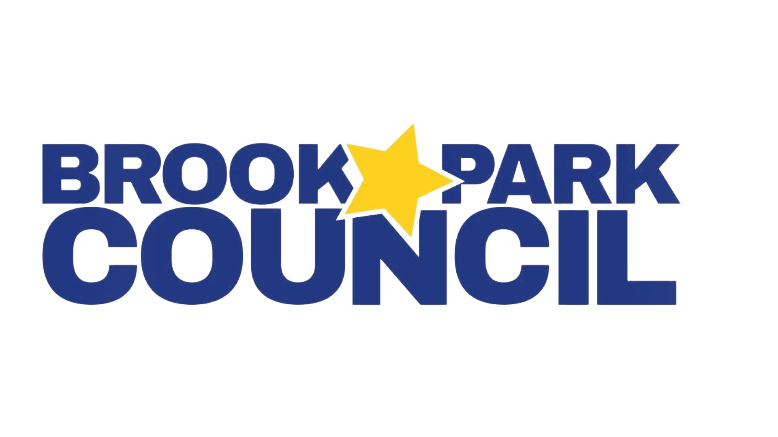
2026-2027 Executive Board
President – Dragana Vidakovic, President@BrookParkCouncil.org

Vice President – Jenn Twardosz, Vicepresident@BrookParkCouncil.org
Treasurer – Diane Bortoli, Treasurer@BrookParkCouncil.org
Recording Secretary – Vanessa Ferniza, Recording@BrookParkCouncil.org
Corresponding Secretary - Alexandra Paramo, Corresponding@BrookParkCouncil.org
Volunteer Coordinator – Melissa Herrera, Volunteer@BrookParkCouncil.org
Fundraising Coordinator – Renee Cheema, Fundraising@BrookParkCouncil.org
Board Member at Large – Amanda Meyer, MemberAtLarge@BrookParkCouncil.org

9.8.26 - 7pm - Multipurpose room

BPC Meeting Agenda

- Welcome/Call to Order: Dragana Vidakovic, President
  - Pledge of Allegiance
  - Introduction

- Secretary’s Report: Vanessa Ferniza

- Administrative Reports
  - Ms. Kelly King, K-2 Principal
  - Mr. Michael Sorensen, 3-5 Principal

- Treasurer’s Report: Diane Bortoli
  - First Quarter review
    - Superstar Step-Up Day
    - Meet the Teacher Book Fair
    - Block Party
    - Other
  - Upcoming expenditures
    - Hispanic Heritage Month - requested $300, PY $300
    - Art Connections - requested $809, PY $1,299
  - Budgetary decisions
    - Specials rotation (PE)
    - Teacher reimbursements
      - 2025-2026
        - Budget was $5,000
        - 28 reimbursements totalling $3,329
      - 2026-2027
        - Teacher count (33 Gen Ed, assume 50 total)
        - 50 @ $125 = $6,250
        - 50 @ $150 = $7,500

- Board & Committee Chair Reports
  - Vice President:Jenn Twardosz
  - Fundraising Coordinator: Renee Cheema
    - Fun Run progress update
    - BPC Website progress update
    - Principals’ proposed fundraising initiative
    - Pop up Membership Drive in September
  - Volunteers Coordinator: Melissa Herrera
    - One-school-one book
    - Volunteer Interest Form
  - Corresponding Secretary: Alexandra Paramo
  - Member-at-Large: Amanda Meyer
  - Committees- Kindergarten Ice Cream Social, Bookfair, Block Party Review

- Old Business
- Status of taxes and 501(c)3
- PTO Today insurance purchased at Complete Level, includes General Liability, Excess Accident Medical, D&O, Crime and Property - total $868

- New Business
- Upcoming Fall Events: Hispanic Heritage Night - assembly, Fun Run, Classroom parties, Trunk or Treat
- Membership drive - throughout September until 10/3, Blue membership price raised to $25, Superstar T-shirt designed by BPC, Class Party for the “winning class” at Flying High
- Seeking members for Cupid shuffle and Teacher & Staff appreciation committee
- Questions or comments

