Castlemont High School Alumni Association

21st Annual
Membership Fundraising Luncheon,
Hall of Fame Induction Ceremony & Scholarship Award Presentation

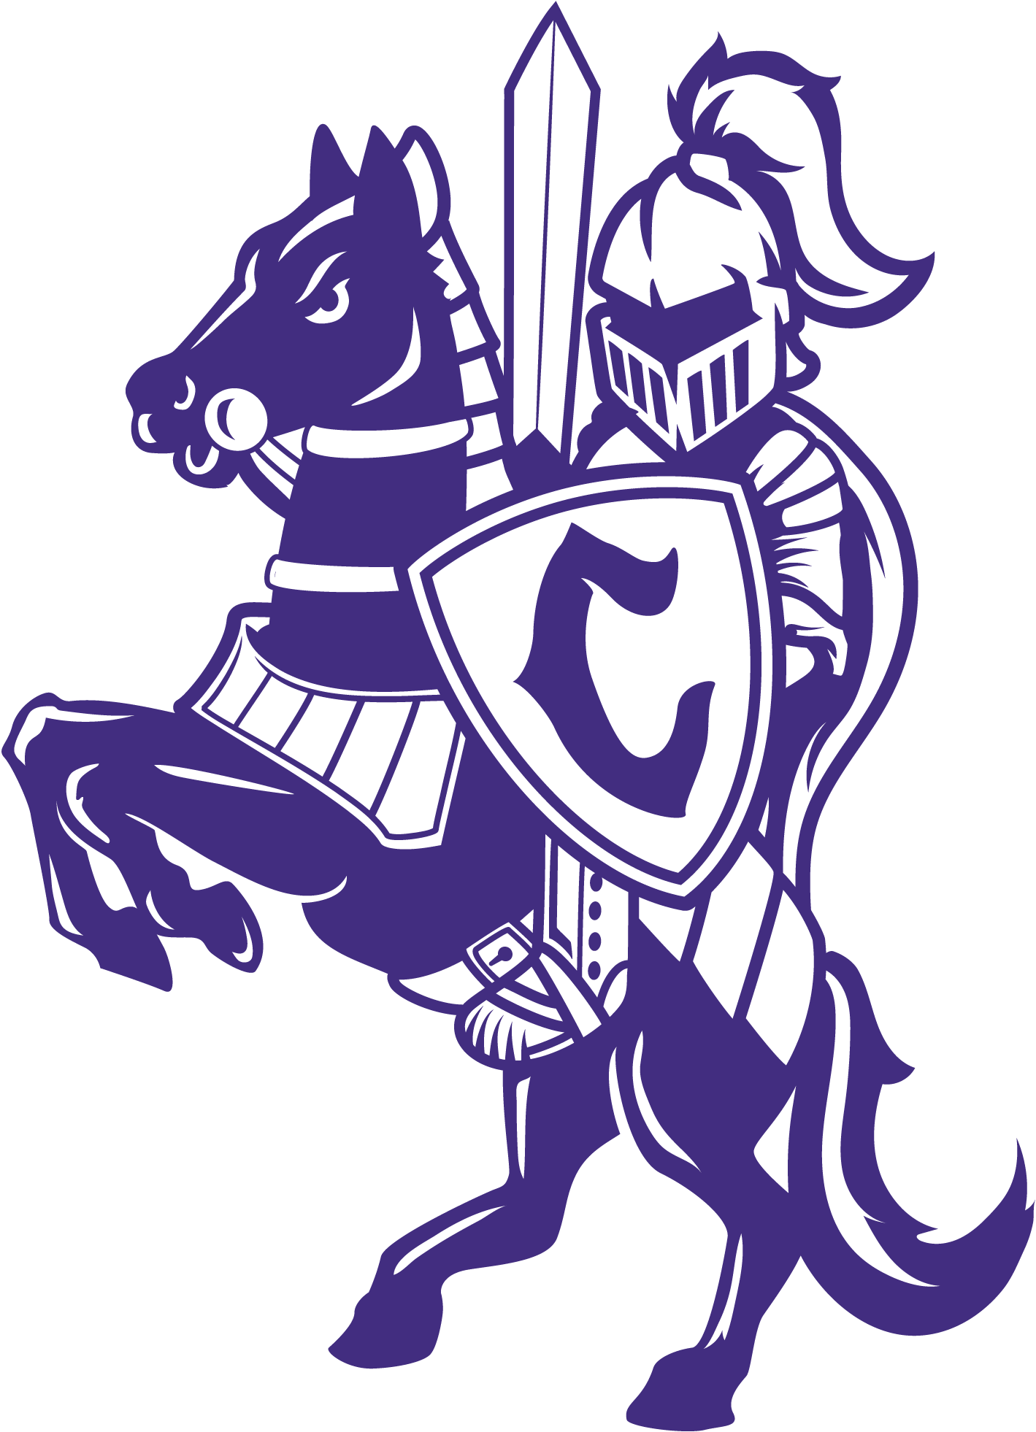
The Castlemont High School Alumni Association will host the 21st annual Membership Fundraising Luncheon/Hall of Fame Induction Ceremony and will also present the CHS 2025 Scholarship Awards. We will celebrate another year of supporting our alma mater and award scholarships to deserving seniors at Castlemont who pursue post-secondary education or occupational training.
This event will take place on Saturday May 17th, 2025, at 12:00 pm at Castlemont High School in the Phil Reeder Performing Arts Theater-8601 MacArthur Blvd., Oakland, CA 94605. Tickets are $50/person (includes admission and lunch) and can be purchased via Zelle using our email address:
knightpride1929@gmail.com Business Name: CHSAA (Please indicate “2025 Luncheon” in the memo
section) or by check or money order made payable to: “CHSAA” and send to:
P.O. Box 20914 - Castro Valley, CA 94546

FOR THOSE WHO WOULD LIKE TO DONATE TO THE CASTLEMONT HIGH SCHOOL ALUMNI ASSOCIATION SCHOLARSHIP FUND, YOU MAY DO SO USING EITHER PAY METHOD ABOVE
PLEASE INDICATE “SCHOLARSHIP DONATION” IN THE MEMO SECTION

DEADLINE TO PURCHASE TICKETS: SATURDAY MAY 3rd , 2025
NAMES WILL BE LISTED ON THE GUEST LIST AT CHECK-IN

THE CHSAA BOARD OF DIRECTORS WOULD LIKE TO THANK YOU FOR YOUR CONTINUED SUPPORT!

