CHSAA 2021
Hall of Fame Induction
and
Scholarship Award Presentation

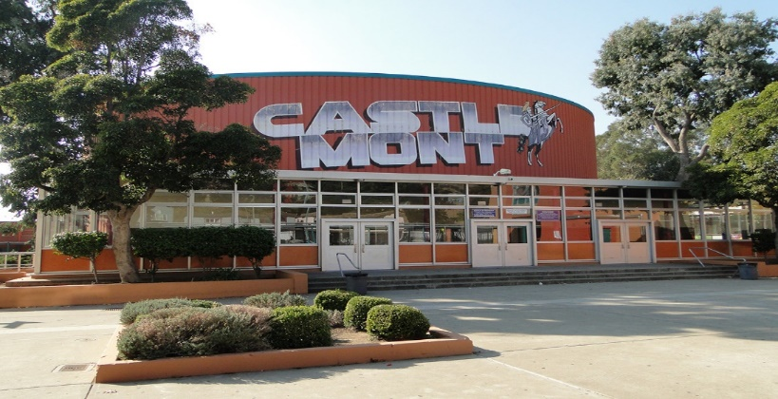

The Castlemont High School Alumni Association will host the 17th Annual Hall of Fame Induction Ceremony and will also present the CHS 2021 Scholarship Awards on May 22nd, 2021 at 12noon. We will celebrate another year of supporting our alma mater and award scholarships to deserving seniors at Castlemont who pursue post-secondary education or occupational training.
This year due to the pandemic this will be an outdoor event for inductees and scholarship recipients only. Each inductee and scholarship recipient will be allowed a maximum of (3) guests each. Facemasks and social distancing will be required. Family and friends will be able to tune in via “Zoom”, final details to follow.

