Castlemont High School Alumni Association

Membership Fundraising Luncheon & Hall of Fame Induction Ceremony

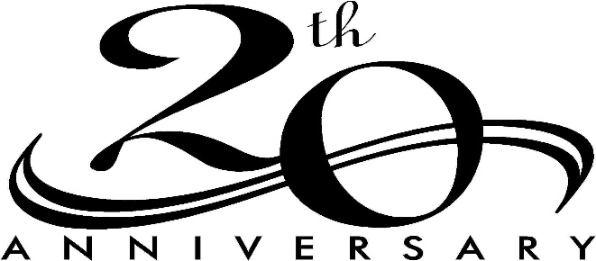

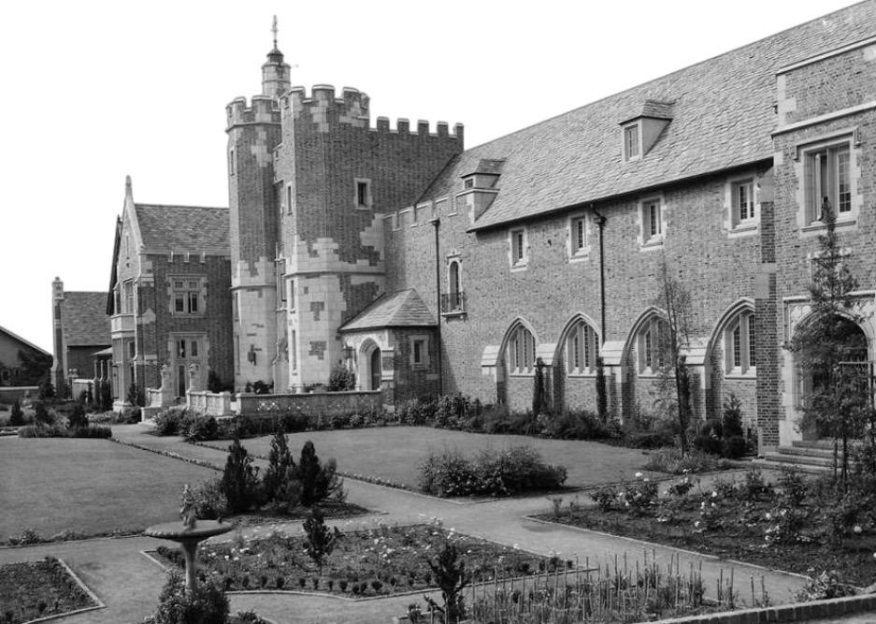
The Castlemont High School Alumni Association will host the 20th Annual Membership Fundraising Luncheon and the Hall of Fame Induction Ceremony. We will celebrate another year of CHS Alumni fellowship and supporting our alma mater.
This event will take place on Saturday May 18th, 2024, at 12:00 pm at Castlemont High School in the Phil Reeder Performing Arts Theater-8601 MacArthur Blvd., Oakland, CA 94605. Tickets are $45/person (includes admission and lunch) and can be purchased via Zelle using our email:
knightpride1929@gmail.com Business Name: CHSAA (Please indicate “Luncheon” in the memo section) or by check or money order made payable to: CHSAA and send to P.O. Box 20914 - Castro Valley, CA 94546
DEADLINE TO PURCHASE TICKETS: SATURDAY MAY 4th, 2024

FOR THOSE WHO WOULD LIKE TO DONATE TO THE CASTLEMONT HIGH SCHOOL ALUMNI ASSOCIATION SCHOLARSHIP FUND, YOU MAY DO SO USING THE SAME PAY METHODS AS ABOVE

THE 2024 SCHOLARSHIPS WILL BE AWARDED ON TUESDAY MAY 21ST AT THE ANNUAL SENIOR BREAKFAST
AT 9:00AM IN THE CAFETERIA AT CASTLEMONT

THE CHSAA BOARD OF DIRECTORS WOULD LIKE TO THANK YOU FOR YOUR CONTINUED SUPPORT!
