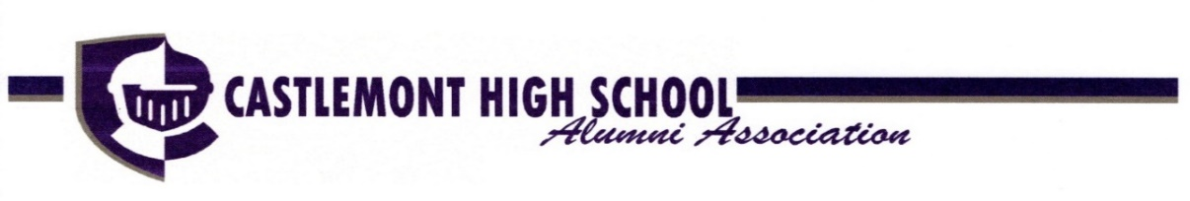
2021

Hall of Fame Nomination Form

Each year the Castlemont High School Alumni Association inducts alumni into its Hall of Fame. Inductees are selected for having excelled in one of five categories: Sports, Distinguished Knight in Shining Armor (best representing the true spirit and ideal character of a Castlemont alumnus); Community Service, Phil Reeder Performing Arts, and the Gold Key (dedicated service to the alumni association). If you know of an alumna or alumnae who has provided distinguished service in one of these categories, please nominate them for induction into the 2021 Castlemont High School Hall of Fame. The induction ceremony will be held on Saturday May 22nd at 12noon, more details to follow.

NOMINATION FORM AND SUMMARY OF BIO MUST BE RECEIVED BY APRIL 16th, 2021 TO BE CONSIDERED

Email to: dmalone05@aol.com
Subject: CHSAA HOF Nominations
Attention: Dana Malone Hubert, HOF Committee Chair

Name of Nominee:
Year of Graduation:
Category of Nomination:
Nominee’s email:
Reason for Nomination:

Name of Nominator:
Email:
Phone:

PLEASE INCLUDE A SUMMARY OF THE NOMINEE’S BIO

