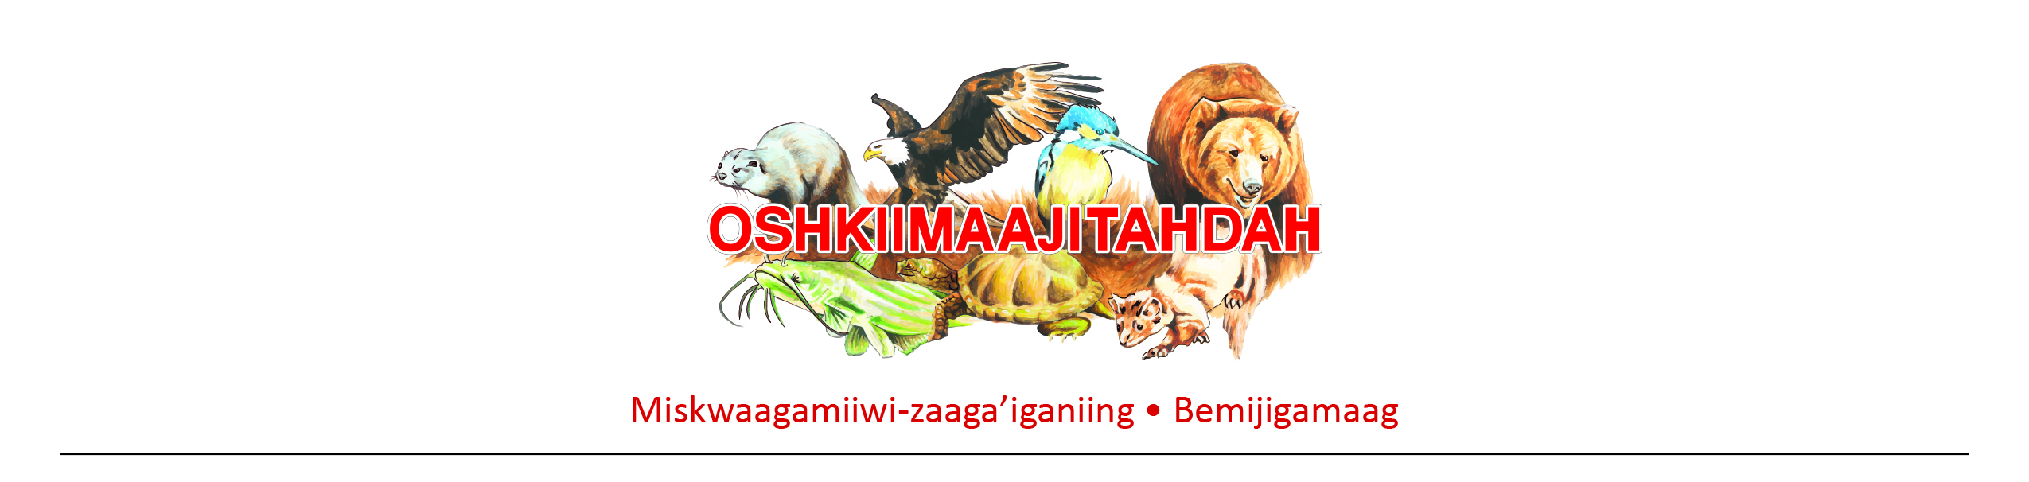

Job Description

***Supplemental nutrition assistance program (snap) eligibility worker***

Oshkiimaajitahdah (New Beginnings)

**Position Summary:**

Serves as primary contact and resource for individuals and families who are receiving SNAP benefit assistance through Oshkiimaajitahdah. Reports to the Family Service Supervisor, Assistant TANF Director, and Executive Director.

**Essential Responsibilities & Duties:**

* Interviews clients to obtain necessary factual information, and verifies information received from clients
* Determines eligibility and the amount of benefits for individual and family SNAP programs
* Explains SNAP application procedures to individuals or groups and answers questions of individuals on how to complete the application forms
* Communicates program time limits, expectations and other program requirements to the client, and serves as central point of communication
* Performs data entry into multiple computer systems and retrieves information from those systems
* Re-determines eligibility and benefit amounts required by changes in a client’s status, by reviewing and verifying client information, preparing budgets and related documents, and calculating benefit amounts in accordance with established benefit standards
* Maintains complete and accurate records on client's eligibility for all assigned programs
* Advises clients of case status, including explaining eligibility requirements and benefit factors, assesses client needs, and refers clients to programs and other community resources to assist them in maintaining eligibility, or in the event that the client is no longer eligible for public assistance.
* Responds to complaints of clients and informs clients of the right and method of appeal and other legal rights
* Ability to interpret SNAP policy, complex rules, manual materials and bulletins as they apply to SNAP program

**EDUCATION/WORK EXPERIENCE/QUALIFICATIONS:**

* Prior experience in Human Services field preferred.
* Exceptional written/oral communication, computer, and organizational skills.
* High degree of skill in motivational techniques, problem solving and group work abilities.
* Previous experience in Maxis preferred.

**Qualifications:**

* GED/High School Diploma.
* Must have a valid Minnesota Driver’s license and auto insurance.
* Employment is contingent upon passing a pre-employment drug test and background check.
* Abide by the New Beginnings Zero Tolerance Policy and Confidential Policy.