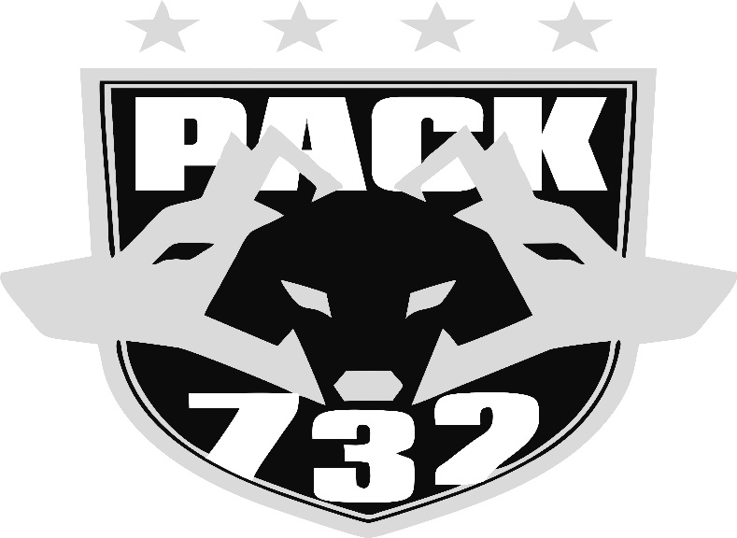

**PACK732 WRESTLING ACADEMY**

**2022 Prospect CAMP 1ST-8TH GRADE**

**Check in Sat. July 30th 9:30am**

**1120 West 5th street Wilton, IA (east of Dollar General Store)**

Saturday July 30th Start 10am-12pm Sunday July 31st 10am-11:30am

Tuesday August 2nd 6-7:30pm Wednesday August 3rd 6-7:30pm

***Sign-up on or by July 27th to guarantee camp shirt***

**Online registration link or use the QR code bottom left:**

[**https://pack732.aidaform.com/pack-summer-camp-form2022**](https://pack732.aidaform.com/pack-summer-camp-form2022)

Pack732 Wrestling Academy is hosting a prospect camp for any New and all returning members that are entering 1st- 8th grade for school year 2022-23. **Camp Fee is $30**, includes T-shirt and the PACK732 experience.

**Things you’ll need to bring: Water Bottle or drink**

Please visit [www.pack732.com](http://www.pack732.com) for more information on this camp along with additional information on the Academy itself. Our 2022-2023 Season Sign-ups will begin immediately following after the completion of this camp on August 4th. Additionally any High Schoolers that are interested in joining PWA for the 2022-23 season, please check out the website and/or get in contact with us.

**CAMP SIGN-UP** **PACK732.com**

