Procedures for Membership Renewals SHR&PC (1.1)

To logon and check/update your details click the link below or copy and paste it into your internet browser and bookmark for future use.  
  
<https://membermojo.co.uk/mm/signin>  
  
*(If you already have a Membership at another club that uses the same e-mail address you can just logon with those details, the existing club name is shown on the top right, if you click on the icon next to the club name then a list of alternative clubs appears, select South Hants Rifle and Pistol Club then the details will appear.)*

The following will be displayed …….

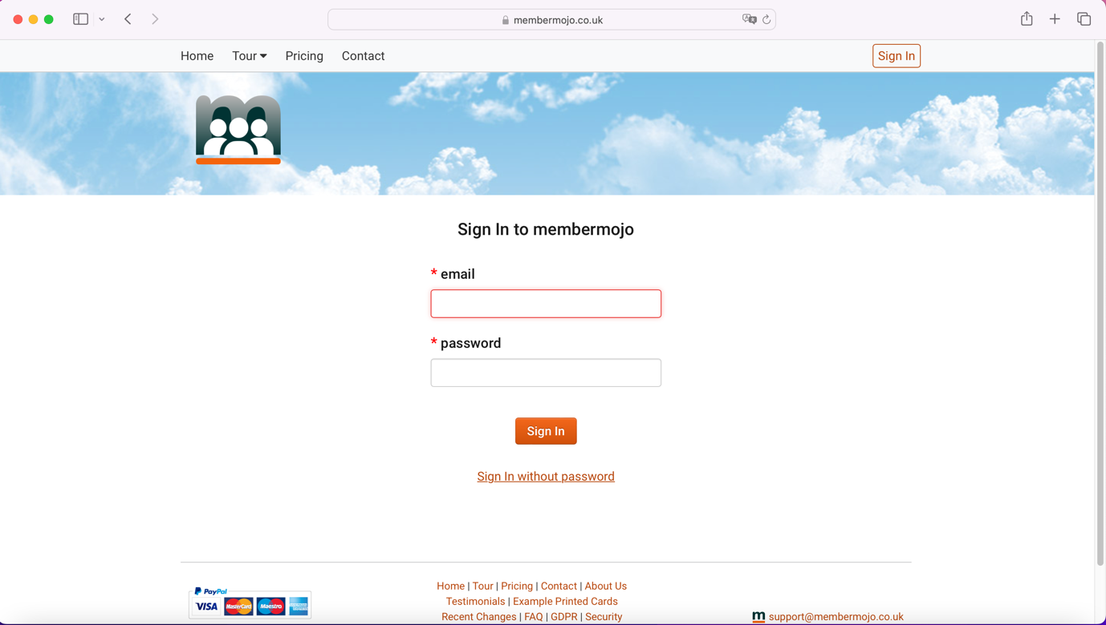

At this point enter your e-mail address and select ***Sign in without password***

The following screen will be displayed ……

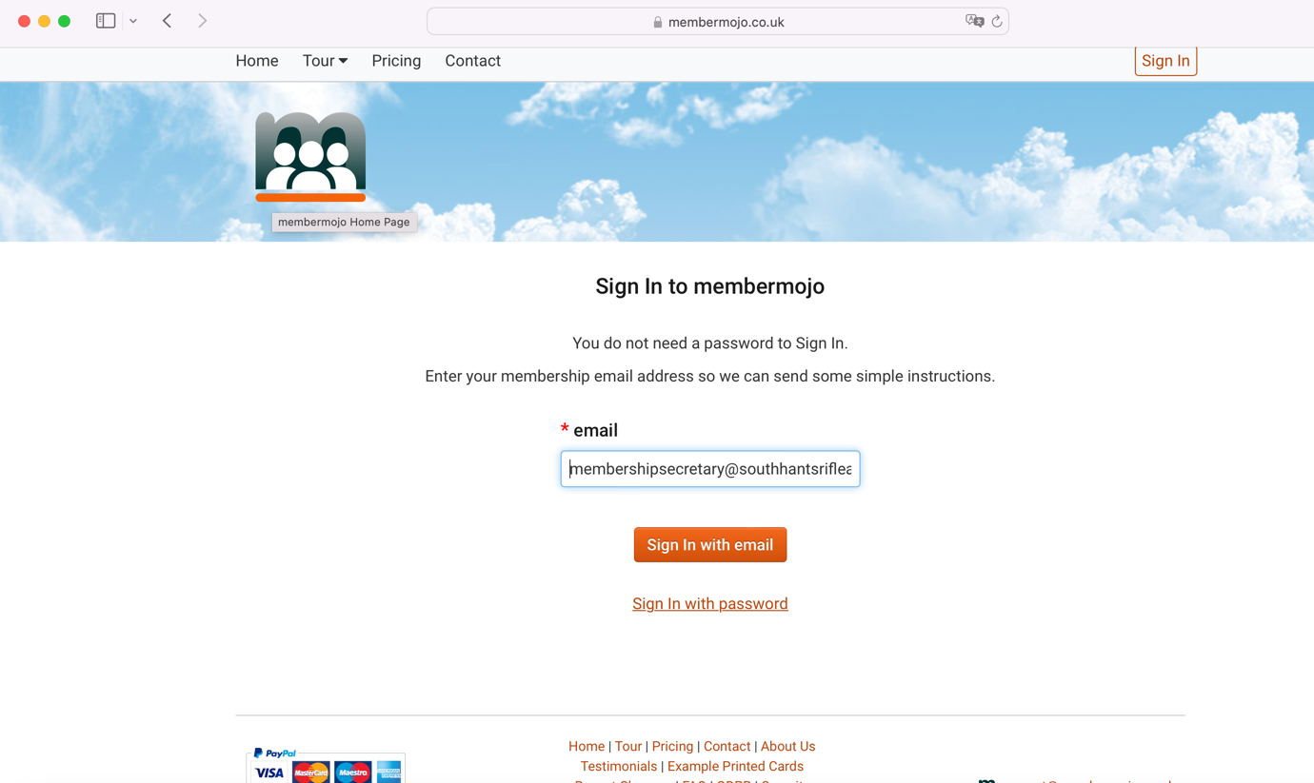

Select ***Sign In with email***

The following screen will be displayed …….

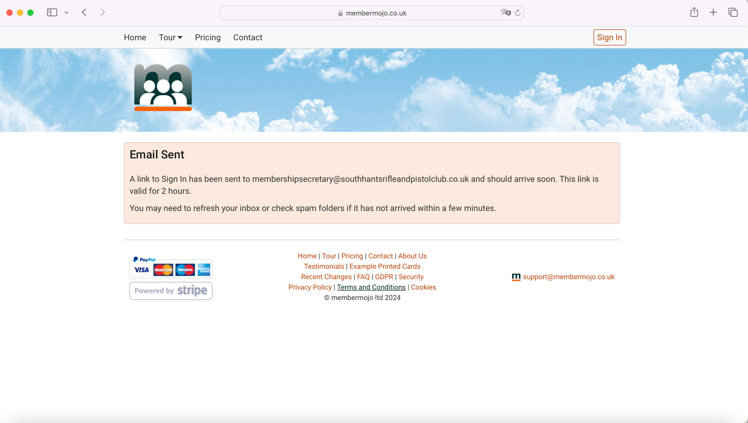

Go to your e-mail client and you will have an email similar to the one below …..

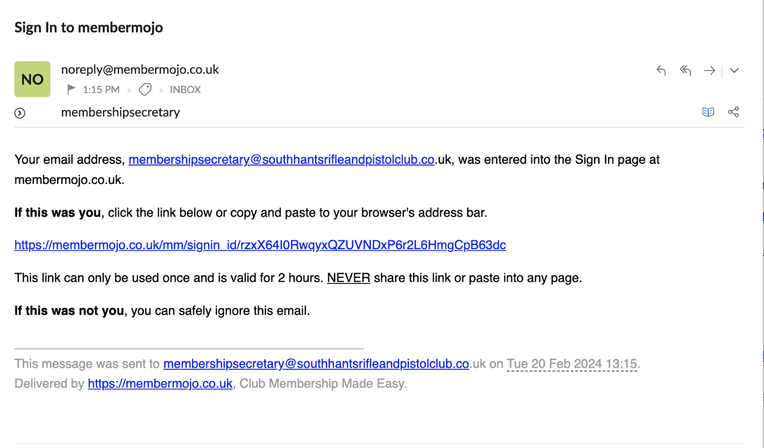

Select the membermojo link in the email and this will load your internet browser with the following screen ……

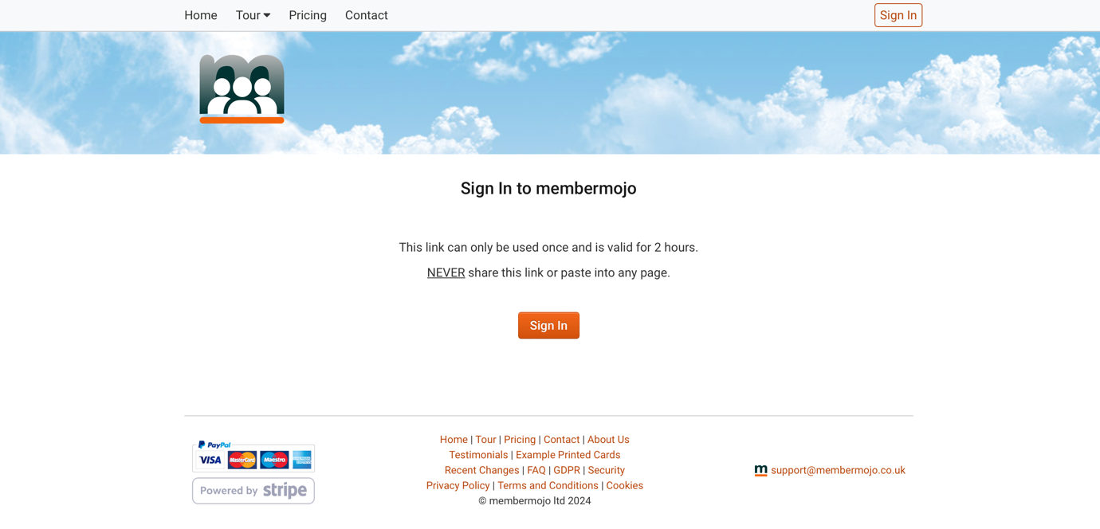

Select ***Sign In***

The following screen will be displayed ……..

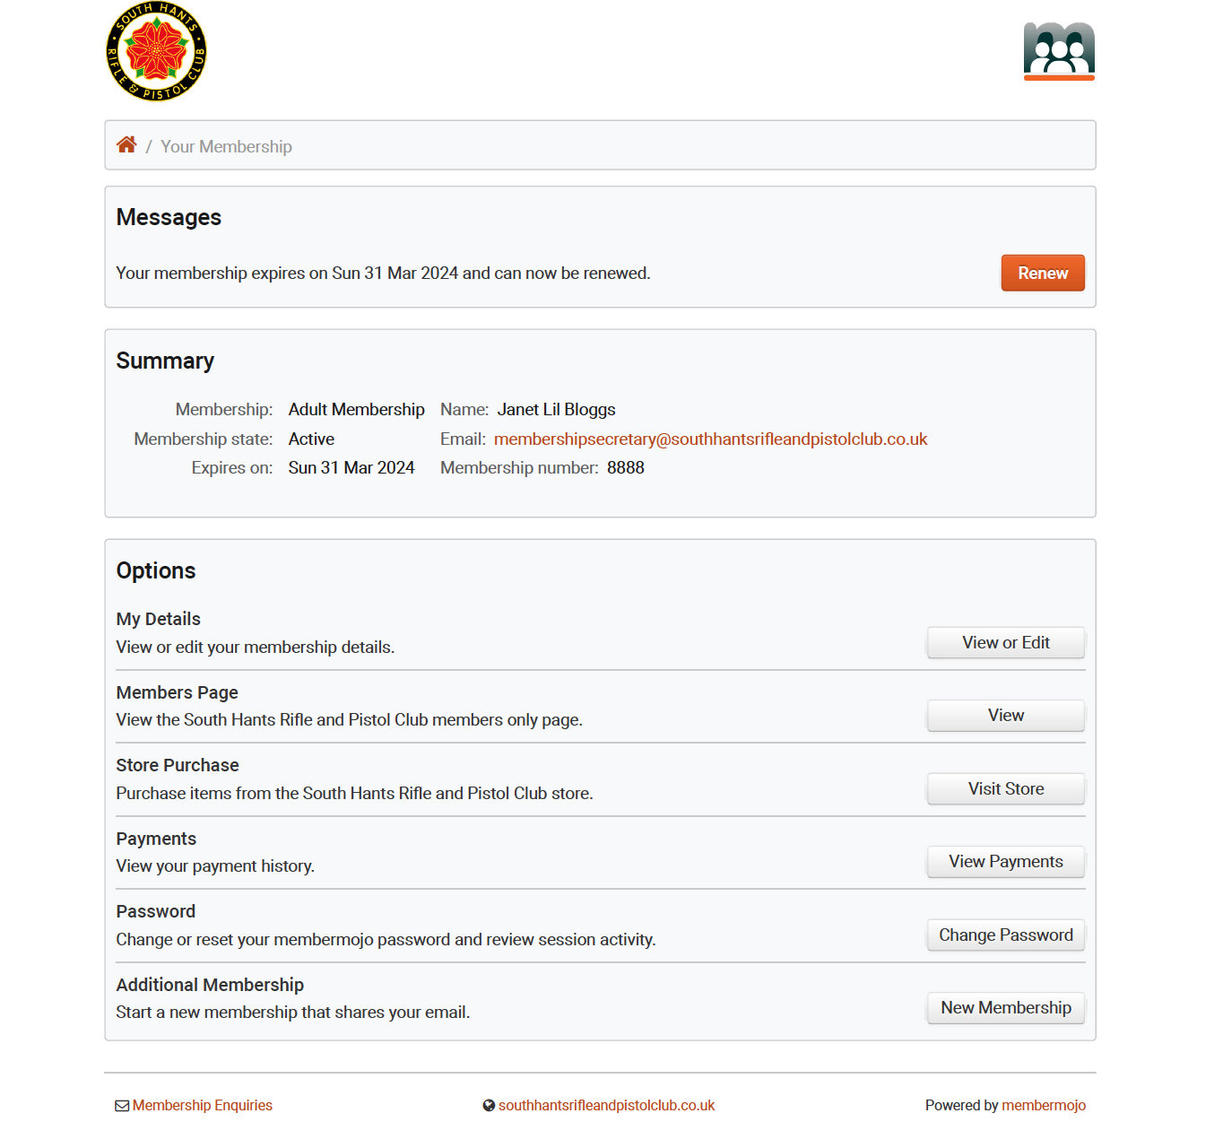

(At this point if you want to be able to logon in future without going through the e-mail login process you can select ***Change Password*** and in future logon to the first screen with an e-mail and password)

Select ***Renew***

The following screen will be displayed …….

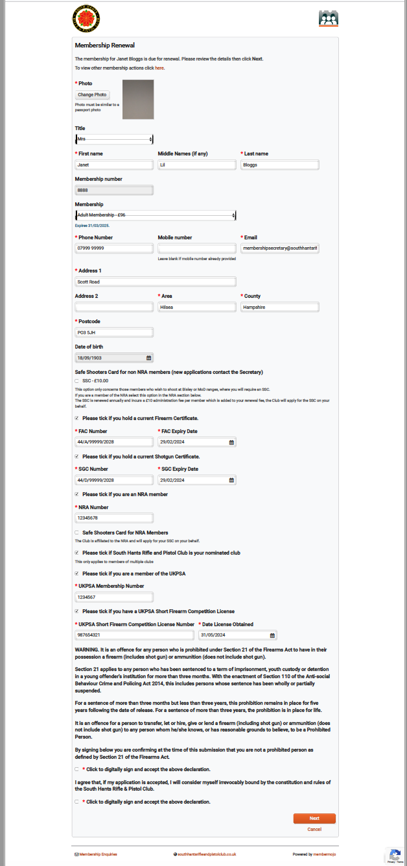

On the above screen you can replace the photo if you require, if the device you are renewing on has a camera, or upload a photo which must be similar to a passport photo. Check your ‘Membership’, if this is incorrect, please e-mail me at ……. [membershipsecretary@southhantsrifleandpistolclub.co.uk](mailto:membershipsecretary@southhantsrifleandpistolclub.co.uk) and come out of the renewal process.

Any changes to your address, this is essential for the membership card deliveries, phone number/s and information relating to FAC, SGC, NRA and UKPSA, any information that is incorrect or has altered then please update. Please also update this information during the year if any of this information changes.

If you require an SSC for the first time, please contact the Club Secretary, e-mail address is ……..

secretary@southhantsrifleandpistolclub.co.uk

When you have completed all the relevant information then select the two acceptance boxes at the end and then select ***Next.*** Any mandatory information not filled in you will be prompted to complete.

The following screen will be displayed

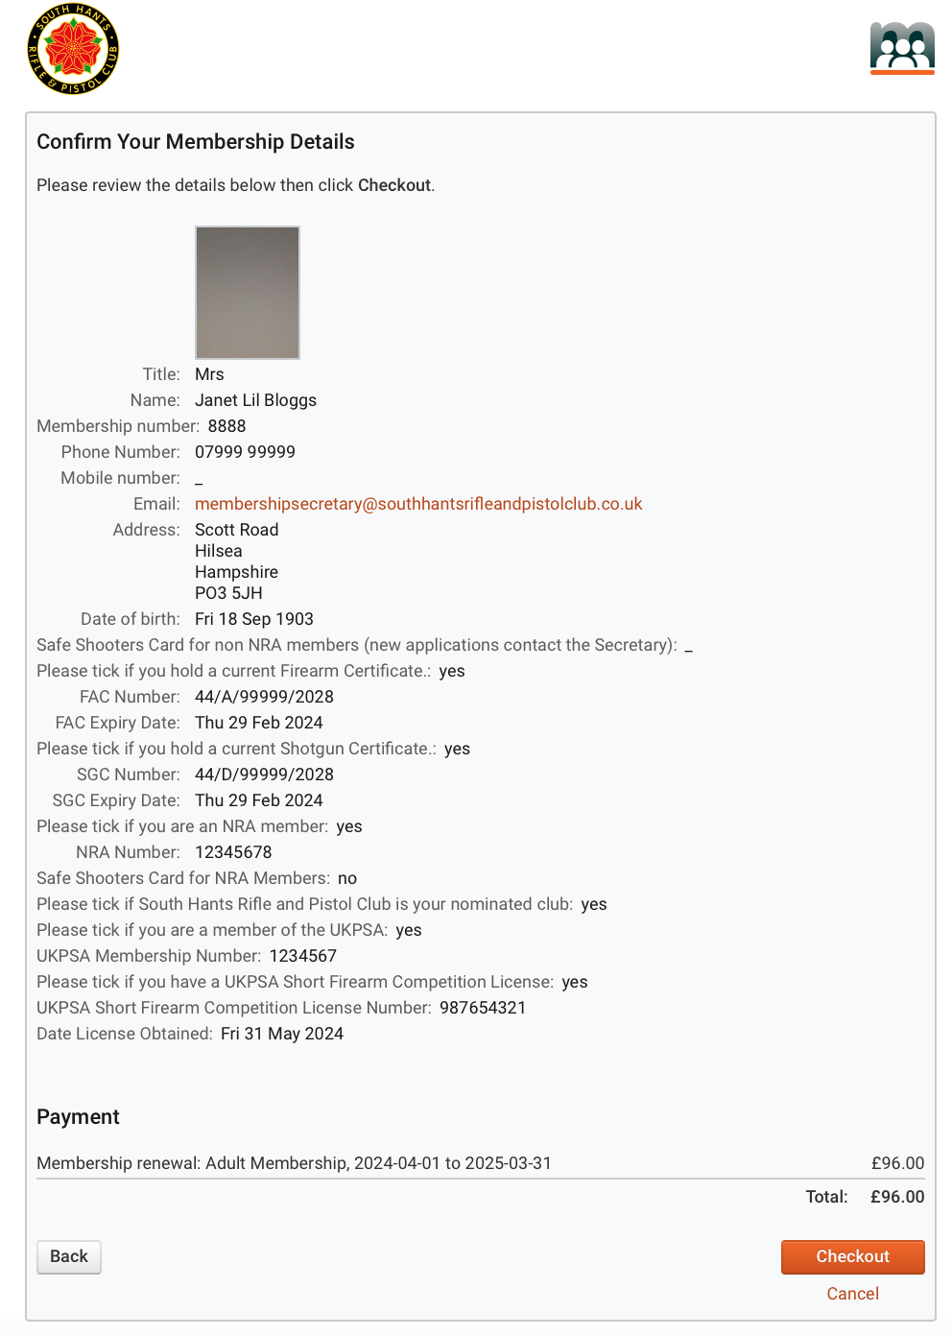

If the information is correct and the amount owing is correct then select ***Checkout***

The following screen will be displayed, select the payment option and proceed by filling in the relevant information.

If paying by cheque or cash please bring this to the Hilsea Range during opening times with your name and membership number written on the outside of a sealed envelope

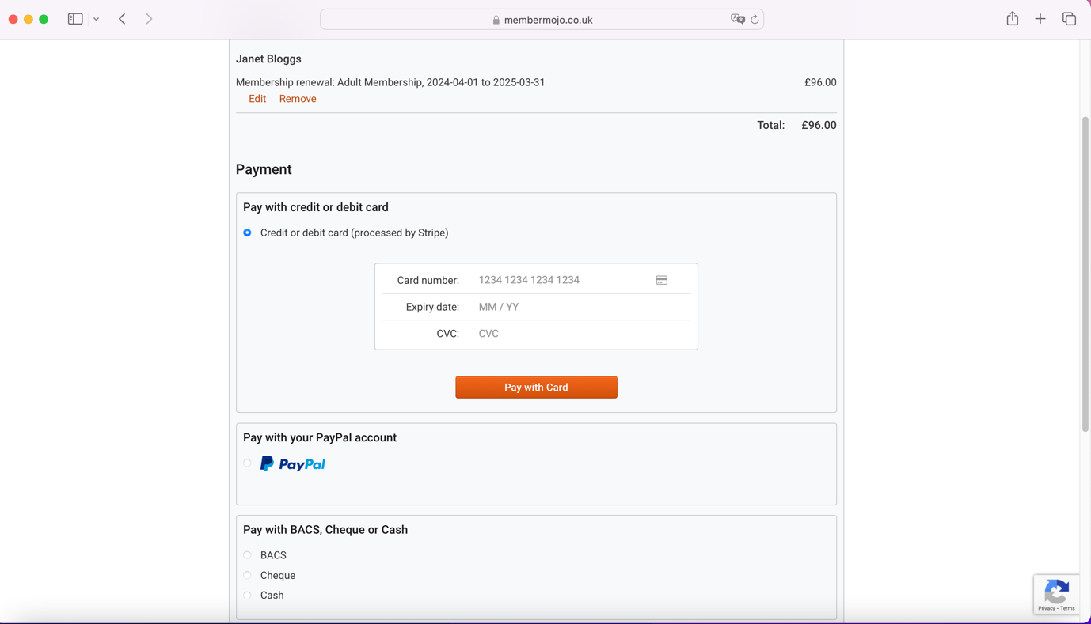

After the payment has been verified membership cards are batched up on a Sunday for printing and dispatching the following week.

Membership cards are sent direct to your home address which is why it is essential to make sure this is correct.

Any assistance required then please come along to one of the events at the Hilsea Range …..

Wednesday 26th March 13:30-16:00

Tuesday 1st April 17:00 - 20:00

Saturday 12th April 09:30 - 12:00

If you come to one of the sessions and you are renewing your membership, if paying by credit or debit card, cash or cheque please bring them to this session. If paying by cash or cheque please place inside an envelope with your name and membership number written on the envelope.