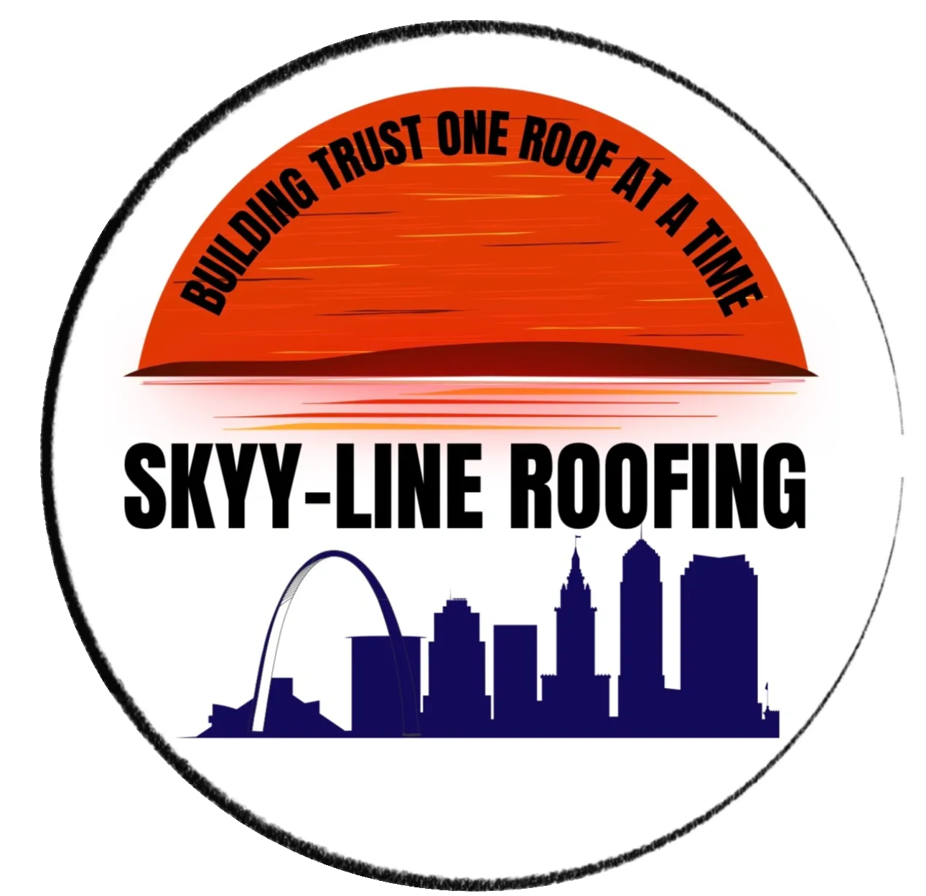

**Skyy-Line Roofing**

2008 Meadow Brook Ln

Pacific, MO 63069

**Unconditional Final Waiver and Release**

In consideration of materials purchased by Skyy-Line Roofing, in the amount of _____________, have been paid in full to furnish the premises known as, ______________________________________________. Skyy-Line Roofing hereby agrees to releasing and discharging the homeowner from all amounts owed pursuant to the agreement and price stated. The company releases and discharges from any liens, claims of liens, and any other charges which Skyy-Line Roofing may now or hereafter have against the Job for the Materials or Services, whether or not evidenced by lien affidavits, and whether or not filed for record

Supplier hereby indemnifies and holds harmless Customer from and against all liability and costs including reasonable attorneys' fees) arising from any claim for payment or lien that may be asserted at any time ni the future against Customer, its heirs, successors or assigns, by Contractor or any other party by virtue of the work performed pursuant to the Agreement.

This release and waiver is hereby executed on, __________________.

________________________________ ________________________________

Sigurature Printed Name

________________________________ ________________________________

Title Date