AZ NAWGJ WELCOME PACKET


Please direct any questions or concerns to
Kristy Brumback kristybrumback@yahoo.com or
Nikki Estes nre787@aol.com

Welcome to Arizona NAWGJ!

Whether you are new to gymnastics judging or a veteran, this document will serve as a guide for understanding the process of becoming a gymnastics judge, the judging rating system, and our organization. AZ NAWGJ has roughly 40 active members and assigns approximately 45 gymnastics meets annually. We hope you will become an active member of our judging community.

What is NAWGJ?

NAWGJ is the acronym for the National Association of Women Gymnastics Judges. This is our National Judging Organization that was established in 1974. The mission of NAWGJ is: “to provide professional development for its members and to support and promote women’s gymnastics in the United States.” AZ NAWGJ accomplishes this mission by providing local educational clinics and lectures with the Arizona gymnastics community. Additionally, judges are encouraged to attend Regional or National Congresses. Various other clinics are offered through Flipping Education to meet the continued educational requirements.

NAWGJ Website www.nawgj.org

AZ NAWGJ Website Information www.nawgjaz.org

Here you will find links to USA Gymnastics as well as information on “How Do I Become a Judge". Topics include:
- WPD Xcel Program
- NCAA Program
- Judges Ratings
- Professionalism & Rules and Policies
- Judging Rule Books
- Study Materials for Exams, Practice Judging, Tests and Videos
- Registration for Testing, Forms and CPE Information
- USA Gymnastics Women’s Development Program (WPD Levels 1-10)

AZ NAWGJ State Judging Board (SJB) Members

- State Judging Director (SJD)- Natalie Koga: azsjdnkoga@gmail.com
- Financial Assistant - Adora Villanueva: villanueva.adora@gmail.com
- Education/Mentor/CPE Co-Chairs – Nikki Estes: nre787@aol.com and Kristy Brumback: kristybrumback@yahoo.com
- Judges Cup Coordinator – Sam Baltierrez: sam@impactgymaz.com
- Webmaster – Lonnie Rule: thunder_gym@yahoo.com
- Assignor- Cherie Bruggeman: cherbroog@live.com
- At Large - Kim Neal: kimneal939@yahoo.com

USAG Website USA Gymnastics is the national governing body for all gymnastics in the United States. The USAG website is www.usagym.org and the Arizona Chapter website is https://www.azusag.com/
  - The Arizona USAG State Committee Chairman (AZ SACC) is Dianne Grayson @ dianne_grayson@yahoo.com

USA Gymnastics Judging Overview: https://usagym.org/women/judges/

Judging Rating System
Here is a general overview of how the judging rating system works. Any individual that has never held a rating may test at Compulsory Level 4/5 and/or at the Optional Level 7/8.
- Individuals may choose to be rated for optional levels only. A Level 4/5 rating is not required.
- The Accreditation year will be defined as August 1-July 31.
- Test sessions are scheduled within the USA Gymnastics Judging Accreditation Program by individual Test Administrators. A master list of all upcoming testing sessions, the test parts to be offered at each, and information on how to register for a test can be found on-line under https://members.usagym.org/pages/women/pages/judging_accreditation.html
- Examinees may take the written and/or practical exam for a specific level a maximum of four (4) times per accreditation year in the attempt to pass.
- Ratings Overview:
Level | Rating Prerequisite | Age | Written | Practical (Video)
4/5 | N/A | 16 | 70% | N/A
7/8 | N/A | 16 | 70% | 70%
9 | Level 7/8 12 months | 18 | 76% | 75%
10 | Level 9  12 months | 20 | 80% | 80%

Meet Your Judging Mentors
- Our AZ NAWGJ board recommends that you have a mentor to assist you with that selection. Mentors are very valuable to help facilitate your testing preparation, answer questions involving judging issues, and support you throughout your "growing years" as an official. Our Education/Judge Mentor Coordinators are Nikki Estes: nre787@aol.com and Kristy Brumback: kristybrumback@yahoo.com

Both Nikki and Kristy will be happy to connect you with a Mentor to help you navigate the process of becoming an Arizona gymnastics judge. Below are some areas a judging mentor will help you facilitate:

  - Testing/Study process/Practice judging form.
  - Judging Fees, travel, and mileage
  - Gymnastics Judging Assigning System (Gymjas)
  - Meet and Judging Protocol
  - Judging your First Meet
  - CPE Continuing Professional Education

Study Materials

For the compulsory level 4/5 test, you will study from the USAG Women’s Development Program Compulsory Book. This is also available in a digital format.

For the optional tests, you will need to study from the USAG Women’s Development Program Code of Points. This is also available in digital format.

These materials can be found in the USA Gymnastics Technical Materials Store on USA Gymnastics website: www.usagym.org

The NAWGJ website also has great study aids and practice tests: www.nawgj.org

If you are studying for an optional test that has a practical component, there are many great practice videos on the NAWGJ website as well

  - If you are testing Development Program Compulsories (Levels 2-5), you'll need the Women’s Development Program Compulsory Book & your exam will cover Level 4/5 rules.
  - Recertification for Compulsories is every 8th year of our gymnastics cycle; 2021, 2029, etc.
  - If you are testing Development Program Optional (Levels 6-10) you will need the Women’s Development Program Code of Points.
  - Once you have achieved an Optional rating, you must hold that rating for 12 months before Taking the exam at the next highest level.
  - Recertification for Optional is every 4th year of our gymnastics cycle; 2022, 2026, etc.

Eligibility to take a Judge Examination
As a new judge you may take the entry level judging test at the Development Program Compulsory Level 4/5 exam and/or at the Development Program Optional Level 7/8.If you have competed as a National team member, NCAA gymnast, or Level 10 you may be able apply to begin testing at a higher level. Please contact our SJD Natalie Koga @ azsjdnkoga@gmail.com for more information.

Registration for Taking a Judge Examination
The compulsory level 4/5 test is offered online by USAG. It is an open-book, timed test.
Optional written exams are offered as an open book, timed test. The film tests are offered by Test Administrators. You need to register for an optional test through the USA Gymnastics website. A master testing schedule with all dates and locations of upcoming exams can be found on the website

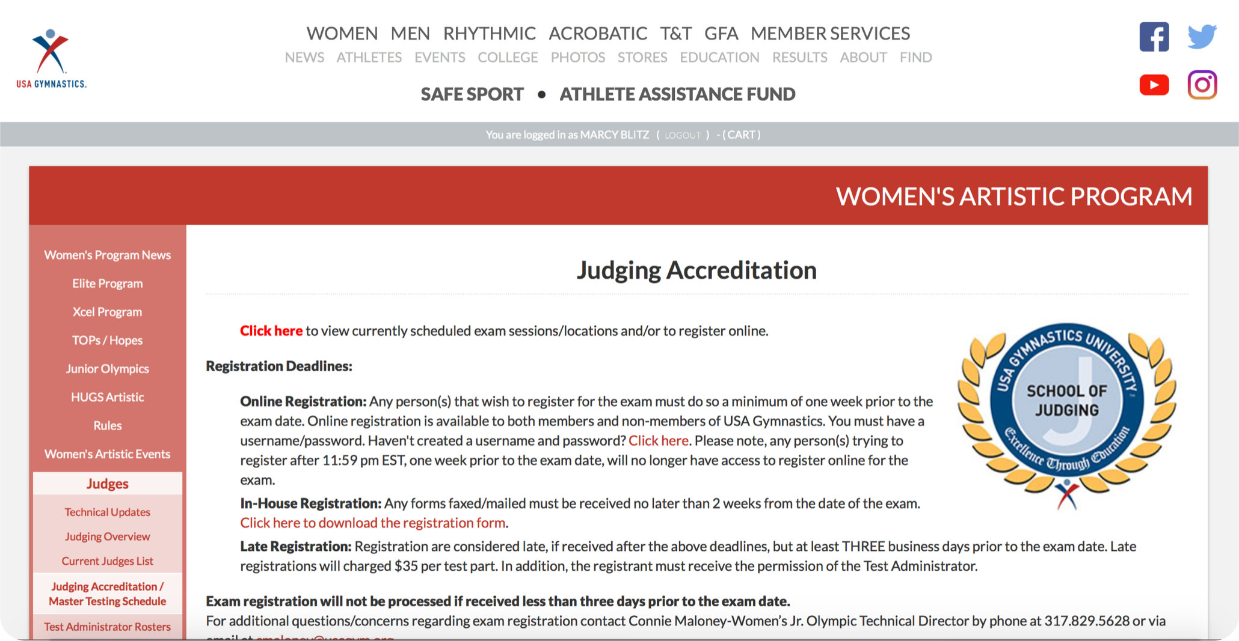

Registration is on the USA Gymnastics website at:
https://members.usagym.org/pages/women/pages/judging_accreditation.html
You must register for an exam at least 7 days prior to the test date. Each exam part (written and practical) costs $25. You may retake an exam up to 4 times per year.

Additional State Requirements prior to judging your first gymnastics meet
Our AZ NAWGJ Board requires all new judges to practice judge two (2) sessions of a sanctioned competition at the Level you are testing before you can be assigned to an “Official Meet”.

You need to pass the exam prior to practice judging and you must be a current USAG Pro Member, have your Background Check and Safety Certification completed. Please contact Nikki Estes or Kristy Brumback to help you set your practice sessions. You will need to have a “Practice Meet” form signed by the Meet Referee of the meet you attend. This form can be found at the end of this packet.

Judging Assignments
AZ NAWGJ uses the online system Gymjas to assign gymnastics meets to active judges. When you are ready to be assigned, please contact Natalie Koga azsjdnkoga@gmail.com. Once she inputs your name and preliminary information into the on-line system, you will be able to access the system as a new user.

As a new user you’ll be able to create your own username and password, create a personal profile and fill out your availability for the upcoming season. The number of meets you will be assigned will be based on your availability, rating, location of the meet, and any Meet Director requests. We assign Development Program Compulsory meets in early August and Optional and Xcel meets in mid-November.

Lastly, you will need to send copies of the following documents to Natalie Koga azsjdnkoga@gmail.com before you can be assigned to a meet.
    - Your USAG Professional Membership
    - Safety Certification,
    - Background Check
    - Your Practice Judging completed form at the end of this packet.
    - The NAWGJ Information Sheet filled out and signed download from link https://nawgj.org/wp-content/uploads/2020/06/NAWGJ-General-Information-Form.pdf

When are the competitive seasons?
- Development Program Compulsory Season Level 1-5 season is August - December.
- Development Program Optional Level 6-10 season is January - May.
- The Xcel season is November - May.
*The competitive meet calendar can be found on the Arizona USAG website is www.azusag.com

Professionalism

NAWGJ Rules: https://nawgj.org/wp-content/uploads/2025/09/NAWGJ-Rules-of-Professional-Conduct-Sept-6-2025.pdf

The Code of Professional Responsibility provides the fundamental ethical principles that guide judges to ensure that their conduct promotes respect for the National Association of Women’s Gymnastics Judges (NAWGJ).

Standards for professional behavior are reflected in the Canons and Rules

USAG Rules and Policies: https://usagym.org/women/rules/

This website includes a section on Judges specific responsibilities

Uniform Information
As stated in the USA Gymnastics Women’s Program Rules and Policies: “Judges must dress appropriately, regardless of the level of competition, in the required uniform (Navy skirt/pants and jacket, white blouse/shirt, NAWGJ navy dress/sweater. Exception: theme invitationals)”
- Suit jackets required for State and above competitions.
- Leggings are NOT acceptable.
Information on ordering a uniform can be reviewed at: https://nawgj.org/become-a-judge/membership/uniform/

NEW Judges have one year to purchase the official uniform. Until then, it is appropriate to wear a white blouse/shirt and navy or black slacks or a skirt. Clothing that is considered inappropriate includes shorts, denim, yoga type pants, tank tops and flip flops. * unless it is a “themed meet.”

What does basic shorthand look like?

You will start to see that the symbols mirror the shape of the skill as much as possible.

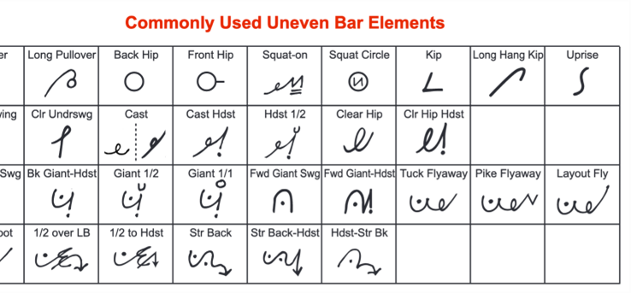

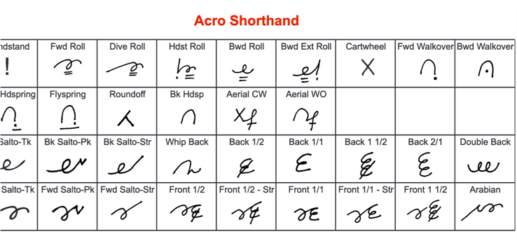

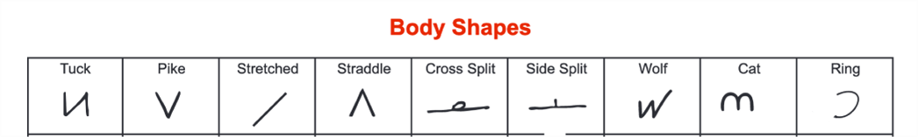

AZ NAWGJ NEW JUDGE CHECKLIST
- JUDGING PREPARATION MATERIALS
*2021-2029 Women’s Development Program (WDP) Compulsory levels 1-5 (Full size) $75.00 (Mini) $50.00. Women's Development Program (WDP) - Compulsory levels 1 through 5.
Google Play Digital Version $75.00 https://play.google.com/store/books/details/USA_Gymnastics_USA_Gymnastics_Development_Program?id=NX4wEAAAQBAJ
*2022-2026 Women’s Development Program (WDP) Optional levels 6-10 (Full size) $75.00 (Mini) $50.00 Women's Development Program (WDP) - Optional levels 6 through 10
Google Play Digital Version $75.00 https://play.google.com/store/books/details/USA_Gymnastics_2022_2026_Development_Program_Code?id=brhoEAAAQBAJ
*2022-2026 Xcel Program Code of Points (Full sized) $60.00, (Mini) $60.00. Women's Xcel Program Google Play Digital Version $75.00
https://play.google.com/store/books/details/USA_Gymnastics_2022_2026_Xcel_Program_Code_of_Poin?id=135yEAAAQBAJ.
USA Gymnastics Women’s Rules and Policies (Free download): https://usagym.org/pages/women/pages/rules_policies.html

- TESTING AND JUDGING ACCREDITATION
USA Gymnastics oversees the testing of judges. Examinations are administered locally several times/year. For information, contact SJD Natalie Koga azsjdnkoga@gmail.com
- USAG master test schedule with dates, locations and registration is available on the USAG website at: https://members.usagym.org/pages/women/pages/judging_accreditation.html
- Test dates will also be posted on http://www.nawgjaz.org/
- Cost $25 per testing area (written and practical) each time. You may retest each area up to 4 times/year.
- Please contact one of the Education/Judge Mentor Coordinators for assistance on testing; Kristy Brumback kristybrumback@yahoo.com or Nikki Estes: nre787@aol.com

PROFESSIONAL MEMBERSHIPS/REQUIREMENTS NECESSARY FOR JUDGING
- USAG Professional Membership (Yearly Membership runs August 1-July 31)
  - Cost $99.00 - Renew every year
  - Website link https://usagym.org/membership/join/judge/
- Professional Background Check (NCSI)
  - Cost $30.00 - Renew every 2 years
  - Course link: https://members.usagym.org/pages/membership/pages/background.html
- Safety Certification (U101: Safety & Risk Management Certification)
  - Cost $65.00 - Renew every 4 years
  - Course link: https://members.usagym.org/pages/education/courses/U101/
- U.S. Center for SafeSport Core Course (U110)
  - Free - Renew every year - Course link: https://usagym.org/pages/education/safesport/
- National Association of Gymnastics Judges (NAWGJ) Membership, August 1-July 31)
  - AZ NAWGJ pays for this membership - Renew every year https://naow3gj.wildapricot.org/.

ADDITIONAL JUDGING NECESSITIES
- NAWGJ Uniform (The NAWGJ uniform consists of a navy jacket, navy skirt/pants, and plain white blouse. (A navy jacket with NAWGJ logo is required for State meets and above).
  - Uniform ordering website https://nawgj.org/uniform/
  - Exception’s: Theme competitions; judges maybe requested to dress in meet theme.
- CPE’s (Continuing Professional Education) Required by USA Gymnastics after first year of judging.
  - Please contact Kristy Brumback kristybrumback@yahoo.com or Nikki Estes: nre787@aol.com
We look forward to having you as part of our judging team!

AZ NAWGJ PRACTICE JUDGING FORM

Competition 1

Every new judge is required to practice judge at two (2) sessions for two (2) separate sanctioned competitions for the Level they're testing before they can be assigned to an "Official Gymnastics Meet".

Please note: you do not need to pass the exam prior to practice judging. However, you must USAG Pro Member, have a current Background Check and a current Safety Certification. Please contact either Kristy Brumback: kristybrumback@yahoo.com or Nikki Estes: nre787@aol.com for help, questions, or concerns regarding your practice judging sessions.

Please take this form with you to each practice judging competition you actively practice judge. After you have completed your practice judging session, fill out this form in its entirety. Make sure the Meet Referee signs this form prior to leaving the meet and submission. Please make a copy for your Annual CPE credits and your records. Next, submit your completed form in PDF format to Natalie Koga: azsjdnkoga@gmail.com
First and Last Name:

Practice Judging Level:

Date Submitted:

Session 1 Date: Meet Location: __________________

Meet Referee Signature: ________________________________________________
Comments: ________________________________________________________________________________________________________________________________________________________________________________________________________________________________________________

First and Last Name:

Practice Judging Level:

Date Submitted:

Session 2 Date: Meet Location: __________________

Meet Referee Signature: ________________________________________________
Comments: ________________________________________________________________________________________________________________________________________________________________________________________________________________________________________________

AZ NAWGJ PRACTICE JUDGING FORM

Competition 2

Every new judge is required to practice judge at two (2) sessions for two (2) separate sanctioned competitions for the Level they're testing before they can be assigned to an "Official Gymnastics Meet".

Please note: you do not need to pass the exam prior to practice judging. However, you must USAG Pro Member, have a current Background Check and a current Safety Certification. Please contact either Kristy Brumback: kristybrumback@yahoo.com or Nikki Estes: nre787@aol.com for help, questions, or concerns regarding your practice judging sessions.

Please take this form with you to each practice judging competition you actively practice judge. After you have completed your practice judging session, fill out this form in its entirety. Make sure the Meet Referee signs this form prior to leaving the meet and submission. Please make a copy for your Annual CPE credits and your records. Next, submit your completed form in PDF format to Natalie Koga: azsjdnkoga@gmail.com
First and Last Name:

Practice Judging Level:

Date Submitted:

Session 1 Date: Meet Location: __________________

Meet Referee Signature: ________________________________________________
Comments: ________________________________________________________________________________________________________________________________________________________________________________________________________________________________________________

First and Last Name:

Practice Judging Level:

Date Submitted:

Session 2 Date: Meet Location: __________________

Meet Referee Signature: ________________________________________________
Comments: ________________________________________________________________________________________________________________________________________________________________________________________________________________________________________________

Moving to Arizona? Please fill out the moving/transfer form below. Make copies of this form, your current or last Annual CPE Record, a copy of your USAG Judge’s Rating Card and send all three documents to the AZ State Judging Director, Natalie Koga: azsjdnkoga@gmail.com Please remember to either make a second copy of these documents or scan then into a pdf file for your documentation prior to emailing them to the SJD.

NAME: RATING(S):

NAWGJ NUMBER: EXPIRATION DATE:

USAG NUMBER: EXPIRATION DATE:

BACKGROUND EXP DATE: SAFE SPORT EXP DATE:

SAFETY CERT EXP DATE: DATE OF BIRTH: / /

EMAIL: Approximate years judging:

Date you will be in AZ Phone:

AZ Address:

Any positions held with NAWGJ and/or USAG in the past, description and length of time:

Comments:

Moving from State: Region: Name of SJD: ___________________________

