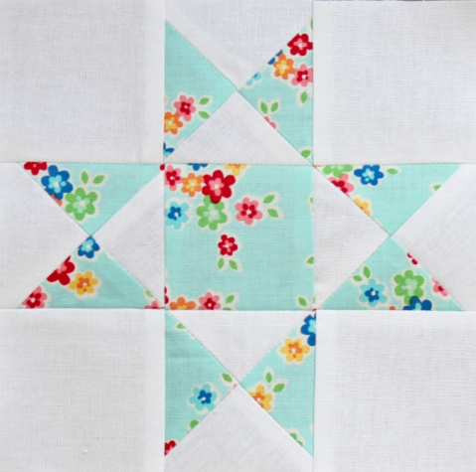Block of the Month

September

12” Square

Two + colors needed

Ohio Star is a nine-patch quilt block made with five plain squares and four quarter-square triangle units.

Fabric:

1 (Light) – Cut 2 squares – 5 ¼ “

2 (Dark) – Cut 2 squares – 5 ¼”

Corner (Light) – cut 4 squares – 4 ½ “

Center (Dark or Fussy Cut) - Cut 1 square – 4 ½ “

Technique:

Mark the diagonal of the two light #1 squares. With right sides together (RST), layer a #1 and #2 together. Stitch a quarter inch away from both sides of the line. Cut the units apart on the drawn line. Press towards the darker fabric. Repeat for both pairs.

At this point you have four half square triangles (HSTs).

Draw a diagonal line that bisects the sewn seam on two of these HSTs. With RST, sandwich a marked and unmarked HST, nesting the seam to make matching the center easier. Align the edges of the HSTs. Use pins to hold things in place if needed. Stitch a 1/4" inch from both sides of the drawn line. Repeat for the second pair. Cut the two apart on the marked line. Press.

You now have four quarter square triangles (QSTs).

At your cutting mat, align your square ruler over the QST. The diagonal 45-degree line matches the seamline. Using the Center Measurement of 2 ¼”, align that ruler mark with the intersection of the seams in the center of your block. Make sure nothing has shifted and then trim the two exposed sides. Flip the unit and repeat these trimming steps so that your QST is 4 ½” square. Repeat for the remaining three units. Press.

Lay out the cut squares and stitched QSTs into rows making sure the 'star points' point to the outside edges of the block. Stitch the units into rows and press rows in alternating direction. Stitch the rows together and press. Results in a 12 ½” square.