The Messenger
OCTOBER 2019

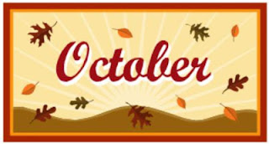

Ebenezer United Methodist Church
P. O. Box 307
220 Kansas Street
Murdock, NE 68407
Phone: 402-867-3191
Email: murdockumc1@gmail.com

St. Paul United Methodist Church
P.O. Box 130
400 West G St.
Elmwood, NE 68349-0130
Phone: 402-994-6735
Email: stpaulelmwood@gmail.com

Pastor Michelle Chesnut
Cell phone: 402-314-7988
Email: mchesnut@greatplainsumc.org
Website: elmwoodmurdockumc.com

WORSHIP HELPERS FOR OCTOBER
ELMWOOD
October 6
Greeters: Merle and Joyce Backemeyer
Scripture Reader: OPEN
Worship Refreshments: Carolyn Oehlerking
October 13
Greeters: Walter and Carolyn Oehlerking
Scripture Reader: Myrna Bornemeier
Worship Refreshments: OPEN
October 20
Greeters: Suzie Allgayer, Marcie Miller
Scripture Reader: Barb Minch
Worship Refreshments: Martha Ann Bornemeier
October 27
Greeters: OPEN
Scripture Reader: OPEN
Worship Refreshments: Joyce Backemeyer
MURDOCK
October 6
Greeters: Wayne and Helen Luetchens
Ushers: Dan and Liz Murdoch
Scripture Reader: Sherry Farmer
Donut Time: Bill and Sherry Farmer
October 13
Greeters: Tom and Linda Lawrence
Ushers: Gene & Bette Backemeyer
Scripture Reader: Kelli Brewer
October 20
Greeters: Debby Sampson
Ushers: Dave and Angie Friesell
Scripture Reader: Angie Friesell
October 27
Greeters: Hanson Family
Ushers: Dave and Angie Friesell
Scripture Reader: Angie Friesell

ANNUAL CHURCH CHARGE CONFERENCE FOR 2020
Sunday, October 27, 2019, 5:00 p.m.
New Hope UMC, 1205 N. 45th Street, Lincoln
All Church Members are invited to attend.

CHURCH COUNCIL MEETINGS
The Murdock’s Church Council meeting will be held on Tuesday, October 8, 2019 at 7:00 p.m.

The Elmwood’s Church Council meeting will be held on Tuesday, October 22, 2019 at 7:00 p.m.
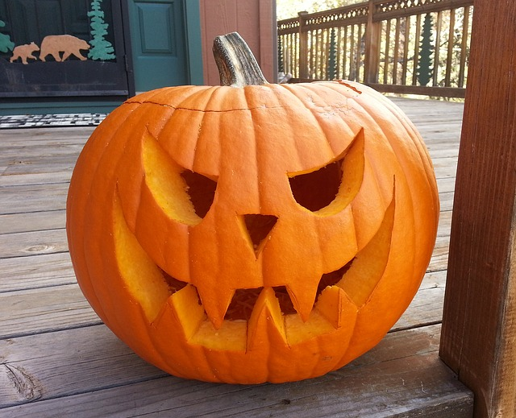

(UMYF is for all 7th-12th graders.)
Halloween Party at the Oehlerking’s
Sunday, October 20, 2019
3:00 p.m.-6:00 p.m.
Pumpkin carving, volleyball and
cooking over the fire pit
UPCOMING COMMUNITY EVENTS

Bess Streeter Aldrich House
During the month of October, Primitives Exhibit with demonstrations in the Garden

Also, Beginners’ Genealogy Workshop
Saturdays, October 5 and 19, 2019
1-2:30 p.m., Cost $15

American Red Cross Bloodmobile
Monday, October 7, 2019, 1-6:00 p.m.
Elmwood Fire Hall

Shop at Bits and Pieces
Sunday, October 13, 2019, 1:00-4:00 p.m.

Waffleman at Elmwood Fire Hall
Sunday, October 13, 2019, 9:00 a.m. to Noon
Sponsored by the Elmwood Rescue Squad

Cass County Food Pantry Distribution
Saturday, October 19, 2019, 9:00–11:00 a.m.
Elmwood Community Center

UMW CORNER

Next Meeting – Elmwood
Monday, October 7, 2019
Location: TBA
Lesson: Pledge to Mission

Next Meeting - Murdock
Wednesday, October 2, 2019, 5:45 p.m.

Blue River District Annual Meeting
Saturday, October 12, 2019
9:00 a.m. to 3:00 p.m.
St. Mark’s UMC, Lincoln

Monday Night Out-Buffet Dinner
Monday, October 28, 2019, 5:00-7:00 p.m.
Elmwood Community Center

Pancakes and More, Elmwood Fire Hall
Sunday, November 10, 2019, 7 a.m. – 1:00 p.m.
Hosted by American Legion Post 247

October Birthdays-Elmwood
Jerry Fleischman – October 12
Dominick Leone – October 12
Martha Bornemeier – October 12
Barbara Minch – October 14
Renee Holland – October 14
Rebecca Brettmann – October 14
Karen Rase – October 19
Nicole Wenzel – October 1
Andrew Rorie – October 2
Danielle Dunker – October 5
Maddie Zeorian – October 7
Audriana Romero – October 8
Derick Vogt – October 9
Robert Frederickson – October 10
Jeanne Spaulding – October 20
Tyler Rosenow – October 22
James Jicha – October 23
John Oehlerking – October 23
Shirley Bornemeier – October 25
Brayam Burrows – October 25
Owen Kunz – October 26
Ryan Rorie – October 29

October Birthdays-Murdock
Pastor Michelle Chesnut – October 18
Katie Bornemeier – October 25
Matt Rase – October 25
David Baumeister – October 28
Wayne Luetchens – October 29
Lane Mills – October 29
Aaron Panska – October 2
Brenda Stewart – October 4
Estelle Rase – October 6
Kylee Synovec – October 10
Renea Panska – October 14
Evelyn Schafer – October 14
Pat Bornemeier – October 18

PASTOR’S PEN

Happy October!
Here we are friends, October! I am anxiously waiting for the leaves to start changing colors and soon harvest will be in full swing. For me it brings great memories of my childhood. I didn’t realize until recently how much I have really missed living in a farming community. It feels more earthy, more human, more humble. It is a place of warmth and greatness.
When I think about my childhood, I think of the many hours that were spent at the church, whether it was in service, at handbell practice (which my mom played for years), or Christian Education Classes. They are memories filled with so much fun and time of great learning. So, for October my goal is to take us all back to our childhood a little.
We will be beginning a new sermon series called “Stories They Didn’t Tell You in Sunday School.” We will be looking at stories and characters that played a vital part in the story of the Bible but are often overlooked or neglected when it comes to our Sunday School curriculum. Reasons they are overlooked may have good reasons, such as the concepts are maybe too big for little children or they don’t have favorable characters in them. However, they are so important, so we will talk about what happens when our reputations are not always favorable, what it means when we feel like we may not have the more important part, respect and how trust in God leads to our joy.
We also have exciting things like confirmation really getting started, youth group events and on the 27th we have the community Trunk or Treat. All are invited to decorate a trunk in a fun, scary or fall theme and pass out candy to our community children. If you want to participate send us an email at the church office or call and let us know.
As we enter this season of physical harvest, let us remember that the Bible also talks about the soul harvest. Matthew 9:35-38 states: ³⁵ And Jesus went throughout all the cities and villages, teaching in their synagogues and proclaiming the gospel of the kingdom and healing every disease and every affliction. ³⁶ When he saw the crowds, he had compassion for them, because they were harassed and helpless, like sheep without a shepherd. ³⁷ Then he said to his disciples, “The harvest is plentiful, but the laborers are few; ³⁸ therefore pray earnestly to the Lord of the harvest to send out laborers into his harvest.” I challenge you that as we learn about these stories that we don’t focus on often, to think about what part you are playing in the preparing the harvest. I pray that we can explore our parts with some childlike excitement this month.

Blessings,
Pastor Michelle Chesnut
TRUNK-OR-TREAT
MISSION MESSAGE FROM EBENEZER U.M. CHURCH
Submitted by Linda Glantz

The Sunday morning Farmer’s Market is winding down. It will continue as long as members bring produce to share. When it ends, the donations will go to the Cass County Food Bank. Thank-you to those who shared fruits and vegetables and to those who made a donation after making their selection. You are appreciated!

Our collection of new and gently used children’s books will go to UNL’s Children’s Justice Clinic for low income children who are going through difficult times. Books are used to build rapport. When leaving, children may select a book to take home. Sunday, September 29 is our last opportunity to donate. Thank-you for making a difference in the life of a child!

Beginning January 2020, please consider serving as the Mission & Outreach coordinator to continue our service of helping others in need.
Come dressed in your costume to enjoy an afternoon of fun!
Date: Sunday, October 27th
Time: 2:00-4:00 PM
Place: Elmwood Christian Church Parking Lot
**Please park in the Elmwood Park parking lot.

**In case of rain, we will be set up inside the
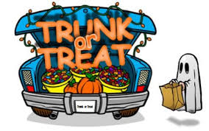Christian Church.

**Contact Deb Lenz with any questions at 402-450-3034.

VOLUNTEERS NEEDED! We would like your help with the second annual Trunk-or-Treat event hosted by the Elmwood Christian Church, Murdock Methodist Church and Elmwood Methodist Church. Let’s continue to make this a fun and safe event for the children of our congregations and communities. Please contact Deb Lenz (402-450-3034) if you will be joining us.

October 2019

Sun | Mon | Tue | Wed | Thu | Fri | Sat
 |  | 1 | 2 | 3 | 4 | 5
 |  | 1-5:00pm Church Office Hours-E | 9:00am-  3:00pm Church Office Hours - M  5:45pm UMW- Murdock | 1-5:00pm Church Office Hours-E
6 | 7 | 8 | 9 | 10 | 11 | 12
9:00am Worship Service - M  9:30am Sun. School –E  10:35am Worship Service – E | 6:30pm Cub Scouts - E  7:00pm UMW-E | 1-5:00pm Church Office Hours-E  7:00pm Church Council - M | 9:00am-  3:00pm Church Office Hours - M  6:15pm Bell Practice  7:30pm Choir Practice | 1-5:00pm Church Office Hours-E
13 | 14 | 15 | 16 | 17 | 18 | 19
9:00am Worship Service - M  9:30am Sun. School –E  10:35am Worship Service - E | Columbus Day | 1-5:00pm Church Office Hours-E | 9:00am-  3:00pm Church Office Hours - M  1:30pm Sew ‘N Sews - M  6:15pm Bell Practice  7:30pm Choir Practice | 1-5:00pm Church Office Hours-E |  | 9-11:00am Food Pantry Distribution
20 | 21 | 22 | 23 | 24 | 25 | 26
9:00am Worship Service - M  9:30am Sun. School –E  10:35am Worship Service – E  1:00pm Confirmation Class - E | 6:30pm Cub Scouts - E | 1-5:00pm Church Office Hours-E  7:00pm Church Council - E | 9:00am-  3:00pm Church Office Hours - M  6:00pm Confirmation Class - M  6:15pm Bell Practice  7:30pm Choir Practice | 1-5:00pm Church Office Hours-E
27 | 28 | 29 | 30 | 31
9:00am Worship Service - M  9:30am Sun. School –E  10:35am Worship Service - E  2-4:00pm Trunk or Treat – E  5:00pm Charge Conference, New Hope UMC, Lincoln |  | 1-5:00pm Church Office Hours-E | 9:00am-  3:00pm Church Office Hours - M  6:15pm Bell Practice  7:30pm Choir Practice | Halloween  1-5:00pm Church Office Hours-E

St. Paul United Methodist Church
P. O. Box 130
400 West “G” Street
Elmwood, NE 68349-0130

Address Service Requested

