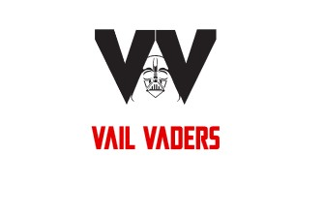
Thank you for your sponsorship of Vail Vader's Club Softball! We are happy to partner with you and your business and appreciate your support!
Vail Vaders Corporate Sponsorship Application

Business Name (as it should be published)

_____________________________________________________________________

Contact Name

______________________________________________________________________

Email/Phone

______________________________________________________________________

Address

______________________________________________________________________

Sponsored Player (if wish to name)

______________________________________________________________________

Sponsorship Level (circle)
Community ($200) Bronze ($500) Silver ($750) Gold ($1750)
Platinum ($5000) Other

Please make checks payable to Vail Vaders Sports
or send digital payments to Venmo @vailvaders or PayPal vailvaders@gmail.com
Thank you for your generosity!

