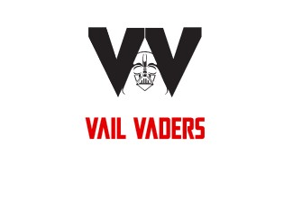
Date______________________

VAIL VADERS SPORTS INC
17220 S ALDER BROOKE WAY
VAIL, AZ 85641
EIN 92-3254678

Dear_____________________________________________,

Thank you for your corporate sponsorship of $_____________________ in value described as:

Monetary Donation ______check _______ cash _______ other

Vail Vaders Sports Inc. is classified as a 501(c)(3) non-profit organization by the standards of the Internal Revenue Service (IRS). Therefore, the donation may be tax-deductible to the extent allowed by law.

No goods or services were given in exchange for this donation unless expressly noted.

Thank you again for supporting Vail Vaders,

