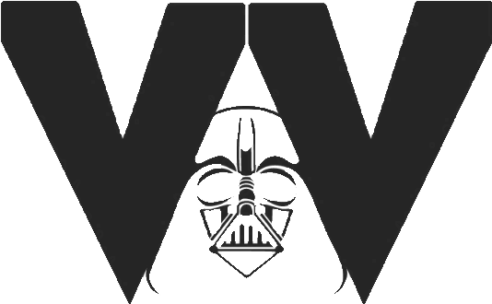



Introduction
On behalf of Vail Vader's Club Softball, I would like to invite you and your company to partner with us to assist our girls’ softball program. Vail Vaders was founded in 2022 out of a desire to provide competitive softball for players who reside in east Tucson, Rita Ranch, Vail, Corona de Tucson, Benson, Wilcox, and Sierra Vista. We are a non-profit, all-volunteer club softball team with a mission to provide a constructive learning environment where each player will excel, on and off the field, by using lessons and skills from the game of softball to succeed in the game of life.
Our mission: To provide a constructive learning environment where each player will excel, on and off the field, by using lessons and skills from the game of softball to succeed in the game of life.
Our Goals:
o Promote positive self-image, self-respect, and confidence
o Simultaneously teach valuable life and softball skills
o Teach the “student-athlete” mentality. We encourage academics and family life before softball
o Promote team building while coaching sportsmanship, accountability, discipline, and love of the sport
o Remove economic barriers by keeping costs low by removing unnecessary expenses and by fundraising
A critical step in preparing for our upcoming tournament season is securing corporate sponsors to help offset the costs of practice fields and tournament registration fees. As a corporate sponsor, we will do everything we can to maximize your exposure to our families, fans, as well as Facebook and website visitors.
If providing sponsorship for Vail Vader’s softball club is an option for you and your company, please review the following documents. I have included sponsorship levels as well as an application form. You can also find a digital copy of this letter on our website at: vailvaders.com.
I appreciate your consideration,
Sincerely,

