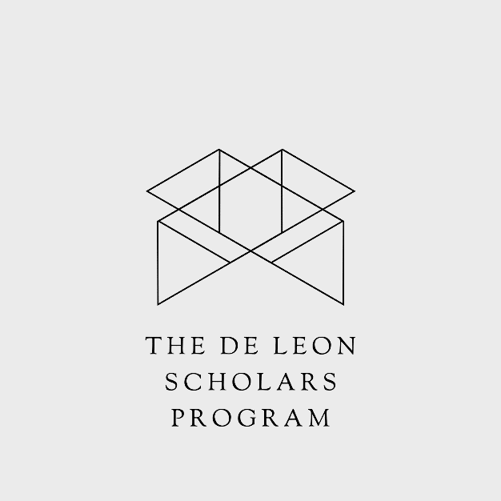

De Leon Scholars Program Application
PURPOSE:
The purpose of the De Leon Scholars Program is to recognize and reward students in the 9th – 12th grade who contribute to and make a difference at school, in their home, and community at large, and who are likely to continue to do so in the future. The Scholars Program encourages these dynamic individuals with financial support during their time in the Upper School and offers continued support with our global business and financial network as recipients put their talent, work ethic, and original ideas into action.
APPLICATION:
This is both a need-based and merit scholarship award.
REQUIREMENTS:
Applicants must:
- Be enrolled in the school that they are applying for the scholarship
- Complete the De Leon Scholars Program Application
- Remain in academic and disciplinary good standing
- Submit one or two letters of recommendation from a teacher or administrator
- Select applicants will interview with the De Leon Scholars Program representatives
- Be a role model or have contributed and made a difference in the lives of other students and community members
- Submit a one-page essay that describes your past and future objectives
- Complete the personal short answers below
All application materials must be submitted to deleon@deleonscholars.com by March 31st, 2023.

APPLICATION:
Student Name: ________________________________ Current Grade:_______
Email:___________________________________ Cell Phone:___________________
Address:______________________________City:_______________________ State:____
Top 3 College Preferences:
_______________________ _______________________ _______________________

Please answer each of the following short answer questions in 150 words or less.
- What traits do you possess that will help you be successful in your education and career?
- Name one thing that you believe to be true, that others do not agree with.
- Review a problem that you have solved and describe in detail how you solved it.
- Describe a challenge that you have encountered in your life and how you overcame it.
- Where will you be and what will you be doing in 5 years? 10 years? What will you be most proud of?

