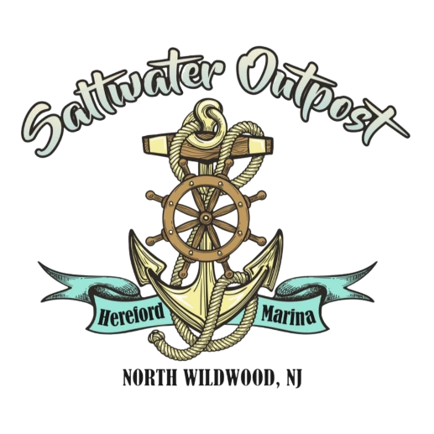
PONTOON BOAT RENTAL AGREEMENT AND RELEASE OF LIABILITY
Saltwater Outpost agrees to rent a pontoon boat to Renter on the dates and times provided below.
Renter Name: ______________________________
License # and State: _________________________________
Address: __________________________________
Phone: ____________________________________
Email: ____________________________________
Passenger Details
# Of Passengers: ________ Adults: _______ Children under 13: _______
Credit Card on File
Credit Card Number: __________________________ Expiration Date: ____________
Name on CC: ______________________________ Security Code: ______________
Rental Details
Pontoon: ____________________ Date: _______________________
__ AM (8a-12p) __ PM (1p-5p) __ All Day (8a-5p)
- $200 security deposit required
- $100/hour Late fee. There is no grace period. Be courteous to other bookings.

Saltwater Outpost agrees to rent a pontoon boat to Renter. The pontoon will contain the following items:
- Up to 12 regular adult life preservers
- 2 Child size life preservers (More upon request)
- First aid kit
- Fire extinguisher
- Anchor
Renter agrees to the following:
- That the pontoon is to be used solely by renter and his/her guests.
- That no more than total amount of passengers or weight as prescribed by the boat manufacturer are allowed on the boat.
- That the pontoon is not to be operated in a negligent manner.
- That the pontoon is not to be operated under the influence of drugs or alcohol.
- That the renter is the only person to operate the pontoon.
- That the pontoon boat will be properly moored when not in motion.
- That the equipment stated as the contents of the pontoon are present, and that renter is responsible for any damage or missing contents regardless of reason that occurs during the rental period.
- That renter has experience as to operation of a boat and is familiar with the laws and safety requirements of operating the boat, is at least 21 years of age and a licensed driver of a motor vehicle.
- Renter shall obey all state, federal and local Boating Regulations, laws, ordinances and lawful directives from appropriate emergency or law enforcement personnel, while operating or renting boats or equipment.
- Renter is solely responsible for any citation or violation occurring during the use of, or as the result of using, rental boats or equipment.
- That renter will ensure that all passengers will have properly fitted life jackets available.
- That renter is responsible for all damage to pontoon boat or to property of others. Including a charge for the necessity of excessive cleaning.
- That renter is responsible for any and all injuries that occur to himself, herself, passengers or third party during the rental period whether renter is the case of the injury
- That the renter agrees to hold Saltwater Outpost and Hereford Marina harmless from any claim by a passenger or third party for any damage that arises from the use of pontoon during rental period including reasonable attorney fees.
- Renter consents to security deposit being applied to any damage to pontoon, motor, prop, personal property of owner. That renter acknowledges he/she is responsible personally for damages above and beyond security deposit.
- That if renter experiences any issues, they will call Saltwater Outpost at the following number for any help or call 911 for emergency: 609-854-3806
- That this agreement shall be binding on renter’s heirs or assigns.
- That renter has read and understood the terms of the agreement and acknowledges that he/she has been instructed by Saltwater Outpost as to the operation of the pontoon.
- That further, renter acknowledges that owner is renting upon renter answering the above in a truthful manner.

RELEASE OF LIABILITY, PROMISE NOT TO SUE, ASSUMPTION OF RISK AND AGREEMENT TO PAY CLAIMS
In consideration for being allowed to participate in this activity, at the times and locations provided below, on behalf of myself and my next of kin, heirs and representatives, I release from all liability and promise not to sue Saltwater Outpost or Hereford Marina from any and all claims including claims of negligence, resulting in any physical or psychological injury (including paralysis and death), illness, damages, or economic or emotional loss I may suffer because of my participation in this activity, including travel to, from and during the activity.
I am voluntarily participating in this activity. I am aware of the risk associated with participating in this activity, which includes but is not limited to physical or psychological injury, pain, suffering, illness, disfigurement, temporary or permanent disability including (paralysis), economic or emotional loss, and /or death. I understand that these injuries or outcomes may arise from my own or others’ actions, inaction, or negligence. Nonetheless, I assume all related risks, both known or unknown to me, of my participation in this activity, including travel to, from and during the activity.
I agree to hold Saltwater Outpost and Hereford Marina harmless from any and all claims, including attorney’s fees or damage to my personal property, that may occur as a result of my participation in this activity, including travel to, from and during the activity.
If Saltwater Outpost and/or Hereford Marina incurs any of these types of expenses, I agree to reimburse Saltwater Outpost and/or Hereford
If I need medical treatment, I agree to be financially responsible for all costs incurred as a result of such treatment. I am aware and understand that I should carry my own health insurance.
I am 21 years or older. I understand the legal consequences of signing this document, including (a) releasing Saltwater Outpost and/or Hereford Marina from all liability, (b) promising not to sue Saltwater Outpost and/or Hereford, (c) and assuming all risks of participating in this activity, including travel to, from and during the activity.
I understand that this document is written to be as broad and inclusive as legally permitted. I agree that if any portion is held invalid or unenforceable, I will continue to be bound by the remaining terms.
I have read and understood this document, and by signing below, I am signing it freely. No other representations concerning the legal effect of this document have been made to me.

ACCEPTANCE
By completing the online rental reservation form and signing in the form field where indicated, the Renter accepts the terms of this Pontoon Boat Rental Agreement and Release of Liability.

___________________________ ______________________ ______________
Print Name Sign Name Date

Boat Rental Rules
By signing the field below, the Renter has read, understands, and accepts the Boat Rental Rules as displayed on the boat.

__________________________ _____________________________ ______________
Print Name Sign Name Date

