Watershed Regional Risk and Resilience
Playbook
The Watershed Regional Risk and Resilience Playbook offers guidance, tools, and resources to organize, conduct, and sustain stakeholder developed and managed collaborative initiatives to assess risk and enhance the resilience of watershed regions. The Playbook operationalizes a Nationwide Watershed Regional Risk and Resilience (R3) Goal & Strategy developed under the U.S. Army Corps of Engineer’s Dam Sector Regional Risk and Resilience Program (DSR3P). The Goal & Strategy and Playbook were produced by a national Task Group of practitioners and experts to help meet the urgent need to improve the resilience of the Nation’s watershed regions and the communities and critical infrastructures located within them.
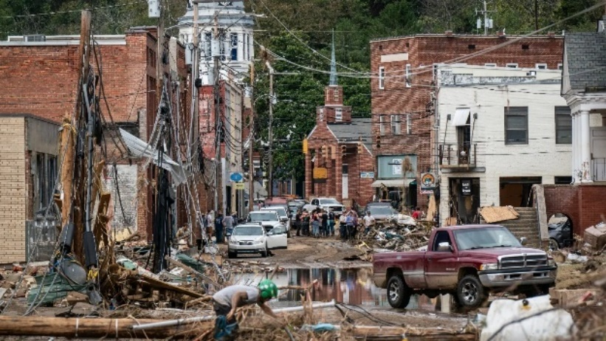
The Changing Risk Landscape. Watershed regions are being increasingly impacted by extreme weather events and other natural and manmade hazards of growing scope, scale, and costs with long-term deleterious effects on health and safety, the economy, the environment, and way of life.
Inter-related factors behind this trend include:
- Climatic changes resulting in an unprecedented increase in annual global temperatures, sea-level rise, and altered weather patterns;
- Critical infrastructure dependencies and interdependencies—cyber and physical linkages among watershed critical infrastructure functions and services and their supply chains that can exacerbate impacts of disasters and other events;
- Societal changes— ongoing expansion of people and infrastructure into rural and undeveloped areas that lack the resources necessary to devote to hazard prevention, preparedness, and mitigation.
Addressing the challenges of the changing risk landscape requires:
- Broad multi-stakeholder engagement and involvement to assess watershed regional risk and undertake planning, mitigation, and other resilience improvement actions Most of these actions will require cross-sector and jurisdiction collaboration in execution and investment.
- A continuous Holistic Approach and process with enabling tools and resources that public, private, and non-profit organizations can customize and use to work together to assess risk and improve resilience consistent with their interests and priorities.
The Holistic Approach:
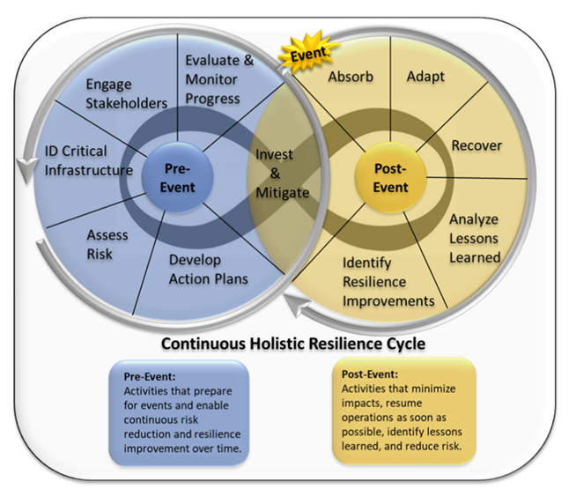
- Assesses regional risk and resilience needs and capabilities across the disaster management mission-space of preparedness, pre-event mitigation, response, recovery/restoration, and post-event mitigation, and includes protection and prevention.
- Requires an understanding of the ongoing relationship between pre-and post-event resilience planning and activities and the need for continuity and enhanced coordination among them; also investments to help assure the integrity of the interdependent critical infrastructures that support the watershed and communities within it.
Playbook Purpose, Anticipated Users, and What It Provides
The Playbook was developed for decision-makers, practitioners, and experts across all government levels and infrastructure sectors; private sector and non-profit organizations, associations and institutions; and regional governance bodies (e.g., councils of government and economic development organizations) with roles and responsibilities or vested interests in leading, facilitating, or contributing to a collaborative multi-stakeholder initiative to better understand risk and improve watershed regional resilience.
Towards this end, the Playbook is designed for users with differing levels of resilience-related knowledge, capabilities, staff, and financial resources. Users can adapt the Playbook guidance to fit their needs and available resources and employ any of the resilience guides or other planning resources cited in the Playbook depending on their interests and/or the requirements of the initiative’s sponsoring organization(s).
The Playbook offers guidance and selected tools and resources that can be customized for undertaking the continuous Holistic Approach with a multi-step process, providing a description of each step in the process and how to accomplish it:
- Laying the foundation with broad stakeholder engagement
- Characterizing regional infrastructures and designing the assessment
- Data collection
- Undertaking the risk assessment
- Developing an action strategy and implementation plan
- Identifying and securing resources and investment for implementation and sustainment, and
- Enabling continuous resilience improvement using lessons learned from future events, exercises, and best practices from other states and regions.
The Playbook also provides information on challenges decisionmakers and key stakeholders typically face and how to address them, including how to facilitate information-sharing, obtain necessary data, secure investments, and generate political will and community support. The Playbook in addition provides examples of Watershed Regional Resilience Initiatives that have employed a multi-step process.

Using the Playbook
The Playbook is organized into sections and subsections that describe how to outreach and engage key stakeholders and develop, conduct, and sustain a Watershed Regional Risk and Resilience Initiative. Each section and subsection provides the relevant guidance with a list of selected enabling tools and resources. Each reference is described with its type (fact sheet, backgrounder, guide or plan, database, software tool, training tool, study or report, website, PowerPoint presentation, or article, and what it provides with an access link to its host Internet site. Playbook users can scan the guidance for each of the topical areas and examine and choose relevant tools and resources to acquire background information or customize them for undertaking a Watershed Regional Risk and Resilience Initiative or to meet specific needs associated with assessing multi- risks, identifying gaps, mitigation and other risk reduction actions, and resilience capacity-building.
Watershed Regional Risk and Resilience (R3) Artificial Intelligence (AI) Assistant
Interested Playbook users can also choose to use the Watershed R3 Assistant to facilitate use of the Playbook. The R3 Assistant is a prototype artificial intelligence tools based that currently employs ChatGPT as the platform for user convenience. It was developed as a practical, AI-powered companion tool to the Playbook in recognition that many state and local agencies, regional organizations, and other potential users face significant time constraints, limited staffing, funding and other resources. The Playbook provides guidance on the R3 Assistant and how to use it and explains its benefits and limitations:
The Playbook lastly includes an Ask the Expert feature that provides contact information and areas of expertise of Task Group members available to answer questions about using the Playbook guidance, tools and resources, assist in using the Watershed R3 Assistant, or direct users to other useful information to help them improve watershed regional resilience.

For further information: (name and contact information to be added)

