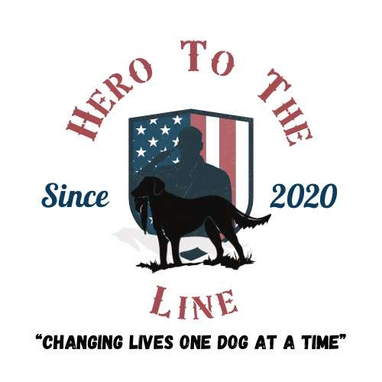
Application Form

Please answer the following questions.
The more detail you give will aid in the selection of you
becoming a recipient of the HTTL program.

Please email form back to Apply@hero2theline.org

Applicant Name:

Address:

Phone Number:

Best time for phone Interview?

Branch of Service:

U.S. Air Force
U.S. Army
U.S. Marine Corps
U.S. Coast Guard
U.S. Navy
U.S. Space Force
Retired
Gold Star Family

How did you hear about us?

Google
Event
Social Media
Word of Mouth
Staff Member

Tell us about your military career/civilian career/self?

What is your current living situation (house, apartment, etc) (land, access to training grounds, etc)?

Tell me about your work schedule / OPTEMPO (Operational Tempo)?

Have you ever owned a Labrador Retriever or any other type of working dog?

Do you have access to training grounds?

Do you have any waterfowl or upland experience?

How often/long do you think a dog would need to be trained?

Would you be willing to travel for training days / hunt tests, etc?

Are you willing to work toward a title for your dog in AKC/UKC hunt tests?

Do you understand there would be a financial commitment to the puppy for things such as training, tests, travel, etc.?

What are your thoughts on the topic of silver, charcoal, and champagne labs?

Please email form back to Apply@hero2theline.org

