Evacuation Shelter 1: Kauai Lagoon to Kilauea Elementary Shelter (12.8 miles)

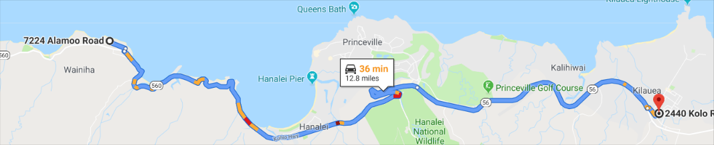
From: 7224 Alamoo Road, Haena HI 96714 Head southwest on Alamoo Rd toward Alealea Rd
131 ft then Turn left onto Alealea Rd 0.3 mi then Turn right onto Oneone Rd 289 ft Turn left at the 1st cross street onto HI-560 E 7.6 mi Continue onto HI-56 S 4.6 mi Head south on HI-560 E toward Wainiha Powerhouse Rd Then 7.3 mi Continue onto HI-56 S
Then 4.6 mi Turn left onto Kolo Rd
Then 0.2 mi Arrive at Shelter: 2440 Kolo Rd Kilauea, HI 96754

Evacuation Shelter 2: Kauai Lagoon to Kilauea Neighborhood Center (12.9 miles)

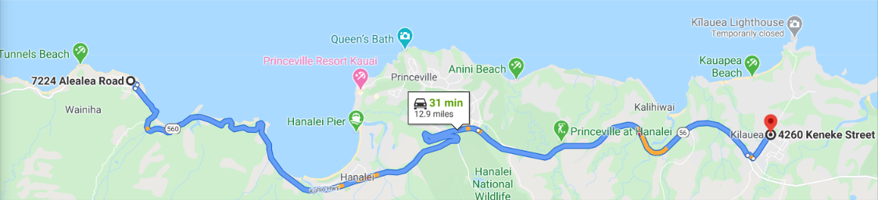

From: 7224 Alamoo Road, Haena, HI 96714 Take Alealea Rd to HI-560 E 2 min (0.3 mi)
Continue on HI-560 E to Kilauea 29 min (12.2 mi)
Then 4.6 mi Turn left onto Kolo Rd
Then 0.1 mi Turn left onto Kilauea Rd
Then 0.4 mi Turn right onto Keneke St
Then 85 ft Arrive at Shelter: 4260 Keneke St Kilauea, HI 96754`

What to do when evacuating:
- Gather water, food, clothing, emergency supplies, and insurance / financial records.
- Wear protective clothing and sturdy shoes.
- Secure your home.
- Turn off the main water valve and electricity, if instructed to do so.
- Let others know where you are going.
- Leave early enough to avoid being trapped by severe weather.
- Follow recommended evacuation routes.
Prior to departing for your Hawaii vacation set up emergency notification With Connect 5. This service allows officials to send text messages to cell phones, Personal Digital Assistants (PDAs), email accounts, and TTY/TDD receiving devices for the hearing impaired. Examples of civil defense emergencies include tsunamis; tropical cyclones; earthquakes; flash floods; and any other situation that could impact the safety, property, or welfare of Kauaʻi residents. To start receiving notifications, you can sign up online https://countyofkauai.bbcportal.com/, or call Kauaʻi Emergency Management Agency (808) 241-1800

Printable flyer https://www.kauai.gov/.../TsuFacts_11x17_2-fold%20ITIC_Kauai_nonbr_Final.pdf
a Safe Zone. • Study the Tsunami Evacuation Information also seen in the local Hawaiian Telcom White. Pages Telephone Book.

Planning for evacuation: Tsunami (pronounced soo-na-mee), sometimes called a tidal wave, is a series of enormous waves created by an underwater disturbance or earthquake. Tsunamis can move hundreds of miles per hour in the open ocean and smash into land with waves more than 100 feet high. All tsunamis are potentially dangerous, even though they may not damage every coastline they strike. Some waves in the series are less hazardous than others.
What to do if a tsunami threatens your area?
- If you are advised to evacuate, do so immediately.
- Stay away from the area until local authorities say it is safe. Do not be fooled into thinking that the danger is over when a single wave has come and gone. A tsunami is not a single wave, but a series of waves.
- Do not go to the shoreline to watch for a tsunami. When you can see the wave, it is too late to escape it.
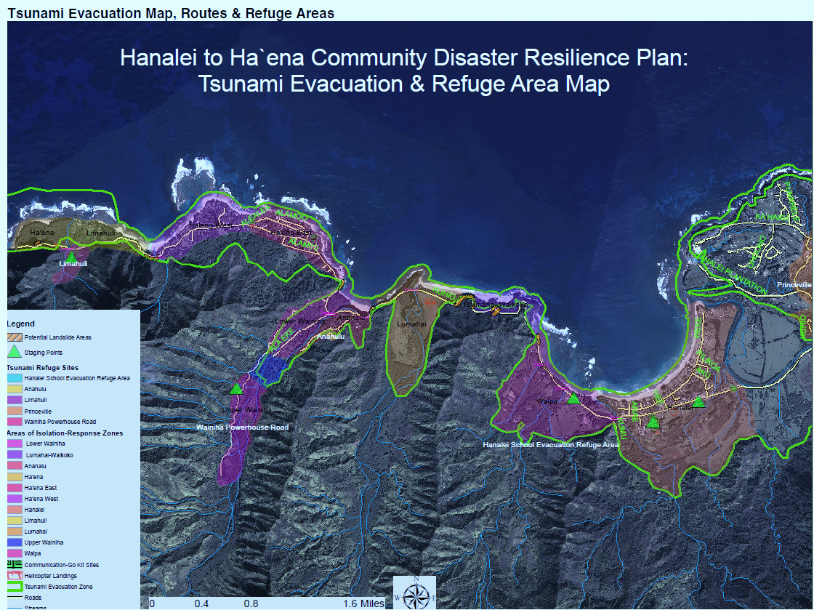

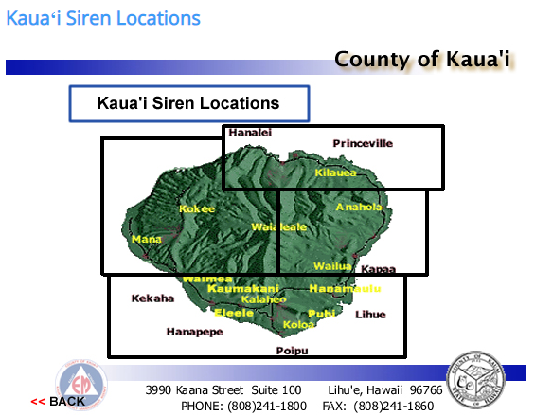

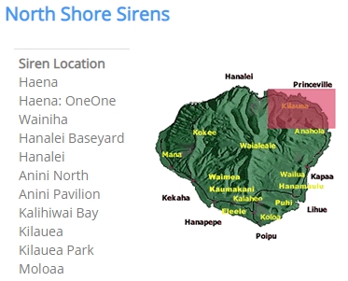

Tsunami Risk
Knowledge is safety. To reduce your risk, know your tsunami facts.

What is a tsunami?
A tsunami (Japanese for “harbor waves”) is a series of ocean waves produced by a sudden rise or fall in the earth’s crust, most commonly caused by an earthquake or underwater landslide.
In the open ocean, tsunami waves cannot be seen or felt by ships or airplanes because the waves are actually hundreds of miles wide, with a height of only a few feet. But as the waves approach the coast, their height increases dramatically and can be very destructive when they reach the shore.

Understand the Threat
- Tsunamis are Hawai'i's number one natural disaster killer.
- All low-lying coastal areas, harbors, streams, and rivers in Hawai‘i are vulnerable to tsunami impacts.
- Tsunamis can occur at any time. Earthquakes or landslides that may trigger tsunamis cannot be forecast.

Local Tsunamis vs. Distant Source Tsunamis
Locally generated tsunamis can arrive at the coast within minutes, even before a warning can be issued.
All islands are also vulnerable to distant-source tsunamis. These tsunamis result from distant earthquakes or landslides in places like Chile, Alaska, and Japan, and can arrive within hours.

Visit these resources for additional tsunami information:

Tsunami Warning

Know the Natural Warning Signs of a Tsunami - use your senses!

FEEL - Feel the ground shaking severely?
Head for higher ground. Strong local earthquakes may cause tsunamis.

SEE - See an unusual disappearance of water, or an oncoming wall of water?
Immediately leave low-lying coastal areas and move inland. As a tsunami approaches the shoreline, sea levels often recede, exposing the ocean floor, reef, and fish.

HEAR - Hear the roar?
An approaching tsunami may create a loud “roaring” similar to the sound of a moving train or jet aircraft

Official Tsunami Warnings
NOAA’s Pacific Tsunami Warning Center (PTWC) is responsible for tsunami monitoring and issuing necessary watches or warnings for Hawai‘i and the U.S. Pacific Islands.

Tsunami Message Definitions
Tsunami Warning: Take Action- Danger! A tsunami that may cause widespread flooding is expected or occurring. Dangerous coastal flooding and powerful currents are possible and may continue for several hours or days after initial arrival. Follow instructions from local officials. Evacuation is recommended. Move to high ground or inland (away from the water).
Tsunami Advisory: Take Action- A tsunami with potential for strong currents or waves dangerous to those in or very near the water is expected or occurring. There may be flooding of beach and harbor areas. Stay out of the water and away from beaches and waterways. Follow instructions from local officials.
Tsunami Watch: Be Aware- A distant earthquake has occurred. A tsunami is possible. Stay tuned for more information. Be prepared to take action if necessary.
Tsunami Information Statement: Relax- An earthquake has occurred, or a tsunami warning, advisory or watch has been issued for another part of the ocean. Most information statements indicate there is no threat of a destructive tsunami.

Emergency Information
The Emergency Alert System, often called the EAS, is used to notify the public of approaching hazards. The EAS will be activated along with other warning methods such as the Outdoor Siren Warning System, Wireless Emergency Alerts, and local emergency notification systems.
If you are alerted about a tsunami hazard by any of the above methods, turn on the nearest radio or television and listen for emergency information and instructions.
Foreign language emergency broadcasts can be found on the following stations: KZOO 1210AM (Japanese), KREA 1540AM (Korean), and KNDI 1270AM (variety of Pacific Islander languages).
Hawai'i Emergency Management Agency

Tsunami Evacuation
If you are in a low-lying area near the coast or in the tsunami evacuation zone and you feel shaking that causes you to fall or have difficulty standing, get to higher ground immediately. A locally generated tsunami could reach the shore within minutes!

Evacuation Tips
Tune in to your local television or radio stations for the most up-to-date information about tsunami evacuation centers in your area.
For questions about evacuation procedures in your community, contact your county civil defense agency:
- City and County of Honolulu Department of Emergency Management
- Maui Civil Defense Agency
- Kauai Civil Defense Agency
- Hawai'i County Civil Defense Agency

When Sirens Sound
Follow the instructions issued by local officials. Tune in online, on TV, Radio or talk to your neighbors.
If you are in the evacuation zone (Hanalei, Haena, Wainiha), prepare to move inland. If located outside a tsunami evacuation zone, stay outside of the evacuation zone and limit all non-emergency travel.
For strong local earthquakes, if you have access to an undamaged concrete or steel reinforced building of ten or more stories, move to the fourth floor, or above, and stay put.
For distance-source tsunamis, you may have more time to react. A Tsunami Warning will be issued three or more hours before the estimated arrival time. If you are in the evacuation zone when the warning sirens sound, prepare to move inland, or if you have access to a concrete or steel reinforced building of six or more stories, move above the third floor and stay put.

- Avoid traffic gridlock! It may be safer and more efficient to walk out of the tsunami evacuation zone.
- Remain outside the evacuation zone until local officials tell you that it is safe to return.
- Do not use your telephone or make calls on your cell phone except for emergencies (texting and data use is ok).
- Save yourself, not your possessions.
- Remember, all public schools in tsunami evacuation zones have emergency evacuation plans in the event of a Tsunami Warning.

Tsunami Plan
You cannot prevent a tsunami, but you can be prepared for one. Actions you take now could save your life and the lives of your loved ones.

Develop a Family Emergency Plan
Prepare yourself and your family for a disaster by making an emergency plan. Your family may not be together when disaster strikes, so it is important to plan in advance.
Create your Family Emergency Plan, and visit the Hawai‘i Emergency Management Agency website for more preparedness information.

Assemble an Emergency Preparedness Kit
Emergency kits should contain the essentials your family needs to survive during a disaster. You may be on your own for three days or more before emergency personnel reach you.
Download the Emergency Preparedness Kit Checklist

Plan Ahead
Become familiar with potential evacuation routes, develop an evacuation plan, and update your plan when issues arise. Practice your evacuation plan at least twice a year with your family so that when a tsunami occurs, you are prepared to act! Keep in mind that hundreds of families in your area share the same concerns, and it may be difficult to access supplies because of shortages and competition.

