

**Autumn 2019**

**Please mail all donations/correspondence to: PO Box 914**

**Webster, NY 14580**

Please note: If you have a direct monthly withdrawal from your checking account to us, please be sure to change our address with your bank.

2018-2019 Bible Clubs

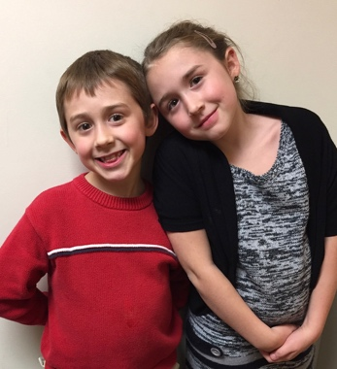Thanks to your donations along with all of our volunteers at Empire State Bible Clubs we are able to reach more and more children each year in our after school Bible clubs! This year we held clubs for children in the following schools: Webster State Road, Webster Klem North, Newark Kelley, Newark Perkins, Newark Lincoln and Marion Elementary. We started the Marion club this past year with these two children who signed up at the Wayne County Fair last summer. They each invited friends and at the end of the year we had 5 children attending that club regularly. We are excited to watch this club grow!

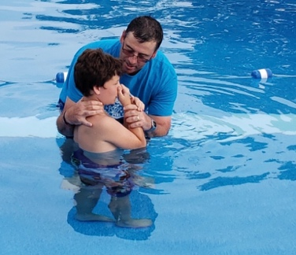One of our Bible Club teachers tells of a young child that comes to club each week. Even though this youngster is sometimes chatty and seemingly not paying attention, the teacher was amazed when he was able to correctly answer questions from the previous week’s Bible lesson. Is God’s word powerful? Are children listening? Praise the Lord we can say a resounding, yes! This year we are also planning to open a club in Williamson.

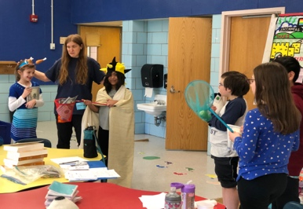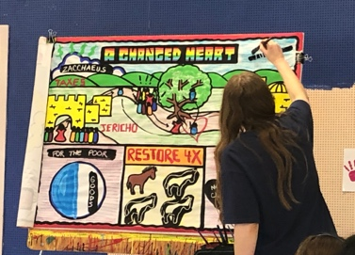

ESBC Bible club at State Road School in Webster

Wayne County Fair Aug 12-17 & Canal Town Days Parade Sept 14

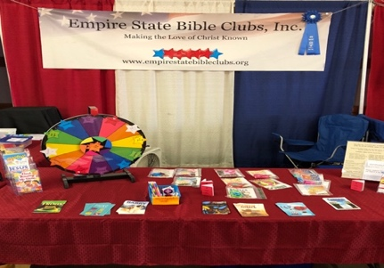We are always thankful for the opportunity to represent the Lord through ESBC. This year at the Wayne County Fair we were in contact with more than 700 parents and children that came to our booth. We had several people that signed up for our mail in Bible Club lessons. On September 14 at 4pm we will march in the Canal Town Parade in Palmyra and hand out 1400 packets that will contain a Bible Club permission slip, piece of candy and a tract.

# **Ephesians 2:8**

# **8**For by grace are ye saved through faith; and that not of yourselves: it is the gift of God:

## Summer 2019 Bible Camp

Ready, Set, Go! This was the camp theme at Ontario Bible Camp for the 2019 season based on Hebrews 12:1, and let us run with endurance the race set before us. Because of your generous gifts, we were able to help 10 children attend Bible Camp! This year the Fritzi Irwin Memorial Camp Scholarship was awarded to Elisha & Isaiah Wheeler. During the week at camp, each camper enjoys Bible time, small group time, memory work, personal devotions, and activities such as archery, biking, kayaking, crafts, and swimming. Located on the shores of beautiful Lake Ontario in Oswego NY, OBC has been proclaiming the good news of the Gospel for nearly 100 years. This summer, in July and August, young people ages 8-17 built friendships, made memories, and grew in their relationship with Christ as they spent a week at OBC. In her own words, a girl from one of our Bible Clubs said, “I had the most fun at camp with friends I knew from last year.” Your financial giving to ESBC makes it possible for children from our Bible Clubs to attend camp; some would not be able to go without your support. The boy pictured above made a decision to be baptized while at camp. Thank you for your gifts! They have eternal blessings.

## Mailbox Club These colorful, fun and instructive correspondence Bible lessons are free and available to any child 4+ years who is interested in joining. They are good for children that are homeschooled, those that do not have an after-school Bible club in their school during the year or our Bible club kids during the summer months. The child will receive a certificate upon course completion and small prizes when completing each lesson as a way of encouragement. If interested, please contact Lorri at [LorriErbland@gmail.com](mailto:LorriErbland@gmail.com) or [EmpireStateBibleClubs@gmail.com](mailto:EmpireStateBibleClubs@gmail.com) or you may write to ESBC.

Volunteer appreciation

We are thankful for all of our teachers and helpers that volunteer their time to ESBC. Please keep them in your

Request or Update your ESBC newsletter preferences To request a newsletter, or to update your current preferences, please contact us. This can be done either by a request through mail, by emailing us your preferences at EmpireStateBibleClubs@gmail.com , or by calling Lorri Erbland at (585)265-4548. If you email us, please be sure to include your name and any other pertinent information.

Donations/Contributions ESBC is an independent Christian faith ministry supported solely on donations from our home Churches, friends, and supporters. We are a 501(c)3 non-profit organization and therefore donations are tax deductible. Donations are used for things such as Bibles, teaching supplies, and helping children to go to a Christian summer camp. All ESBC teachers, helpers and fair workers are volunteers and are not paid, so all money that is received goes directly back into the clubs for the children. If you would like to make a donation to help support the ministry, please indicate where you would like your funds to be used by writing on the memo line of your check. If there is no indication on the check, we will use it where it is most needed. We appreciate your donations as we could not continue to reach boys and girls without your generous support!

Board Members

Judy MacCheyne – President Barry MacCheyne – Vice President

Carolyn Foell – Treasurer Betty Peters – Secretary

Lorri Erbland Katie Decker

Dawn Salatino Raphael Spezio

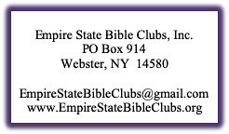

prayers as we start a new year of clubs in October. Our teachers and helpers are Erin, Regina, Tracy, Katie, Dawn, Jessica, Nate, Gordon, Bethany, Rachel, and Caleb.

We have additional volunteer opportunities available. If you are looking to volunteer for an hour of at home work, be an occasional helper at one of our clubs or commit as a one day a week Bible club teacher or helper from Oct-May, we have opportunities for you to do so. We will not pressure anyone into doing more than they would like to do. Please contact us at [EmpireStateBibleClubs@gmail.com](mailto:EmpireStateBibleClubs@gmail.com), print and complete the volunteer application on our website and return to us, or call Lorri Erbland at 585-265-4548 for more information.

## Charles In India

Charles is a missionary in India and a longtime friend of the Founder of ESBC, Vada Bullock. Charles teaches in several villages where he is able to reach many children and their families. If you would like to make a donation to this ministry, Laura Smoot (Vada’s daughter) will be gathering the donations and sending them on to Charles. Please make checks payable to Laura Smoot and mail to her at 10405 Erie Rd. Parrish, FL 35219. Please indicate on your check memo line “Charles”. Charles has also requested for us to pray for the training and spiritual growth of newly emerging young ministers in the villages of India, for more people to listen and accept Jesus as their Savior, and for Charles and his family.

Memorial Gifts

We are thankful for memorial gifts that were received in memory of Mary L. Decker, Lisa Lilley, Earl Lilley, Evalyn & George Schaefer and Linda MacCheyne. Your generous donations in memory of your loved ones are being used to support this important ministry.

Prayer Requests

- For the administrations in schools to value the importance of our Bible Club ministry

-For salvation of Bible club children along with their families

-For a 10-year old girl whose father died recently

-For children whose parents are incarcerated

-For children who live in homes where there are addictions

-For wisdom for the ESBC Board of Directors as important decisions are made

-For more volunteers – teachers, helpers, workers for our fair booth next year, at home helpers preparing crafts, and other things we need help with

-For necessary funds for ESBC to operate so we can reach more children & help send children to Christian summer camp

Happy 98th Birthday to Vada Bullock,

ESBC Founder and President Emeritus!

Vada Bullock turned 98 years old this year on Sept 9. If you would like to send Vada a card, letter, or message she can be reached on Facebook or at: Rivera Palms Rehab/Vada Bullock

926 Haben Blvd, Room 205A

Palmetto, FL 34221

John 3:16

For God so loved the world, that he gave his only begotten Son, that whosoever believeth in him, shall not perish but have everlasting life.

John 3:17

For God sent not his Son into the world to condemn the world; but that the world through him might be saved.