Bee Photo Helper
Lesson 1 Patterns Are Everywhere
Name ________________________ Team ________________________
A school garden team wants help organising insect photographs. You will compare real examples, record your predictions and design a helper that asks for review when the evidence is unclear.
Our learning goals
□ I can describe a repeating pattern
□ I can group photos using a shared feature
□ I can explain how an AI model can use labelled examples
□ I can explain why missing or misleading examples matter
A repeating unit
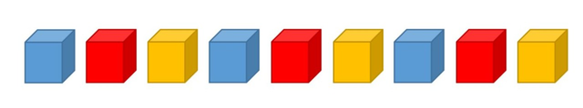
The repeating unit is __________________. If it continues, the next colour is __________________.
Create a pattern with three classroom objects or actions. Describe the unit and repeat it three times.
_________________________________________________________________________________________________________________________
Words for today
Word | Meaning
Feature | A property or clue we can observe or measure.
Label | The category given to an example, such as BEE.
Prediction | The category a model suggests for a new example.
The photograph cards contain source labels. Our paper guide is a prototype made by people. A real machine learning model learns patterns through software.
Pattern image: NSW Department of Education. Source links and image credits appear on page 8.
The same photos sorted in two ways
Use labelled reference cards A–D on page 6. A group needs a shared visible feature. Use “not visible” or “cannot tell” when a useful detail is hidden.
Sorting rule | Group names and photo letters
1 A feature of the insect________________________
2 A different feature or background________________________

One photo moved groups because _________________________________________________________________________
_________________________________________________________________________________________________________________________
Real bee length examples
Bee example | Approximate length
Quasihesma bee | 2 mm
Sugarbag bee | 4 mm
Blue banded bee | 11 mm
Teddy bear bee | 12 mm
Great carpenter bee | 24 mm
The difference between the longest and shortest is __________ mm.
Extension: 24 mm is __________ times as long as 2 mm.
Source: Get into STEM, Bee Habitat. The values describe example lengths. Photos are enlarged by different amounts, so do not measure the printed insects to find their body lengths.
Our first guide and test record
Our helper is for ______________________________. Guide version V1
We compare these two visible clues with the labelled examples:
_________________________________________________________________________________________________________________________
_________________________________________________________________________________________________________________________
We choose UNSURE and ask for review when _____________________________________________________________
_________________________________________________________________________________________________________________________
Keep the guide unchanged while you predict E–H. The teacher will give you page 7. Record BEE, OTHER INSECT or UNSURE. Explain what you can see or what is missing.
Photo | Prediction before reveal | Visible clue or missing information | Source label after reveal
E
F
G
H

Correct definite predictions _____ Incorrect definite predictions _____UNSURE _____ Check: all three counts together equal 4.
One result surprised us because ____________________________________________________________________________________ A reasoned UNSURE can identify a missing clue. These four photos do not measure how accurate a real AI system would be.
Our improved Bee Photo Helper
Team __________________________ Prototype version V2
Reference photo ____ has the checked label ______________________________Reference photo ____ has the checked label ______________________________
The comparison guide we would use now
_________________________________________________________________________________________________________________________
_________________________________________________________________________________________________________________________
An uncertain image goes to ______________________________________________________________________________
One better example we need
We want a new photograph showing ____________________________________________________________________
_________________________________________________________________________________________________________________________
It would help because ____________________________________________________________________________________
_________________________________________________________________________________________________________________________
Our evidence for the change
Photo ____ challenged our first idea. We changed _______________________________________________________
_________________________________________________________________________________________________________________________
On revisiting that photo, our prediction or explanation is now _______________________________________
_________________________________________________________________________________________________________________________
We have now used this photo to improve the guide. A fair new test would use a different photograph that we have not used to design it.
Our one minute pitch
Show your sorting rule, one actual test result and your improvement. Explain where software would learn from examples in a real AI system. Ask your partner which new photograph they would test next.
Individual exit ticket
Name __________________________ Date __________________________
1. A B C A B C A B C What is the repeating unit? What comes next if this rule continues?
_________________________________________________________________________________________________________________________
_________________________________________________________________________________________________________________________
2. Name a shared feature that could group two of today’s photos. Give their letters.
_________________________________________________________________________________________________________________________
_________________________________________________________________________________________________________________________
3. How can labelled examples help an AI model recognise a new photograph?
_________________________________________________________________________________________________________________________
_________________________________________________________________________________________________________________________
4. A model only sees honey bee examples. What might it miss? Name one example you would add.
_________________________________________________________________________________________________________________________
_________________________________________________________________________________________________________________________
5. Did our paper guide train itself? Who changed it?
_________________________________________________________________________________________________________________________
_________________________________________________________________________________________________________________________
□ I can support my idea with a photo. □ I would like another example.

Labelled reference cards A to D
Use these examples for sorting and designing guide V1. Each label comes from the image source. Flower backgrounds and stripes occur in more than one category.
PHOTO A  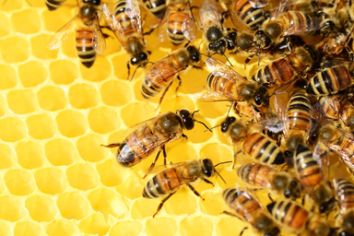  Honey beesBEE  Pixabay via Bee Habitat | PHOTO B  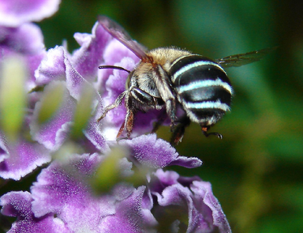  Blue banded beeBEE  Louise Docker / CC BY 2.0
PHOTO C  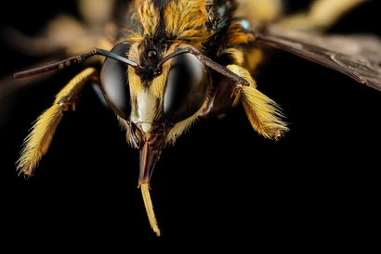  Great carpenter beeBEE  Sam Droege / public domain | PHOTO D  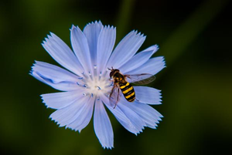  Hover flyOTHER INSECT  Steve Schoof / NCSU via Agriculture Victoria
Cut between cards if helpful. Full image credits and links are on page 8.

New photographs E to H
Teacher holds this page until guide V1 is complete. Record your predictions on page 3 before checking the names or credits on page 8.
PHOTO E  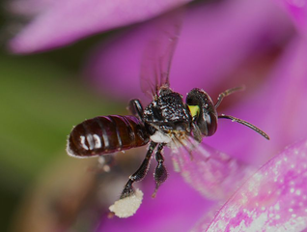  BEE / OTHER INSECT / UNSURE  Graham Wise / CC BY 2.0 | PHOTO F  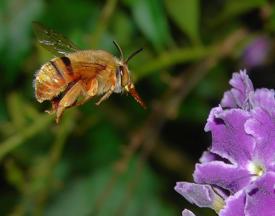  BEE / OTHER INSECT / UNSURE  Louise Docker / CC BY 2.0
PHOTO G  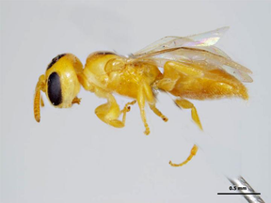  BEE / OTHER INSECT / UNSURE  K. Walker / PaDIL, CC BY 3.0 AU | PHOTO H  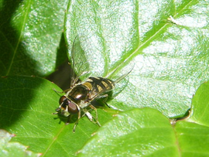  BEE / OTHER INSECT / UNSURE  Ashley Walsh / ABC Adelaide via Agriculture Victoria
These photos have different views and scales. Keep the scale bar in photo G. If you cannot see a useful clue, explain what information you need.

Sources and photograph credits
Read this page after the first predictions are recorded. A–C and E–G are bees. D and H are hover flies, which belong in OTHER INSECT. Different photographs can make related animals look very different.
Learning context and original bee photographs Get into STEMhttps://www.getintostem.edu.au/educators/stem-lesson-plans/lessons-for-years-5-6/bee-habitat/
A Honey bees Pixabay via Bee Habitathttps://pixabay.com/photos/honey-bees-beehive-honey-bees-326337/
B Blue banded bee Louise Docker CC BY 2.0https://commons.wikimedia.org/wiki/File:Australian_Blue_Banded_Bee-Best_viewed_large.jpg
C Great carpenter bee Sam Droege Public domainhttps://www.flickr.com/photos/usgsbiml/31416596982
E Sugarbag bee Graham Wise CC BY 2.0https://commons.wikimedia.org/wiki/File:Tetragonula_carbonaria_(14521993792).jpg
F Teddy bear bee Louise Docker CC BY 2.0https://commons.wikimedia.org/wiki/File:Aussiegall_-_Not_you_again_(by).jpg
G Quasihesma bee K. Walker PaDIL CC BY 3.0 Australiahttp://www.padil.gov.au/pollinators/pest/main/138841/17545
D and H Agriculture Victoria Hover flieshttps://agriculture.vic.gov.au/biosecurity/pest-insects-and-mites/non-pest-insects-and-invertebrates/hover-flies
Pattern image NSW Department of Educationhttps://education.nsw.gov.au/teaching-and-learning/curriculum/literacy-and-numeracy/teaching-and-learning-resources/numeracy/patterns
D photograph: Steve Schoof, North Carolina State University. H photograph: Ashley Walsh, ABC Adelaide. Images retain their original content and proportions. Bee images come from the linked Bee Habitat presentation; some have been converted to PNG for printing.
CC BY 2.0: https://creativecommons.org/licenses/by/2.0/CC BY 3.0 Australia: https://creativecommons.org/licenses/by/3.0/au/Sources checked 3 October 2026. The Teacher Guide includes the research and curriculum references.

