Declination of The Pfizer-BioNtech COVID-19 Vaccination
My employer or affiliated health facility, Brownway Residence, Inc. , recommends that I receive The Pfizer-BioNtech COVID-19 vaccination to protect myself, patients, staff, and others in the healthcare facility.
I acknowledge that I have received, read and understand the Fact Sheet given to me titled, FACT SHEET FOR RECIPIENTS AND CAREGIVERS EMERGENCY USE AUTHORIZATION (EUA) OF THE PFIZER-BIONTECH COVID-19 VACCINE TO PREVENT CORONAVIRUS DISEASE 2019 (COVID-19) IN INDIVIDUALS 16 YEARS OF AGE AND OLDER. I also acknowledge that I can go to the website to see updated Fact Sheets at https://www.cvdvaccine-us.com/ .
Despite these facts, I am choosing to decline influenza vaccination for the following reasons:
________________________________________________________________
________________________________________________________________
________________________________________________________________
________________________________________________________________
I also understand that after the dates of the Pfizer-BioNtech COVID-19 vaccination clinic at Brownway Residence, it is unknown of when I could receive the vaccination if I change my mind.
I have read and fully understand the information on the declination form.

____________________________________________ ____________________
Signature (Resident/Staff/Guardian) Date

____________________________________________ ____________________
Name Printed Date
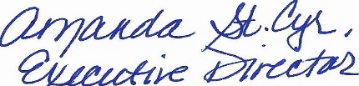
01/13/2021
____________________________________________ ____________________
Amanda St.Cyr, Executive Director Date

