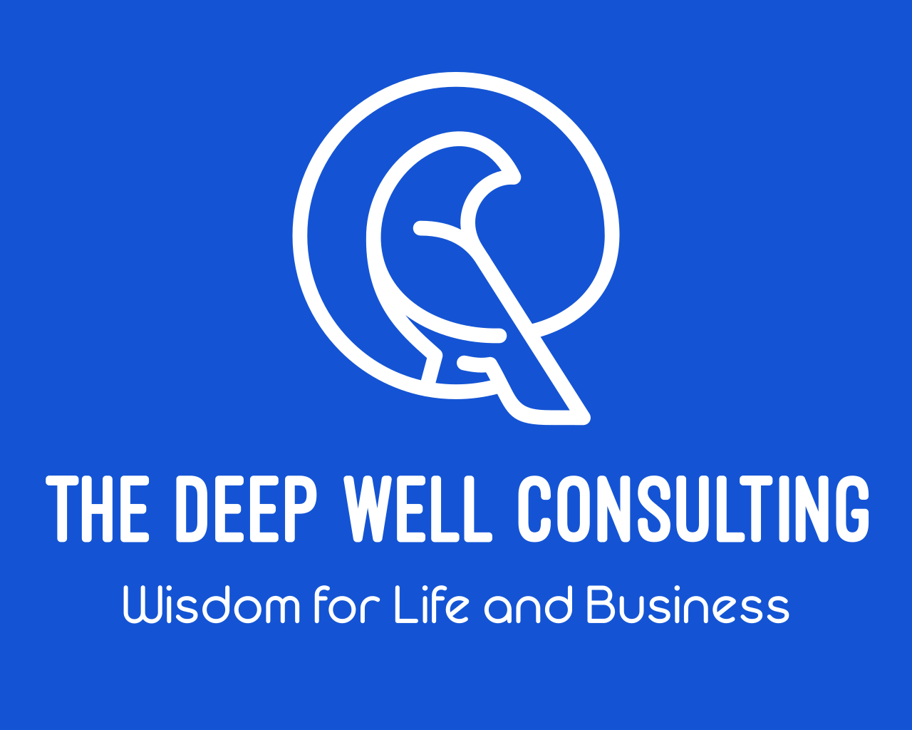

Client Information and Practice Policies

Effective communication is essential in a good, therapeutic relationship. I value our relationship and want to be able to provide the most clear and transparent answers to questions frequently asked in counseling. These are the policies and practices I utilize here at The Deep Well both to maintain a therapeutic relationship, but also to be respectful of the needs of my clients.

HIPAA Notice of Policies and Practices to Protect the Privacy of Your Health Information:

As healthcare professional, we are required by state and federal laws to maintain the privacy of your health information. Your confidence in me to strictly protect your privacy is extremely important. A copy of The Deep Well Notice of Privacy Practices is available for viewing, or your personal records, at any time.

This Notice of Privacy Practices describes how The Deep Well may use and disclose your protected health information as well as your rights to access and control it. “Protected health information” (PHI) is information about you, including demographic information, that may identify you and that relates to your past, present or future physical or mental health and related health care services.

Fee Policy:

The fee is $175.00 for the initial session and $125.00 for follow-up sessions

Intake and Follow up Sessions are 50 minutes. It is customary to pay professional fees at each visit..

Appointments and Scheduling:

I have office hours Monday through Friday. I schedule my own appointments as an independent practitioner and while most appointments are made at the conclusion of each regular appointment, I can also be reached by email at carri@thedeepwellconsulting.com. Reminder emails are made as a courtesy to clients. Do not respond to these automatically generated emails as I will not get your response. Please know that appointments are ultimately the responsibility of each client.

I keep an ongoing cancellation list for those who are unable to schedule an appointment that is convenient for their schedule. Please ask to be added to the cancellation list if you find yourself in this situation.

Usually multiple calls and messages are made to fill an appointment with it being offered to the first returned call. Please make sure your contact information and preferences are up to date.

Tardiness:

Appointment times are provided at the time of scheduling. It is important that you are on time for your scheduled appointment. If you are late to your appointment, you may be asked to reschedule and you may be charged a late cancellation fee if you need to be rescheduled due to tardiness.

Cancellations and No Shows:

Please provide at least **48 hours** notice if you need to cancel an appointment. I keep a cancellation list for clients who are waiting an appointment. The advanced notice allows me to offer the cancelled appointment to someone on the waiting list. Late cancellations and missed appointment are charged your normal session rate. Exceptions are made for circumstances which are beyond your control. Because I believe that consistency and commitment are part of the therapeutic process, two (2) no-shows and multiple cancellations will result in dismissal from services. If this occurs and continued care is recommended,I will provide referral information at the time of dismissal.

Confidentiality:

Tennessee law provides strict protection for clients seeking mental health services; all information regarding services is controlled by the client and is not to be released to anyone without the client’s written authorization.

There are, however, two exceptions in which mental health professionals may be required to breach the rule of confidentiality. First, in an emergency where there is imminent danger to the client or other person(s), the mental health professional must act so as to protect the lives of those involved and may breach confidentiality to assure such protection. Second, in cases of child abuse, or abuse of an incapacitated adult, mental health professionals are required to act to protect the child or incapacitated adult from abuse and must breach confidentiality to do so.

Credentials:

Carri McClellan is a Licensed Professional Counselor with the additional Mental Health Service Provider designation as well as as being an approved clinical supervisor in the state of Tennessee.

Ms.McClellan adheres to the statutes of the American Counseling Association Code of Ethics.

Gifts:

Licensed Professional Counselors are unable to accept gifts of monetary value from clients.

Social Media Policy

Email Communication:

I use email communication only with your permission and only for administrative purposes unless we have made another agreement. Please understand that my email address includes my contact information, and therefore, may indicate to others that you participate in counseling with Carri McClellan. Email exchanges should be limited to changing appointment or other general issues. Please do not use email to send content related to your therapy sessions, as email through my GMAIL is not secure or confidential.

You may email a request to call you if you need to talk to me prior to our next session. If you do, please include your contact information. All emails are printed out and kept as part of your legal medical record. Please do not use email to communicate with me during a crisis or emergency. While I try to check email regularly, you need to call me directly at the office during office hours for emergencies. If I am unable to immediately respond to your call because I am with another client, or it is outside of office hours, please call 911, the Tennessee Crisis Line at 855-

274-7471, or proceed to the nearest emergency room.

Text Messaging:

Because text messaging is a very un-secure and impersonal mode of communication, I do not text message to, nor do I respond to text messages from anyone in treatment with me. Please do not text message me unless we have made other arrangements.

Social Media:

I do not communicate with, or contact, any of my clients through social media platforms like LinkedIn or Facebook.

Please do not try to contact me in this way as I will not respond. Your privacy is my primary concern and I also want to maintain a healthy therapeutic relationship. Interaction through these forms of social media is prohibited by me through the American Counseling Association Code of Ethics and I also believe that this type of contact can blur boundaries and have a potential to negatively impact our professional relationship and your care. If I discover that

an accidental online relationship has been established with you, please know that I will cancel that relationship when I become aware of it.

I do not accept friend or contact requests from current or former clients on any social networking site (Facebook, LinkedIn, Twitter, etc.) I believe that adding clients as friends or contacts on these sites can compromise your confidentiality, our respective privacy, and our professional relationship.

Web Searches:

I will not use web searches to gather information about you without your permission. I believe that this violates your privacy rights. However, I understand that you might choose to gather information about me in this way. In this day and age there is an incredible amount of information available about individuals on the Internet, much of

which may actually be known to that person and some of which may be inaccurate or unknown. If you would like to discuss any information you read about me through a web search, please feel free to talk to me about it. You may find my practice information on sites such as Bing, or Yelp which list businesses. Some of these sites include forums in which users rate their provider and add reviews. Many of these sites comb search engines for business listings and automatically add listings regardless of whether the business has added itself to the site. If

you should find my listing on any of these sites, please know that my listing is NOT a request for a testimonial, rating, or endorsement from you as my client. Of course, you have a right to express yourself on any site you wish.

Due to confidentiality, however, I cannot respond to any review on any of these sites whether it is positive or negative. I urge you to take your own privacy as seriously as I take my commitment of confidentiality to you. You should also be aware that if you are using these sites to communicate indirectly with me about your feelings about our work, there is a good possibility that I may never see it. If we are working together, I hope that you will bring your feelings and reactions about our work directly to me. This can be an important part of therapy, even if you

decide we are not a good fit. If you choose to write something on a business review site, I hope you will keep in mind that you may be sharing personally revealing information in a public forum.

Location Based Services:

If you use location based services on your mobile phone, you may want to be aware of the privacy issues related to using these serves. I do not place my practice as a check-in location on various sites, however, if you have GPS tracking enabled on your device, it is possible for others to surmise that you are a therapy client due to regular check-ins at my office on a weekly basis. Please be aware of this risk if you are intentionally “checking in,” from my office or if you have a passive LBS app enabled on your phone.

Contact Information :

Carri McCellan, MA, LPC-MHSP-S, LMHC

The Deep Well Consulting

117 Huxley Drive

Suite E

(P)865-297-3353

carri@thedeepwellconsulting.com