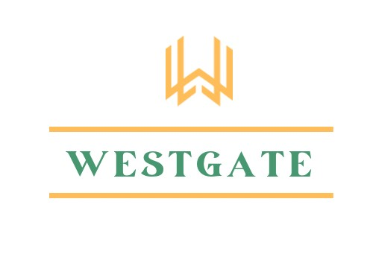
2025 Westgate Co - Tree Price List
613-382-3111

Delivery starting from $55.00 + Tax as per location (please inquire).
Prices are subject to change at any time.
All trees sold are field grown. They are either B&B (balled and burlapped) or Potted.
See specific tree tags on site for more details on care, soil/sun needs and appearance.
Please follow watering and care instructions as trees are final sale.

TREE TYPE | Description/Size | Cost
Japanese Maple (upright)  Acer Palmatum Sango Kaku | -B&B  -4-5 feet tall when purchased  -Pink/red bark &stems, green leaves, foliage turns gold & orange in Autumn  -Grows to about 20-25 feet tall and 15-20 feet wide | $179.00  + HST
Dwarf & Weeping Japanese Maple  Acer Palmatum Dissectum  Crimson Queen | -B&B  -24-30 inches when purchased  -Weeping burgundy foliage, turns flame orange in Autumn  -Grows up to 10 feet tall and wide | $149.00  + HST
Ornamental Shade Maple  Acer Rubrum October Glory | -Potted  -7-8 feet tall when purchased  -Mid-sized shade tree with dense, rounded canopy turns orange to deep red fall foliage  -Grows to 40-50 feet tall and 30-40 feet wide | $159.00  + HST
Ornamental Shade Maple  Acer Rubrum Red Rocket | -Potted  -7-8 feet tall when purchased  - Columnar, red flowers with green leaves, turning red in fall  -narrow and upright  -Grows to 35-40 feet tall and 15 feet wide | $179.00  + HST
Betula Birch  Betula Papyrifera Paper Birch | -B&B  -6-7 feet when purchased  -Fast growing with gleaming white bark and golden fall colour  -Grows to 50-70 feet tall and 25-50 feet wide | $139.00  + HST
Cornus – Flowering Dogwood  Cornus Florida Pink Rubra | -B&B  -5-6 feet tall when purchased  -Deep pink bracts with spectacular fall foliage of maroon and scarlet.  -Grows to 15-30 feet tall and 15-30 feet wide | $199.00  + HST
Cornus – Flowering Dogwood  Cornus Kousa Satomi | -B&B  -4-5 feet tall when purchased  -Upright spreading with deep pink bracts and foliage that turns scarlet in fall  -Grows to 12-15 feet tall and 12-15 feet wide | $179.00  + HST
Fagus – Beech Tree  Fagus Sylvatica Dawyck Gold | -B&B  -7-8 feet tall when purchased  -Columnar growth, bright yellow, chartreuse colour in spring and later turns lime green.  -Grows to 40-45 feet tall and 15 feet wide | $279.00  + HST
Magnolia – Butterflies | -B&B  - 5-6 feet tall when purchased  - Fragrant canary yellow flowers that bloom in spring resembling a flock of butterflies  -Grows up to 25-30 feet tall and 10-15 feet wide | $219.00  + HST
Magnolia – Ricki | -B&B  -3-4 feet tall when purchased  - Magenta blooms, compact smaller shrub-like magnolia known for its large fragrant reddish-purple flowers that bloom in late spring before leaves emerge  -Grows 8-12 feet tall and wide | $179.00  + HST
Magnolia – Soulangeana | -B&B  -4-5 feet tall when purchased  -Saucer type, large early-blooming flowers are white, pink, and/or purple  -20-25 feet tall and up to 20 feet wide | $179.00  + HST
Thuja – Cedar  Occidentalis Smarged – Arborvitae | -B&B  -5-6 feet tall when purchased  -Eastern Cedar, bright emerald green foliage, versatile, easy to grow, pyramidal growth shape  -Grows to 12-14 feet tall and 3-4 feet wide | $99.00  + HST
.
Quercus – Oak  Quercus Macroparca – Bur Oak | -Potted  -6-7 feet tall when purchased  -Leathery green lobed leaves, massive trunk & sturdy horizontal branches provide architectural interest.  -Grows 60-80 feet tall and wide | $149.00  + HST
Fruit Tree – Apple Ambrosia | -Potted | $89.00  + HST
Fruit Tree – Apple Royal Gala | -Potted | $89.00  + HST
Fruit Tree – Pear Summercrisp | -Potted | $89.00  + HST

