Oo-Oo-Nah Art & Cultural Center
Youth Mural Apprenticeship Handbook
Celebrating the Sacred Water Cycle
with Dimitri & The Watershed Collective
June 2026
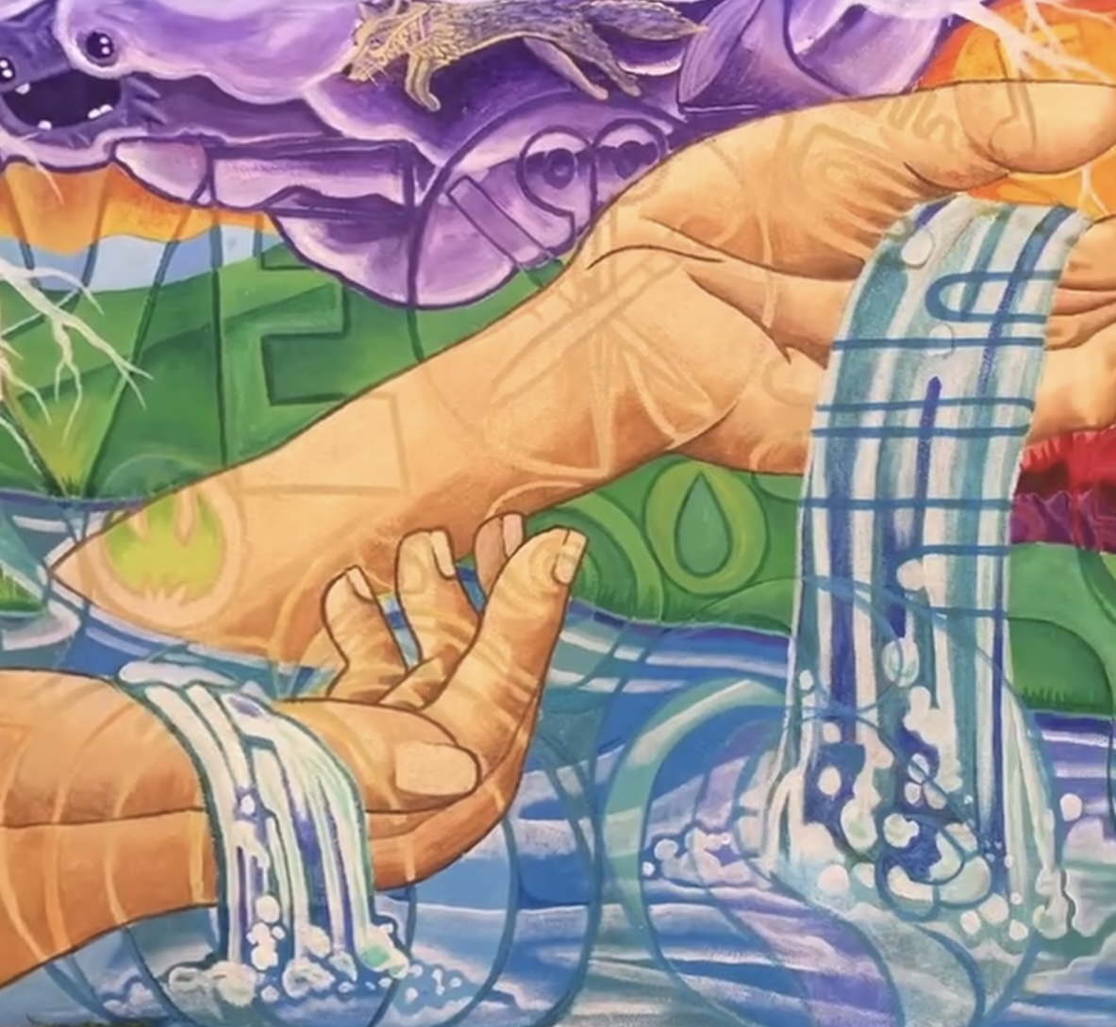
Hosted by Oo-Oo-Nah Art & Cultural Center
and The Watershed Collective

Welcome
Welcome to the Sacred Water Cycle Community Mural Project at the Oo-Oo-Nah Art & Cultural Center.
This youth apprenticeship is an opportunity to learn mural painting, collaborate with professional artists, connect with community, and celebrate the importance of water through public art.
Orientation Meeting
June 8th, 2026
3:00 PM – 4:00 PM
Oo-Oo-Nah Art & Cultural Center
Painting Schedule
Painting Days:
• June 9
• June 10
• June 11
• June 16
• June 17
• June 18
• June 23
• June 24 (TBD)
• June 25
What You Will Learn
• Mural painting techniques
• Drawing and design
• Color mixing
• Scaling artwork to large walls
• Teamwork and collaboration
• Public art practices
• Water stewardship and environmental awareness
• Community engagement through art
What To Bring
• Water bottle
• Snacks/lunch
• Sunscreen and hat
• Closed-toe shoes
• Paint clothes
• Layers for changing weather
• Sketchbook and pencil
• Positive attitude
Safety & Expectations
Attendance is expected for all participants whenever possible.
Respect fellow artists, mentors, and the mural space.
Stay hydrated, follow safety instructions, and help clean up daily.
Weather or project timelines may shift painting dates if necessary.
Contact Information
Oo-Oo-Nah Art & Cultural Center
832-867-5819
Mariel Garcia
505-660-4183
Mariel@thewatershedcollective.life
Website:
thewatershedcollective.life

Youth Application / Letter of Interest
Student Name: _____________________________ Age: ________
Parent/Guardian: __________________________________________
Phone / Email: ____________________________________________
Why do you want to join this mural project?
______________________________________________________________
______________________________________________________________
What do you hope to learn?
______________________________________________________________
______________________________________________________________
Do you have experience with painting or other art?
______________________________________________________________
______________________________________________________________
I understand that participating in this mural project is both a responsibility and an opportunity.
I agree to follow safety instructions, respect the artists and participants, and contribute positively to the project and community.
Youth Signature: ___________________________________________

Parent Consent / Liability / Photo Release
I give permission for my child to participate in the Oo-Oo-Nah Art & Cultural Center Sacred Water Cycle Mural Apprenticeship.
I understand that outdoor art activities involve physical activity, ladders, paint materials, and changing weather conditions.
I release organizers, artists, participants, and property owners from liability during participation in the project.
I grant permission for photographs and video to be used for project documentation and promotion.
My child has transportation to and from the project site.
Special allergies, medications, or health concerns:
______________________________________________________________
______________________________________________________________
Parent Name: ______________________________________________
Signature: _________________________________________________
Date: ______________________________________________________
Emergency Contact: ________________________________________
Phone Number: _____________________________________________

