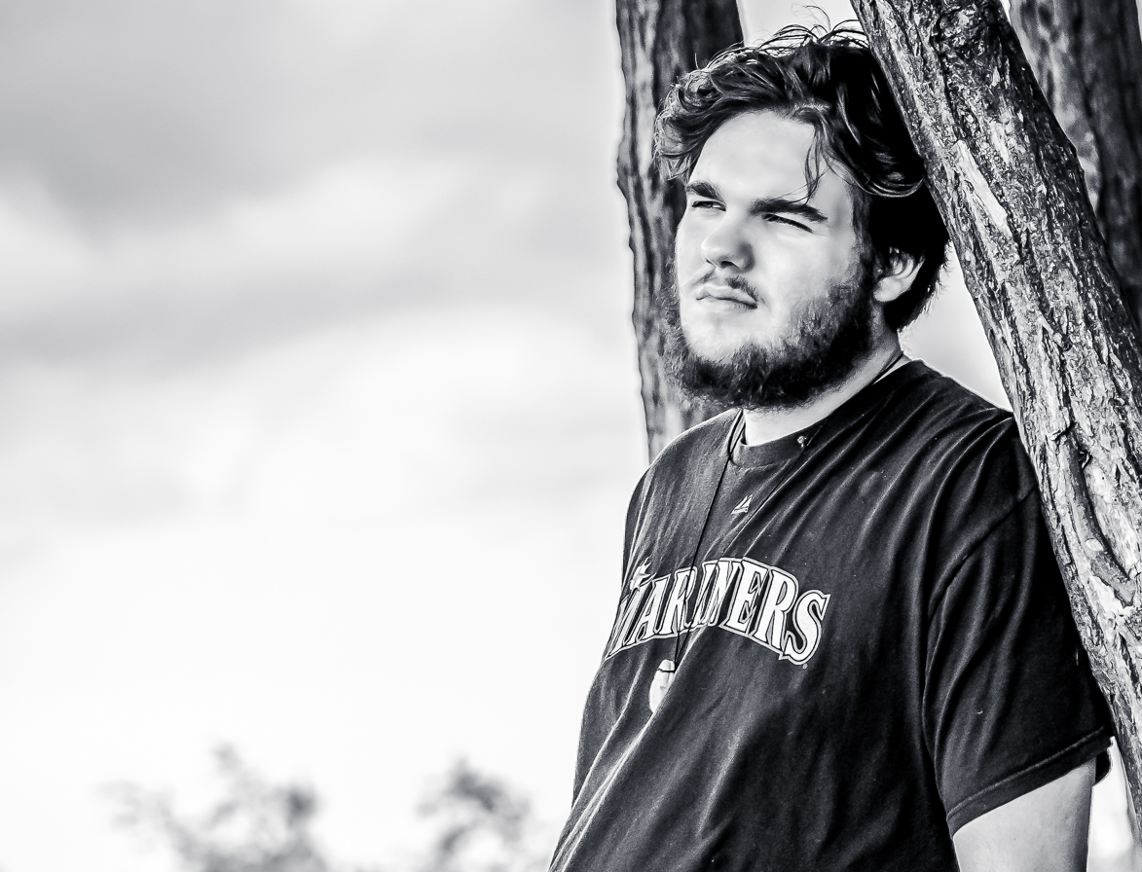
BRAVO
Griffen!

Love you always,
Mom, Dad, Carlin & Troy!

