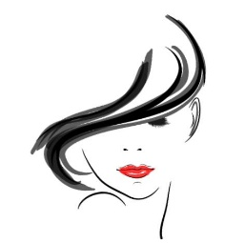
About you and your skin!
- What do you have the most trouble with when it comes to makeup?

- When choosing beauty products, what products do you have the most trouble with?

- What concerns are you having with your skin at the current time?

- Do you have any allergies or sensitivities to certain beauty products?

- What are your main concerns about your current makeup routine? Time? Application technique? What to buy?

- If you could make the perfect makeup product, what would it be?

- What is your age?

- What is your occupation?

- What do you most want to learn in this class?

- Do you aspire to do makeup professionally for others or just master your personal look?

I want to know all about you.
As we spend this time together we will create a beautiful bond. We call it beauty therapy! Your secrets are safe here! Can’t wait to meet you.

Much love,
Tiffany D. Ayala

