Why to attend a Maintenance
Planning and Scheduling Workshop?
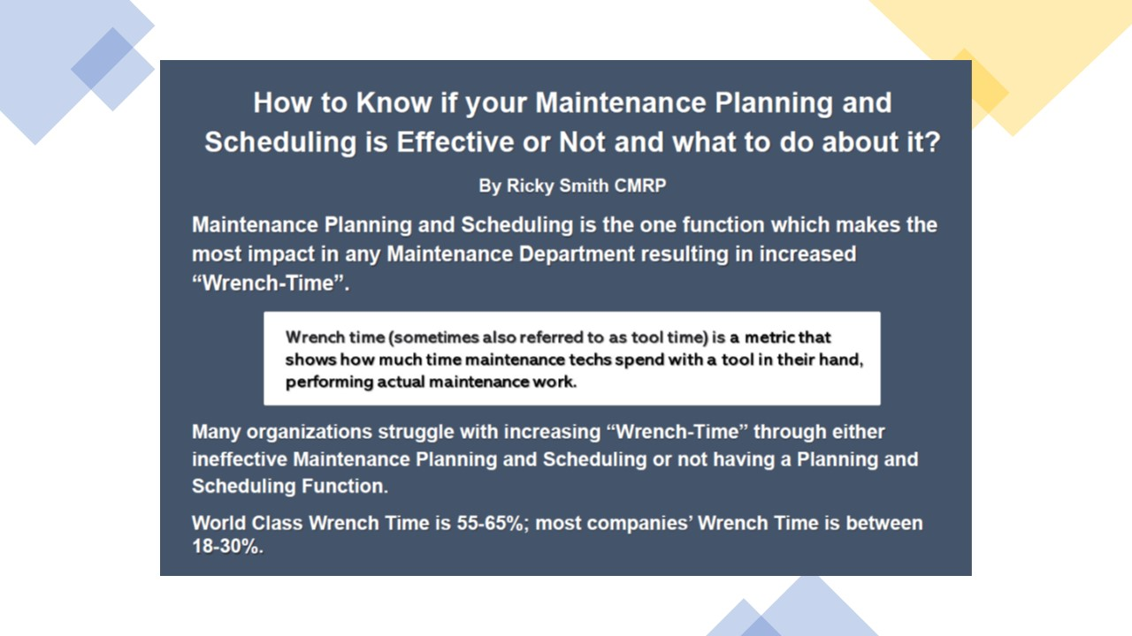

- To increase wrench-time (hands on tool time)

Wrench time is a measure of crafts personnel at work, using tools, in front of jobs
Wrench time does not include time:
- Obtaining parts
- Looking for tools or instructions
- Travel associated with obtaining parts, tools, etc.
- Traveling to or from jobs
- Time spent obtaining work assignments.
- To reduce “Maintenance Human Error” based on John Day’s commented that he created Planning and Scheduling in 1970s to mitigate human error. (John Day PE was the Engineering and Maintenance Manager at Alcoa Mt Holly – first plant in the World Certified as meeting “World Class Maintenance Standards”)
- To reduce Maintenance Cost through Optimizing Maintenance Work by performing the right work at the right time. (See WCM Cost vs Typical Maintenance Organization below)
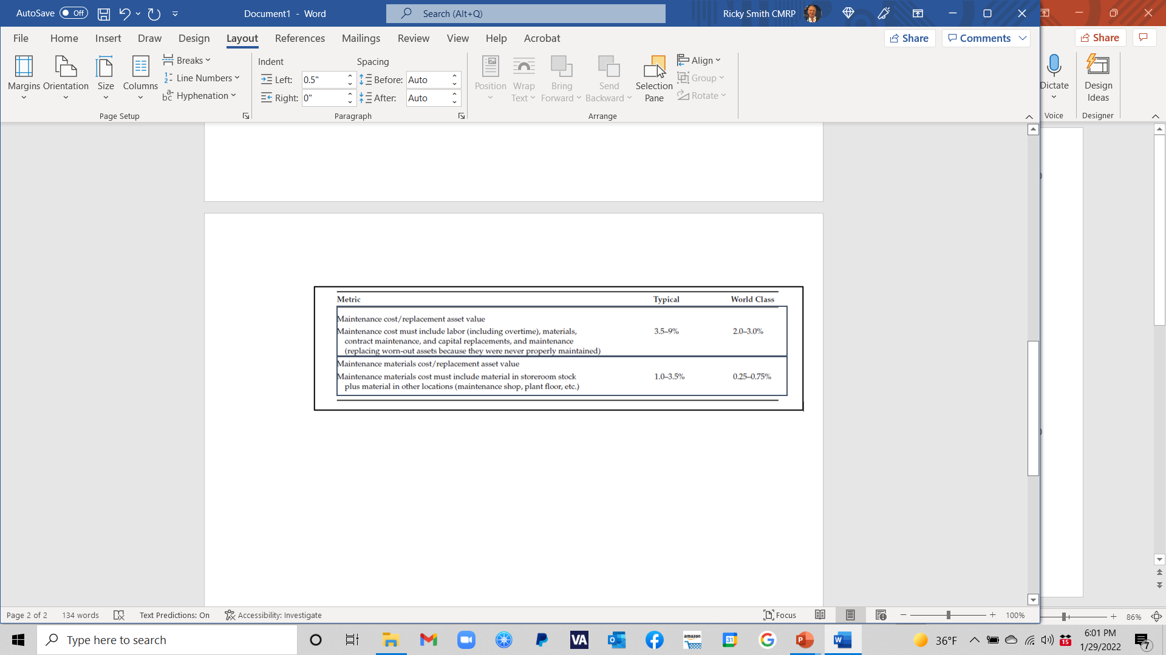
- To learn from “hands on exercise” to enhance knowledge transfer.
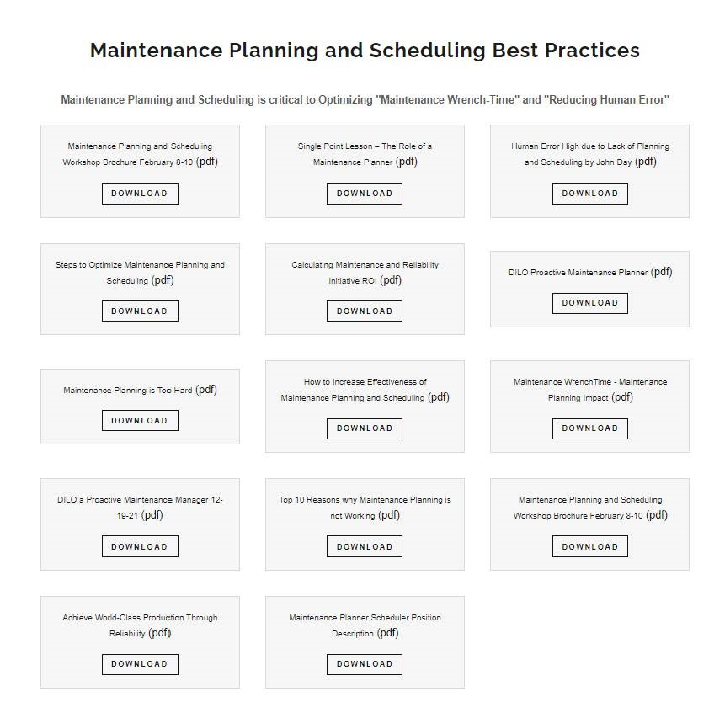
- To enable Maintenance Technicians to perform Maintenance Actions to specification with the right part at the right time.
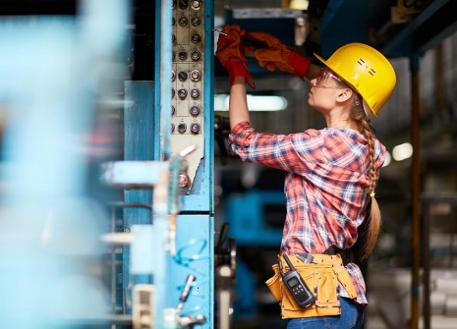
- To learn how to create a Planning and Scheduling Dashboard
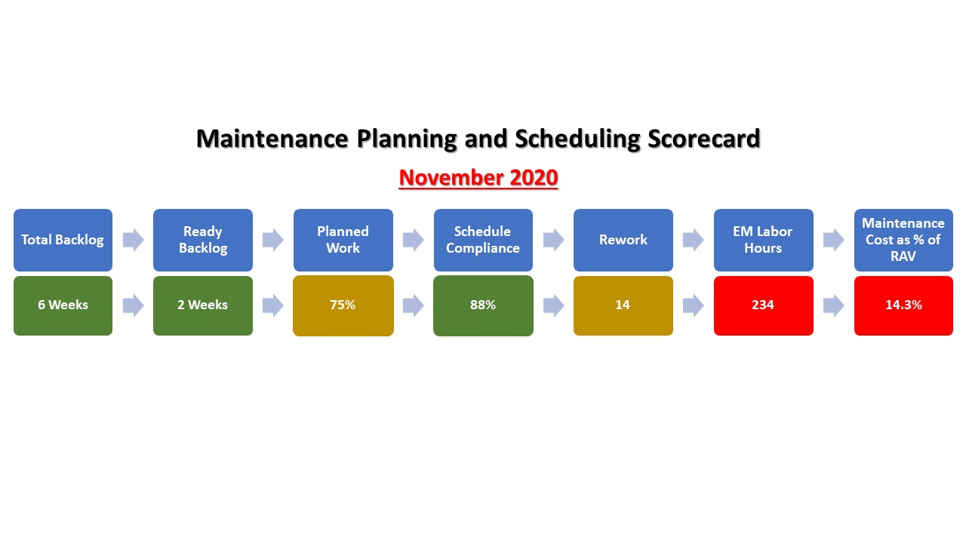
- …send 2 Maintenance Techs and your Maintenance Planner to a public Planning and Scheduling Workshop
