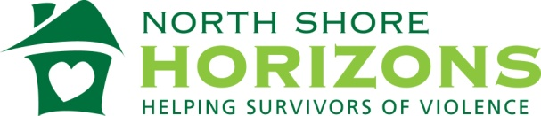

STRONGER TOGETHER:
A support group for people who have experienced harmful relationships.
Focusing on: self-empowerment, healing, coping strategies, and making healthy changes.
Find support in a healthy, safe environment.
TUESDAYS 6-7PM
We will be meeting through ZOOM online
until further notice for a ZOOM invite
to support group
please email
Kate@northshorehorizons.org
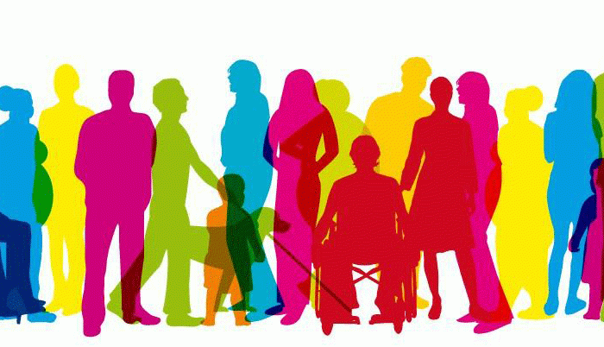
All are Welcome

