TheUnity
Presents
A Beloved Community Concert
Save The Date: Friday, November 22, 2019
The Rotunda: 4014 Walnut Street. Phila. PA 19104

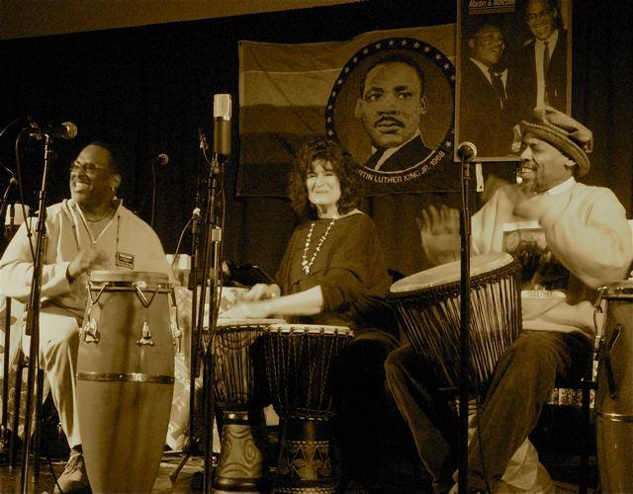

There’s a sound in the air, It seems to flow everywhere.
At a time and place thru our City, our Country, and our World, there is need of Peace, Love, and Power, across all cultures, ethnic divisions and engaged spirits as a Beloved Community.

TheUnity opens that portal heard on the needed importance of harmonic community engagements while avoiding dynamic divisions that are seen and felt in today’s society.
YOU WANNA BE HERE!!
ADMISSION: GOOD WILL OFFERING ACCEPTED
Visit: plptheunity.com
Contact: plptheunity@gmail.com

