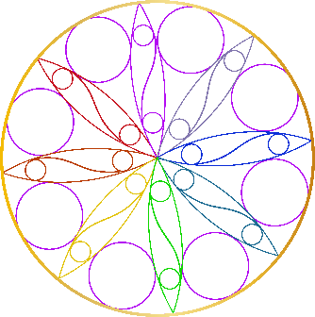

ACKNOWLEDGEMENT OF SERVICES AND FEES
SUBJECT: SELF-IMPROVEMENT PROGRAM

I, the undersigned, acknowledge that I understand and agree to the following:

I agree to pay you, Jennifer Shanteau, a fee of $ __________ per session.

I also agree to pay you for your services, in full, on the date of each session.

I agree to give you 24 hours notice for all cancellations or changes of scheduled appointments. I understand, that missing a scheduled appointment without prior cancellation, or canceling with less than 24 hours notice, may be charged to me at the current full rate.

I understand that the program of conditioning offered by you will include an undetermined number of private sessions, depending on my individual needs. I understand and agree that the major purpose of this program is for Vocational or Avocational Self-improvement and those problems of psychogenic or functional origin are treated by psychological or medical referrals only (Business and Professions Code 2908). I also understand that there are no guarantees as to the results or progress to be made, only that you will, to the best of your ability, endeavor to accomplish the objective of my sessions.

___________________________________________________________________________
Client Date

