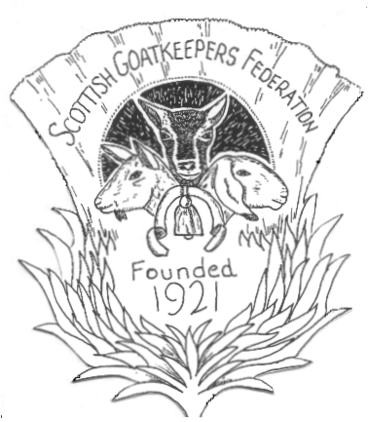
THE SCOTTISH GOATKEEPERS FEDERATION

Affiliated to the British Goat Society
Scottish Charity Number: SC030374

MEMBERSHIP FORM

NAME(s) ..............................................................................................................

ADDRESS ......................................................................................................................................

................................................………..…....... POSTCODE .........................................................

TEL: ……………………………………… E-MAIL: ……………………………………………

Magazines by EMAIL (A4 colour, pdf format)

Magazines by POST (A5 colour booklet)

TICK
£6 ----- SINGLE MEMBERSHIP (One name only)

Date of Birth (if under 12 years old) .........................................

£8------JOINT MEMBERSHIP (Two names living at same address)

£2-----ADDITIONAL MEMBERS

At the same address as SINGLE, JOINT or LIFE members
Names (and ages if under 12)

........................................................................................................................
If in addition to a LIFE MEMBER put life members name at top of form

£6-----CLUB AFFILIATION For clubs wanting to receive S.G.F. publications

Club name ..........................................................................................

Address ………………………………………………………………………………...

Postcode ....................... Tel ......................... Email…………………………….……...

I/We consent to the SGF storing my/our details for the purposes explained in the GDPR statement.

Signed …………………………………………… Date ……………………………

I enclose £ ................... REMITTANCE CHEQUE/BACS/STANDING ORDER/CASH

Please make cheques payable to “SCOTTISH GOATKEEPERS’ FEDERATION”
BACS payments: Sort code: 80-05-27 Acc. No: 00747938
Please use YOUR SURNAME plus SUB as the reference and send notification to email address below.

IN ALL CASES PLEASE SEND OR EMAIL THIS FORM TO: MRS LISA SINCLAIR, MANSEFIELD, MEIKLEOUR, PERTH, PH2 6EH. Email: lisa6sinclair@gmail.com

