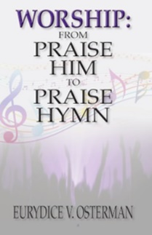

Course Registration Form
Worship: From Praise Him to Praise Hymn

Full Name: Click or tap here to enter text.
Mailing Address: Click or tap here to enter text.
Email Address Click or tap here to enter text.
Cell Phone Click or tap here to enter text.

How did you hear about the course? Click or tap here to enter text.

Course Options: ☐Option #1: $125 (Course and Certificate)

This option is an Independent Study that includes a certificate of completion at the end. The modules will be available to download each week.
REGISTRATION: Open.

☐Option #2: $175 (Course, Group Chat, Certificate)
This option includes a group chat, and a certificate of completion at the end. The modules will be available to download each week. REGISTRATION: October 1-15, 2023.

☐Option #3: $225 (Course, Group Chat, Extra Webinars, Certificate
This option includes a group chat, an extra monthly webinar, and a certificate of completion at the end. The modules will be available to download each week. REGISTRATION: December 15-31, 2023.

Pay Here: https://www.paypal.com/paypalme/awsahmmusic

