WHISPERING HILLS ESTATES

ACC PERMIT APPLICATION
Note that all information must be accurate and complete before the ACC will review the permit request. Each structure requires its own separate permit. Any deficiencies in the application will RESET the review timeline. In addition, physical copies of the permit and accompanying documents will NOT be accepted. They must be emailed to whepoatx.online@gmail.com to be registered by the Board for review.

Section A - Property Owner Information
Owner Name:
Owner Phone:
Owner Email:
Block Number:
Lot Number:
Property Address:
Owner assigns Delegate (provide Delegate Name) (if applicable)
Delegate Phone (if applicable)
Delegate Email (if applicable)
Date of Application:
Proposed Start Date:
Proposed End Date:

Section B – Type of Structure being considered:
Construction Type (Choose an item.)
Other Structure Description: __________________________

Section C - Project Summary
Brief Description of Proposed Project:

Section D - Construction Specifications
Primary Exterior Material: ______________________________________
Exterior Siding Color: ______________________________________
Roof Material: ______________________________________
Roof Color: ______________________________________
Trim Color: ______________________________________
Fence Material: ______________________________________
Fence Height: ______________________________________
Important Note: All additional structures must be comprised of the same material as the single family residence on the lot. The additional structure must be of the same color and design as the single family residence on the lot.

Section E - Building Details
Proposed Square Footage: __________________
Distance From Street (ft): __________________
Distance From Side Property Line (ft): __________________
Distance From Rear Property Line (ft): __________________
Fence Placement (if applicable): ______________________________________

Section F – Minimum Required Attachments (note that additional attachments may be required as part of the ACC review).
☐ Site Plan / Property Sketch with the proposed improvement clearly marked as a location on the sketch/site plan
☐ Photos/Examples of Proposed Structure
☐ Architectural Drawings
☐ Material Specifications
☐ Other Supporting Documents
☐ Survey (required if applying for fence installation)

Section G - Owner Certification
☐ I certify all information provided is accurate.
☐ I understand ACC approval is required before construction begins.
☐ I (Property Owner) commits to handling/disposing of all demolition & waste materials without using the neighborhood dumpsters or burn pit, and that I must contract for a construction dumpster at my own expense.
Property Owner Signature: ______________________________
Date: ____________________

Excerpt from Restrictive Covenants regarding Architectural Guidelines and Requirements:

Quick Summary of the specifications:

The distance of a building from the front lot line must be 25 ft. or greater.
The distance of a building from the side lot line must be 5 ft. or greater.
The floor area of the primary residence must be no less than 1,200 square feet.
Exterior walls of the primary residence must be brick, stone, or wood. Any deviations from these materials require the prior approval of the Architectural Committee.
All other buildings (such as carports, storage buildings, etc) also require approval from the Architectural Committee and they MUST be constructed of the same material as the primary residence. For instance, it is prohibited to build a stone/wood primary residence, and then build a metal carport.
Please review the excerpts for sewage and water supply – you are required to apply for the proper permits with the County and the local water district if applicable.
Fencing around the property is not prohibited, but proper materials (no chain link, barbed wire, etc) should be used and is also subject to Architectural Committee Review and Approval.

Below, you will find snapshots of the various building requirements and specifications in the 6th Amended Restrictive Covenants for Whispering Hills. Any references to Phase II are references to Hidden Village and NOT Whispering Hills.

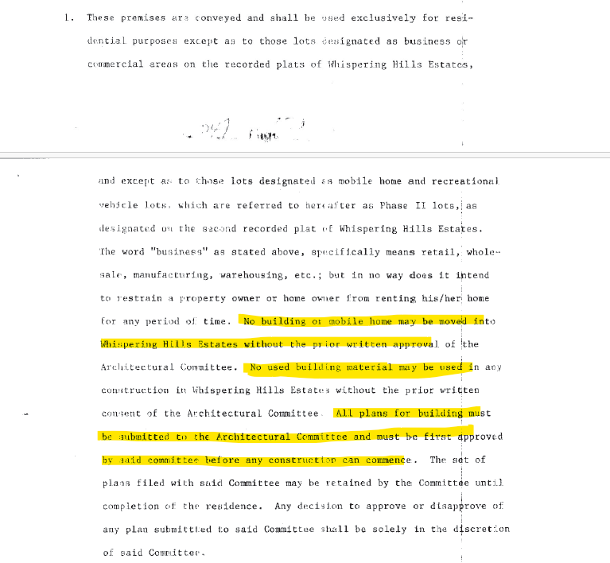

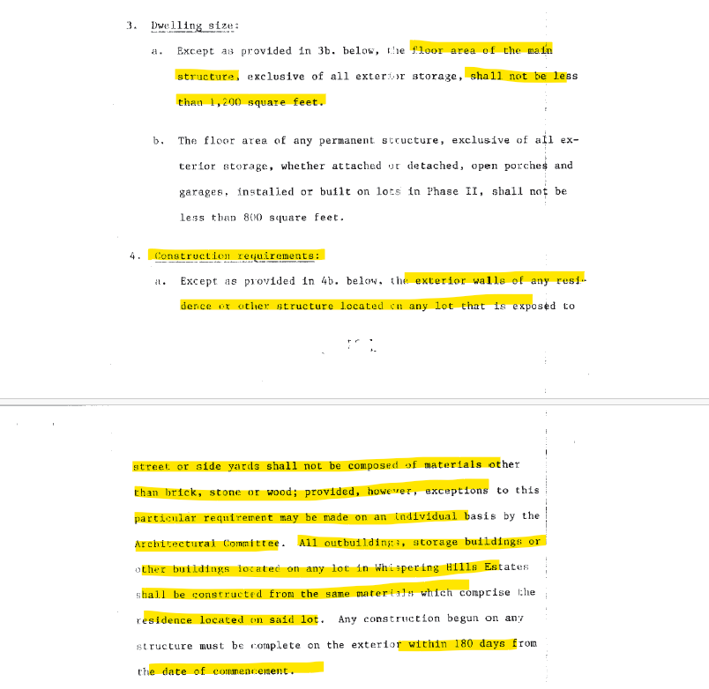

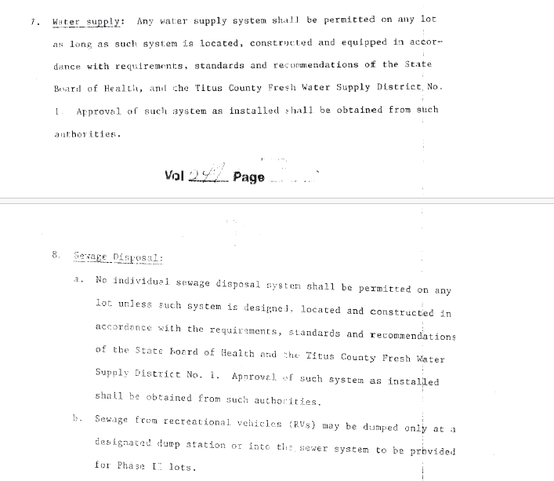

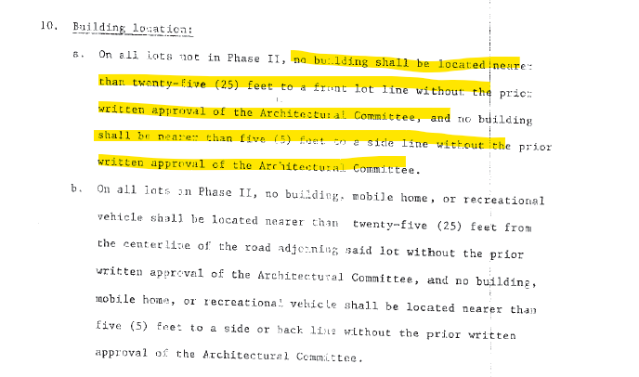

ACC Request for Approval Process (also disclosed in the Whepoatx.org website)
THE ACC REQUEST FOR APPROVAL PROCESS:

1. BEFORE any work can begin on ANY project that may be covered by our Covenants, Approval MUST be gained from the ACC and/or Board.

2. Note that before any Application will be considered, the property owner must be current on POA Annual Assessments and fees, and not have any other outstanding Covenant violations.

3. Request for Approval (RFA) of any such project must be submitted to the ACC at least 60 days prior to the project's Start Date. The request must be in a package that includes the following:
a. Completed Permit Application Form (PAF) -- see download link below;
b. If there are multiple structures to be constructed, i.e. -- a shed and a fence, or a house and a shed, EACH structure MUST be listed on a SEPARATE Application Form (PAF). If a PAF is submitted with more than 1 distinct structure, it will be considered incomplete and returned to the Submitter for correction, causing delays.
c. Any and all plans, blueprints, drawings, photos/images, etc. that visually demonstrate the result of the project;
d. Any supporting documents that contain other essential info not included in (a) or (b).
e. For New build Homes: Site plan showing exactly where the proposed construction is to be located on the lot; specifically showing distances from the street (edge) and to any nearby lot lines.

4. ALL documents must be submitted Electronically to the whepoatx.online@gmail.com email box.
- Hardcopies must be clear photocopies -- NOT the originals, preferably on standard 8.5"x11" paper.
- ALL documents submitted must be able to print on standard 8.5"x11" paper - no Legal size, no Architectural Blueprint size, etc.
- Electronic submissions must be sent via email to at our POA address: whepoatx.online@gmail.com.
- Any documents or info submitted by other means (such as verbally or text message) will NOT be considered an "official" part of the RFA Package.
- Electronic/digital photographs of any of the submitted documents will NOT be accepted.

5. ALL documents in the RFA Package MUST be submitted together as a single group. Any partial or incomplete RFA Packages will be returned to the Submitter with no decision, and the Review/Decision Timeline will RESET. Any material questions, clarifications, or additional documents needed will also RESET the timeline.

6. An Owner may identify a person as their delegate to submit the RFA Package and/or act as their agent during the Permit Application process, and for the duration of the entire project. That Delegate must be named on the PAF including their Phone number and email address.
7. Once the RFA Package is received by the ACC, an email notice will be sent within 2 BUSINESS DAYS to the Owner and/or Delegate confirming receipt of their complete RFA Package, and providing an estimated Date of Response (DOR).

8. If the planned Start Date of the project allows, we will review and decide on the Application during the next scheduled Regular Board Meeting. Otherwise, the Board & ACC shall convene an Executive Session (meeting) to review the RFA Package and respond to the Request within 10 BUSINESS days of receiving the RFA Package.

9. Once the ACC has met and decided, an email shall be sent to the Owner within 2 BUSINESS DAYS informing them of the decision, including a signed, scanned copy of the PAF showing the Approval or Denial for the Owner's records.
10. If the RFA is Denied, per the State Law referenced below, the Owner may appeal that decision to the Board. Procedures for that appeal are detailed within that State Law webpage, and will be handled by the Board accordingly.
APPLICABLE TEXAS STATE LAW: PROPERTY CODE CHAPTER 209.00505:
https://statutes.capitol.texas.gov/Docs/PR/htm/PR.209.htm#209.00505
Any questions regarding this process should be sent to our main email address:
whepoatx.online@gmail.com

Section H. HOA / ACC Review (For Internal Use Only)
Initial Date Received | Review Deadline

Re-set Date Received | Review Deadline
Application Complete?
☐ Yes
☐ No
Property Owner Current on Assessments?
☐ Yes
☐ No
Additional Information Requested?
☐ Yes
☐ No
If Yes, describe:
________________________________________________________________________________________________
________________________________________________________________________________________________

ACC Decision
☐ Approved
☐ Approved with Conditions
☐ Denied

Conditions / Comments

Board / ACC Signatures
Name | Signature | Date
ACC Member #1 | ____________________ | __________
ACC Member #2 | ____________________ | __________
ACC Member #3 | ____________________ | __________
ACC Member #4 | ____________________ | __________
ACC Member #5 | ____________________ | __________
ACC Member #6 | ____________________ | __________
ACC Member #7 | ____________________ | __________

Final Decision Notification Sent
☐ Email Sent to Owner
Notification Date: ______________________

