**Please remain in your car when you arrive.**

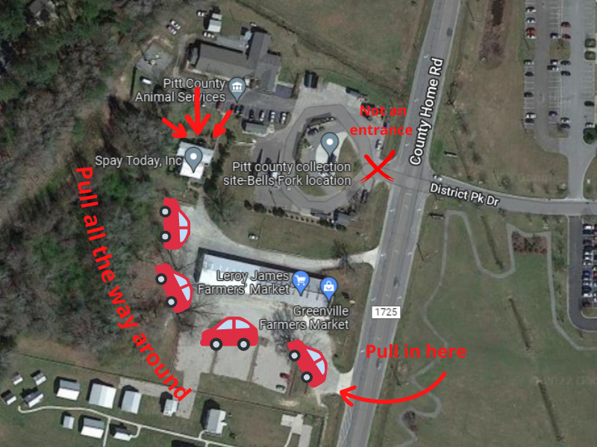

**When do I need to be there?**

**When do I need to be there?**

**-   Drop off is in the morning between 715-745. We are not able to accept animals after 8:15. We have a strict surgery schedule and can't accept any animals after the stated time.**

**-There may be traffic on the way to the clinic, we are located next to a school. This traffic does thin out before the cut-off time.**

**Where are you located?**

-          Our address is 4556 County Home Road, Greenville NC.

-          We can be hard to find. We are located behind the local Farmer’s Market. That is the entrance that you will want to use. You will need to pull all the way around to access our clinic.

-          This is our only entrance, we kindly ask that you don’t use the Animal Shelter parking lot. That leads to the rear of our clinic and a staff member will not be able to see you when you arrive.

**Please do not pull into the shelter parking lot, we need all clients in our parking lot as we have had you fill out paperwork while in your car.**

**What do I need to bring?**

-          **All appointments:**

o   If you’re pet has already received its rabies vaccination, we will need you to bring the paperwork proof to your appointment. You can also email it to us. A rabies tag on the collar, will not count as proof.

-          **For dog appointments:**

o   A dog needs to be on a leash and collar.

o   If you are bringing your own e-collar we will need it on the morning of surgery.

-          **Cats**

o   Cats must come in a carrier.

o   If you have multiple cats scheduled on the same day, each cat with need to be brought in a separate carrier. If you don’t have separate carriers, we offer cardboard carriers at our clinic for 10.00 on the morning of your appointment.

-          **Feral Cats:**

o   All cats scheduled for a feral appointment need to be brought in a feral cat trap.

o   Please have a cover for your trap, this will help keep the cat calm and not thrashing about.

§  It can be an old towel, sheet, or blanket.

o   Inside the trap, we ask that you only put newspaper or a peepee pad. Please **don’t** put blankets, towels, or wood chips **inside** the trap.

**What is the Cost?**

-          For all pets, rabies vaccines are mandatory, unless your pet has already been vaccinated and you have the paperwork proof.

-          These prices below are the cost of only what is mandatory (surgery and rabies). Our clinic does offer other services that you can request on the morning of your appointment.

o   **Dogs:** Rabies is 15.00 and E-Collar is 10.00 **mandatory**

§  Male Dog: 130.00

§  Female under 70lbs: 130.00

§  Female above 70lbs: 150.00

-          **Cats:** Rabies is 15.00

o   Female 100.00

o   Male 100.00

o   Feral (in trap) 50.00

**What forms of payment do you take?**

-          We accept cash or cards.

·         **If paying with a credit card/debit card, there is a 5.00 service fee.**

-          We are **unable** to accept CareCredit or checks.

-          If you have a voucher, we will at the time of pickup.

-          Payment is due in the afternoon at pick up.

**Can my pets eat before their appointment?**

-          No food after midnight. Small kittens under the age of six months can have a very small snack.

-          Water should always be available.

**What to expect at check-in?**

-          When you arrive in the morning a staff member with come to check you in and hand you paperwork to fill out.

-          Once you finish the paperwork, we ask that you put the clipboard on the outside of your windshield. This will notify a staff member that you’re finished and they will come by to check it over. A number will then be placed on your windshield and when it’s your turn a staff member with notify you and you and your pet will enter the clinic.