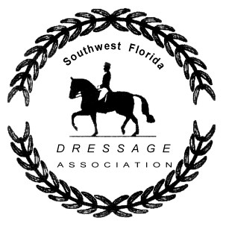SWFDA Work Credits Declaration Form
2020 – 2021 Show Season
Member Name: _________________________________________________________

Date of Event | Description of Task | Points Earned

Deadline May 22, 2020
Mail Form To:

Susan Cox
8691 Kilkenny Court
Ft. Myers FL 33912

Questions? Please contact swfldressage1988@gmail.com

Additional forms can be found on our website: www.swfda.org

